Cover Crops
Experiences From a Retired Educator
Michael Plumer shares some of his unpublished research data

By Bryon Kirwan, State Economist, USDA/NRCS

Michael Plumer is a well-known educator to producers in Southern Illinois. Michael retired from the Extension Service in 2010 after a 35 year career administered jointly between USDA and the University of Illinois. Mike built his career working with producers (primarily south of Interstate 70) to help them enhance productivity, profitability, and incorporate progressive conservation practices.

Cover crops are a ‘hot topic’, but cover crops in and of themselves are not new. In current discussions, they are being used in an attempt to re-create a more complex crop rotation that was evident on many Illinois farms until the late 1960’s or early 1970’s. From the perspective of providing supplemental nutrients to the following crop, there have been academic studies of cover crops for over 25 years. However many of the early studies were looking at the ability of a fall seeded cover crop to provide the necessary nitrogen for the spring crop. Results of that early work were mixed; but no long term or financially feasible options were found during those studies.

In talking to and working with Mike, he shares the following insights regarding Cover Crops:

•Takes commitment
Instituting cover crops is not always easy, profitable, or without problems

•Requires learning curve
You have to learn how to select and manage the species you intend to use

•Must adapt to own farm and soils
Your goals and needs may be different from the neighbor; also there are geographic considerations as to the most effective cover crop species and mixes

•Can be very cost effective
Returns far above establishment costs

•Has significantly increased soil productivity
Based upon measured increases in crop yields and soil fertility
Also greater water infiltration and deeper plant rooting

•Maybe next step in increasing yields to meet goals
Based upon measured increases in yields in plots comparing cover crops vs. no cover crop

•Provides greatest benefit when combined with no-till farming
Measured results are not as great when tillage is included as a part of cover crop management. This is especially telling in measuring changes in soil fertility.

•Can also be effective in changing pest populations
Cover crops have been used successfully to manage weed, insect, disease, and nematode populations

Some specific examples of Mike’s work:

Soybean Cyst nematode suppression by annual ryegrass; replicated trial, 2 of 4 years results

Treatment NW Plot yield SW Plot yield
Bare soil 48.9 48.2
Cereal rye 53.8 52.3
Annual ryegrass 55.7 60.6
Plumer, U of Il

Soybean Cyst Nematodes; 4 year trial replicated 3 times
Egg Count
Bare Cereal Rye Annual Ryegrass

NW 7533 717* 117**
SW 3650 320* 0**
LF 1559 722* 386*
JA 1202 390* 279*

Got Weeds?

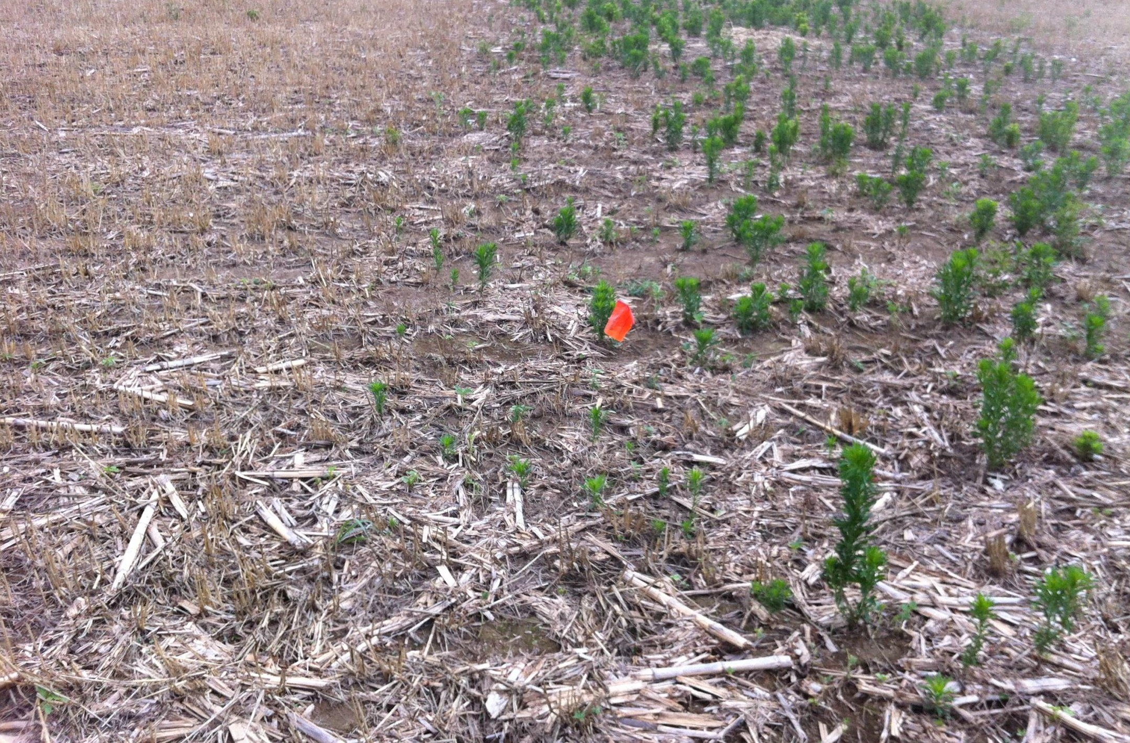

Replicated trial (8), rye residue removed (May 15) and control was not affected –June 15; 4 qt/a glyphosate applied to marestail on right

Cover crops are not quick and easy solutions that can be implemented by any producer anywhere. Mike’s key take-away’s regarding cover crops and management are:

Cover Crops
•Require planning
What are your needs
Are livestock a part of the considerations

•Require much higher level of management
How will cover crops effect following crop

•Are selected based on soil needs
No one size fits all

•Are selected on management system

•Mixes can increase benefits, but higher mgt.
Differing growth rates, termination dates, etc.

•Planning for next year starts today
Herbicide selection, crop, rotation, seed available

Cover crops can be an effective management tool to increase soil health, provide reduced erosion and other conservation benefits, as well as provide environmental benefits. However there are differences between cover crops, their management, and even the year they are used that preclude blanket statements and management plans. Producers and landowners will need to be well educated, prepared for some adverse effects, and willing to begin small and adapt as they learn more to be successful in cover crop adoption.

