
TECHNICAL NOTES
U.S. DEPARTMENT OF AGRICULTURE NATURAL RESOURCES CONSERVATION SERVICE
NEW MEXICO March, 2010
Water Quality Technical Note No. 20:

New Mexico Guidance for Integrated Pest Management

The goal of IPM is to maintain pest populations at tolerable levels (not to eradicate them). The philosophy of IPM involves using ecological concepts and knowledge of pest biology to establish the natural checks and balances between crop plants, pests, beneficial insects, and the physical environment. This approach reduces the reliance on pesticides. Since these interactions are unique for each system, a site-specific strategy must be used. This checklist and guidance will assist you in developing an IPM strategy for your land. For more assistance on this, please contact the NM NRCS State Water Quality Specialist.

As a first step, list the crops that you grow. For each crop, list the major crop pests that you need to control on your lands. Pests include insects, diseases, weeds, vertebrates, etc. Describe where and when the pests are problematic. Use the table below or attach separate sheets.

Crop 1: | Crop 2: | Crop 3:
Insect pests | Insect pests | Insect pests
Diseases | Diseases | Diseases
Weed pests | Weed pests | Weed pests
Other | Other | Other

Crop 4: | Crop 5: | Crop 6:
Insect pests | Insect pests | Insect pests
Diseases | Diseases | Diseases
Weed pests | Weed pests | Weed pests
Other | Other | Other

Scouting, Forecasting and Economic Thresholds

Scouting is done:

- To determine when levels of a pest reach or exceed threshold levels
- To reduce the amount of pesticides used
- To check effectiveness of pest control method
- In response to a local pest report
- To monitor areas where known pests occur or have occurred
- To monitor plant productivity and health

Pest populations must be scouted by individuals trained to recognize pests and their damage, and scouters should understand the proper way to record their findings. Ideally, the field will be scouted during the prior crop, between crops, at preplant, at planting, at crop emergence, at vegetative growth and/or reproductive growth, and at harvest. For some pest-crop problems in New Mexico, specific scouting procedures have been recommended by New Mexico State University. Where there is no specific guidance, the “Basic Scouting Procedures” developed by the Department of Entomology at Purdue University should be used (Attachment 1). The information and scouting forms in this attachment provide guidance for proper scouting and record keeping.

A. What method of scouting did you use most? (select only one and circle)

- Weekly scouting (or timing based on pest biology and crop interaction) by crop scouts utilizing GPS technology and field mapping
- Weekly scouting (or timing based on pest biology and crop interaction) by crop scouts and use of remote sensing to observe patterns of infestation
- Weekly scouting (or timing based on pest biology and crop interaction) by crop scouts looking for potential hot spots and spot checking
- Planned scouting at least several times during the season at specific times to identify pests and extent of problem
- Informal observation during routing farming/ranching operations
- Informal observations of what was happening at edge of field
- Informal observations during drive-by

B. Which method best describes your record keeping of scouting activities? (select only one and circle)
- A hand-held electronic device used to record field scouting data for mapping
- Written scouting records transferred to field map to identify hot spots and patterns
- Written records
- No records kept

The more information sources you can incorporate into your decision-making process, the better. Pest forecasting needs to be reliable and science-based. Weather influences some pests and can be used to help make decisions, run certain pest or disease models, etc.

C. Did you have access to weather data and did you use it in your forecasting and management decisions? Check all that apply.
Wind data
Degree days (source: )
Rainfall (source: )

D. Did you utilize any pest forecasting information to help in your decision-making? Yes or No
If so, which type of information?:

E. Did you use soil analysis to detect the presence of insects, disease, or nematodes?
Yes or No

F. What are the economic thresholds (see Attachment 2 for definition of economic threshold and examples) for major pests on specific crops you grow? Describe (or attach documents showing proper thresholds):

Descriptions of pest damage and economic thresholds can be found in NRCS NM Water Quality Tech Note 15, Practical IPM, http://www.nm.nrcs.usda.gov/technical/tech-notes/water.html or obtained from New Mexico State University. If no thresholds have been determined through research, how do you make your decision on when/if to use suppression methods? Describe:

G. Where noxious weeds are a concern, I am involved with or aware of the local Cooperative Weed Management Area (CWMA), http://www.nmda.nmsu.edu/animal-and-plant-protection/noxious-weeds, and follow the Integrated Weed Management Plan recommendations developed by the CWMA (Attachment 3). Yes or No

Pesticide Use
A key to intensifying natural enemy effectiveness is a sparing, if any, use of insecticides. “If you kill the pests’ natural enemies, you inherit their jobs.” Pesticide use requires proper handling, storage and application, and it is required by law that the applicator follows the label specifications.
The potential effects of the pesticide on biological activity and agroecology should be considered prior to any use of herbicides, insecticides, fungicides, nematicides, etc. NMSU has a fact sheet, “Improving Pesticide Use and Integrated Pest Management”, Farmstead Assessment System Fact Sheet #13, http://aces.nmsu.edu/farmasyst/. Farm-A-Syst, Fact Sheet #2, Improving Pesticide Storage and Handling, is available at http://aces.nmsu.edu/farmasyst/. This self-help assessment tool should be used to indicate and reduce a risk of groundwater contamination due to improper storage and handling.

Proper application includes the following considerations:

Were pesticide applications made by a certified applicator? Yes or No

Was the application equipment calibrated?:
Regularly during the season?
Before the season?
Not at all?

Did you keep accurate and complete pesticide application records according to USDA Recordkeeping Requirements for Private Applicators? Yes or No

Did you reduce the risk of off-site transport of pesticides by applying at proper times (based on weather reports, at appropriate crop stage, etc.), rates, and placement (need for banding, incorporation, etc.)? Yes or No

Do you use any new technology such as precision agriculture, hooded sprayer, low volume directed spray, chlorophyll sensor, etc. to limit pesticide use? Yes or No

Do you use chemicals with the same mode of action continuously on the same field?
Yes or No

Do you spot spray strips (or use non-chemical suppression methods) along fence rows or areas with acute infestations rather than broadcast pesticide application of the entire field?
Yes or No

Do you spot spray or cultivate small infested areas in the field immediately after identification through field scouting? Yes or No

Did you use Windows Pesticide Screening Tool to determine environmental risks prior to application of pesticides? Yes or No

Do you avoid the use of broad-spectrum pesticides wherever/whenever feasible?
Yes or No

Do you use vegetative buffers in sensitive areas or adjacent to water bodies to minimize chemical movement to surface waters? Yes or No

Non-Chemical Alternatives to Pest Management

A single-treatment approach to pest management is ineffective, and short-term effects will not provide long-term solutions to pest problems.

Prevention –
the practice of keeping a pest population from infesting a crop or field, and should be the first line of defense. It includes such tactics as using pest –free seeds and transplants, preventing weeds from reproducing, irrigation scheduling to avoid situations conducive to disease development, cleaning tillage and harvesting equipment between fields or operations, using field sanitation procedures, and eliminating alternate hosts or sites for insect pests and disease organisms.

Avoidance –
when pest populations exist in a field or site, the impact of the pest on the crop can be avoided through some cultural practice. Examples of avoidance tactics include crop rotation, choosing cultivars with genetic resistance to pests, using trap crops or pheromone traps, choosing cultivars with maturity dates that may allow harvest before pest populations develop, fertilization programs to promote rapid crop development, and not planting certain areas of fields where pest populations are likely to cause crop failure.

Suppression –
may become necessary to avoid economic loss if prevention and avoidance tactics are not successful. Non-chemical suppression tactics may include:
- cultural practices like narrow row spacings, alternative tillage approaches, cover crops or mulches.
- physical suppression such as cultivation or mowing, bait or pheromone traps, and temperature management or exclusion devices.
- biological controls such as mating disruption, conservation of beneficial insects, predatory or parasitic insects

Listed are some potential practices. Check all that apply (or add additional practices) and describe how you use these practices (how they are effective in pest management), or document information sources. In some cases, suggested practices may conflict with management for other resource concerns – seek assistance to determine management that best addresses all resource concerns.

Prevention
Tilling, mowing or chopping field lanes, field perimeters, or roadways where pests are resident or before weeds go to seed
Crop residue management to control pests
Clean tillage or harvesting implements after completing fieldwork to reduce the spread of weeds, disease or other pests
Control drainage or irrigation scheduling for water management to control pests
Create habitat for beneficial insects, birds, or animals (like windbreaks, pivot corner plantings, etc.)
Use of certified seeds and compost
Use of weed-free hay
Build soil health by using cover crops, manure, legumes in rotation to reduce pest incidences
Use soil sampling and testing to determine nutrient budget appropriate for emerging crop
Increased crop seeding rates and/or decreased crop row widths
Adjusting crop planting dates to escape pest colonization
Field selection to avoid planting crops next to land uses that serve as reservoirs for pests
Graze areas with weed infestations before they go to seed
Don’t move livestock from a weedy area to a weed-free area if livestock are a dispersal mechanism
Screen irrigation system when the water is coming from an irrigation canal
Proper sanitation practices
Use of green manures
Use of properly composted manure to reduce/eliminate viable weed seeds
Plant seed at proper soil temperatures
Grazing regimes that provide cover characteristics unfavorable for grasshoppers

Avoidance
Seed varieties with insect or disease resistance
Rotate crops to control pests
Use of trap crops to attract and concentrate pests within a small portion of the field
Implement any practice that improves general biodiversity around your lands, such as windbreaks, buffers, or planting pivot corners
Immediate response to new, localized weed infestations on range and pasture followed by rehabilitation of site
Use of cover crops during the year to manage weeds
Preplant tillage to remove early emerging weeds
Field cultivate or chisel plow following harvest to control weeds and volunteers
Post harvest irrigation to promote germination of weed seed
Use cultivation to control small weed patches when found through field scouting
Release of beneficial insects during growing season (see Attachment 4 for beneficials)

Suppression:
Seed varieties modified to be resistant to specific herbicides
Biological pesticide use such as Bt, insect growth regulators, microbial insecticides, natural products
Grazing sheep and goats at appropriate times to reduce weed infestations
Flame weeding
Allelopathic cover crops that control weed seed establishment and/or growth. For example, substances released from sorghum-sudangrass and winter rye inhibit germination of many weeds.
Use cover crops such as mustard, radish, sudangrass or rapeseed which act as biological fumigants
Biological control agents (primarily for long term control goals). See Attachment 5 for potential biological control agents. Check with NMSU on effectiveness of use.
Use mechanical methods (like hilling, cultivation, rotary hoeing, mechanical weeder) to control weeds

Information Sources

In the past year, did you attend an IPM School, field tours, private consultant field days, or educational meetings where research information on pest management was presented?
Yes or No If so, please describe:

Did you utilize any information from other sources (list after each checked)?
Private research reports
University publications
Farm publications
Internet pest alerts
Other

Have you conducted on-farm/on-ranch research or a demonstration project in collaboration with NMSU, private research companies, etc.? Yes or No

If yes, briefly describe the collaboration:

Potential Information Sources:

NMSU IPM website | http://aces.nmsu.edu/programs/sare/western-sare-ipm-worksho.html
NMSU Weeds website | http://weeds.nmsu.edu
NRCS NM Water Quality/Pest Management Tech Notes | http://www.nm.nrcs.usda.gov/technical/tech-notes/water.html
PNW Plant Disease Management Handbook | http://plant-disease.ippc.orst.edu/index.cfm
PNW Insect Management Handbook | http://insects.ippc.orst.edu/pnw/insects
University of Idaho Pest Management Center | http://www.ag.uidaho.edu/pmc/Pests/cropPests.htm
Pesticide Information Profiles | http://extoxnet.orst.edu/pips/ghindex.html
Biological Control | http://www.nysaes.cornell.edu/ent/biocontrol/index.html
University of California – Statewide IPM Program | http://www.ipm.ucdavis.edu/
Western IPM Center | http://www.wrpmc.ucdavis.edu/
Southern IPM Center | http://www.sripmc.org/ipm_states.cfm?state=TX

Putting it all Together – Integrated Pest Management

Combining field scouting, forecasting, and economic thresholds; judicious use and application of pesticides (reducing amounts and hazards); and use of non-chemical methods is Integrated Pest Management in practice. An example of recommendations for a specific crop-pest combination can be found in Attachment 6, and will help in understanding how to formulate an IPM strategy for your lands.

Attachment 1: Basic Scouting Procedures

Source: Field Crops Manual, IPM-1, Entomology Department - Extension, Purdue University

http://www.entm.purdue.edu/entomology/ext/fieldcropsipm/gbsp.htm (accessed August 5, 2005)

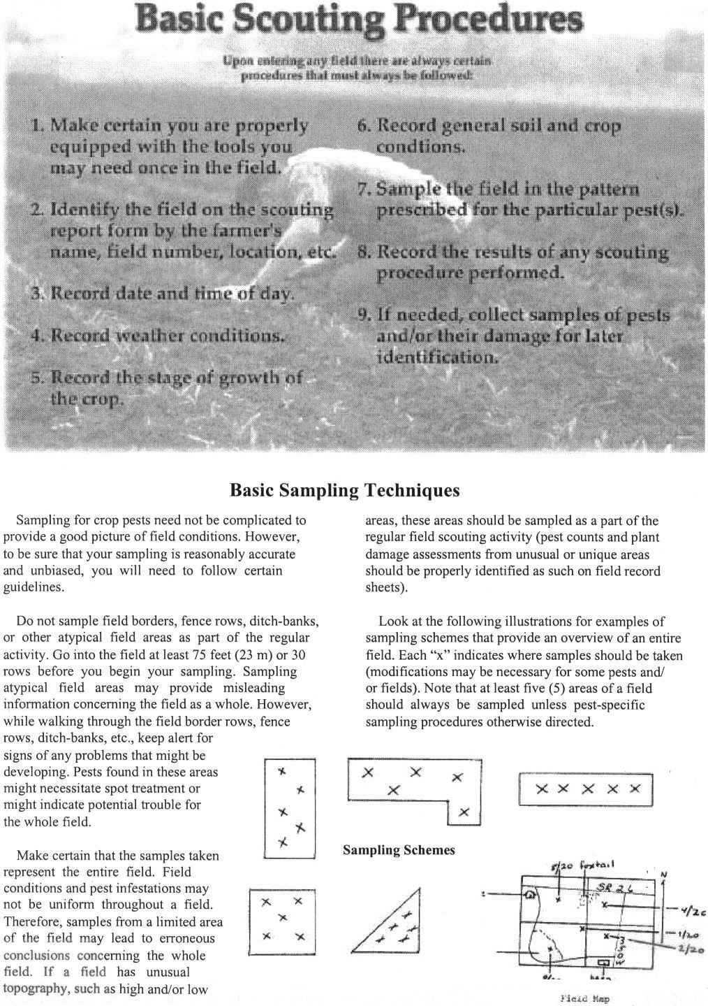
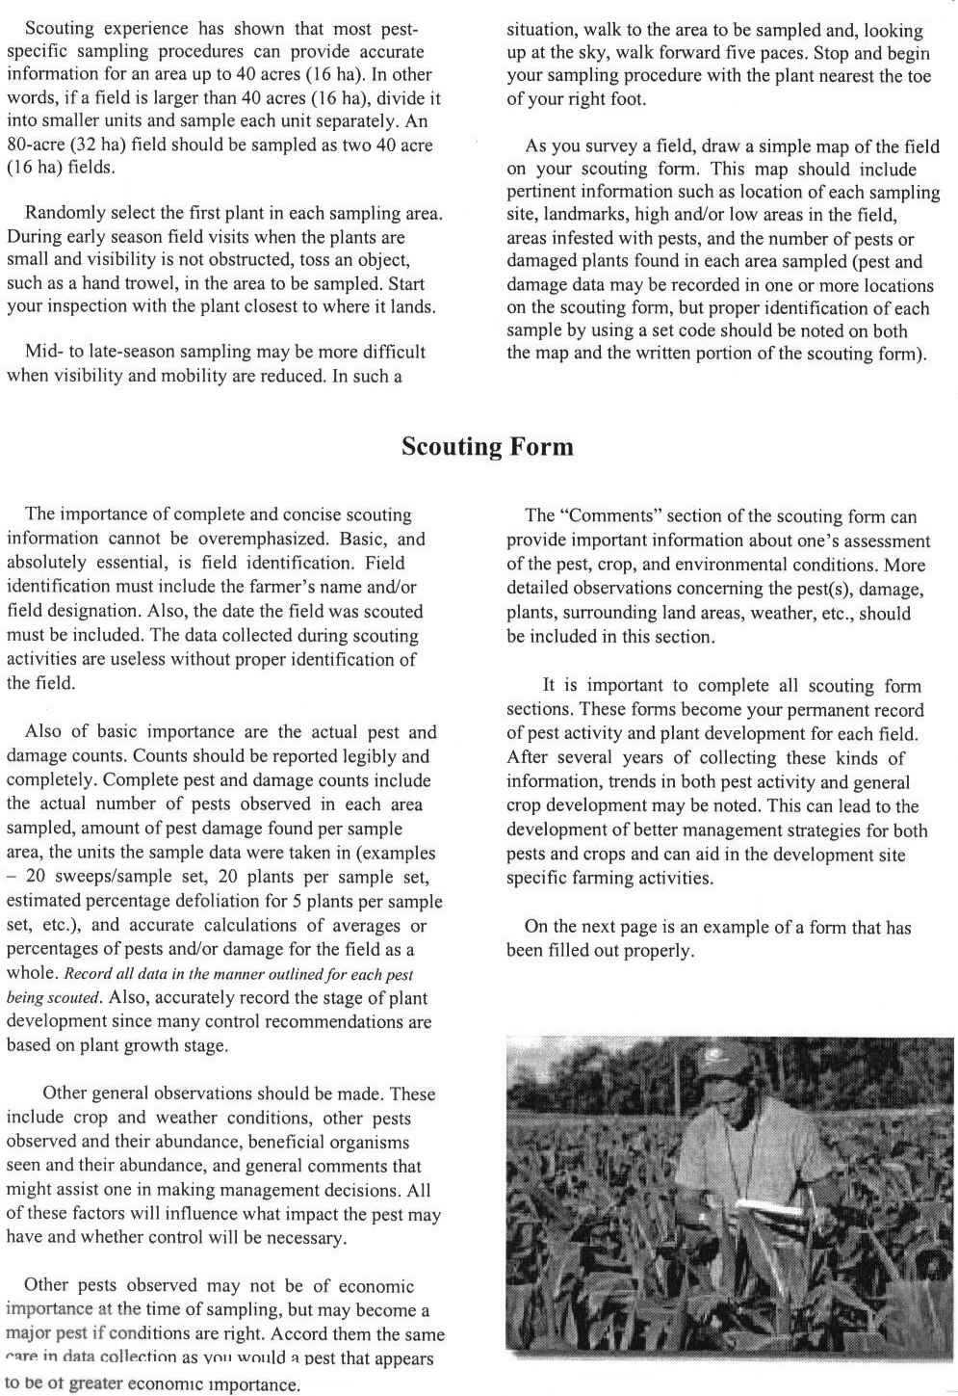

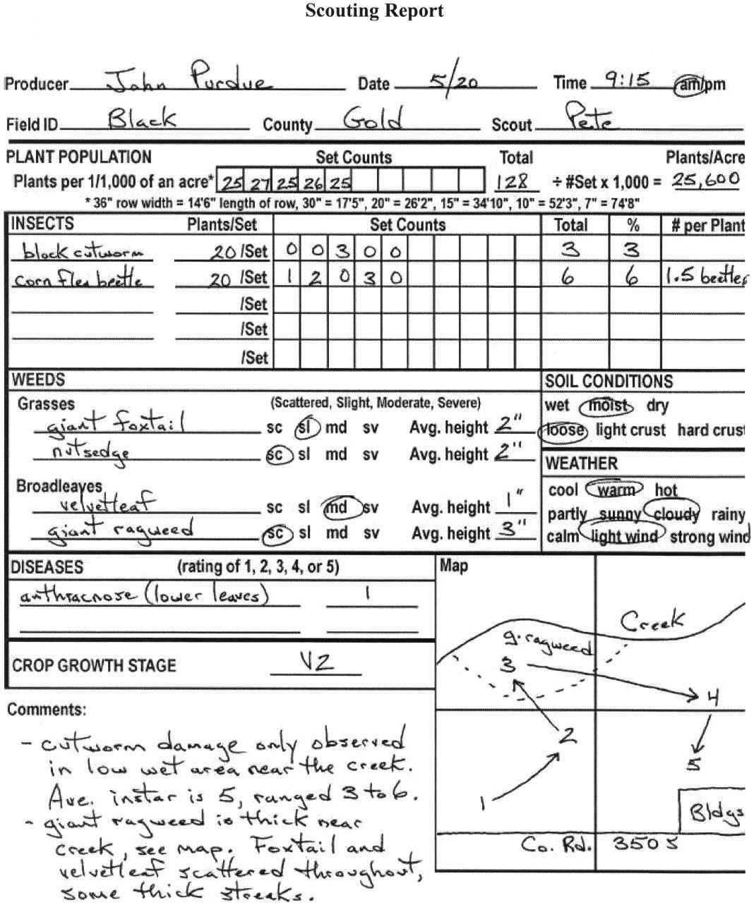

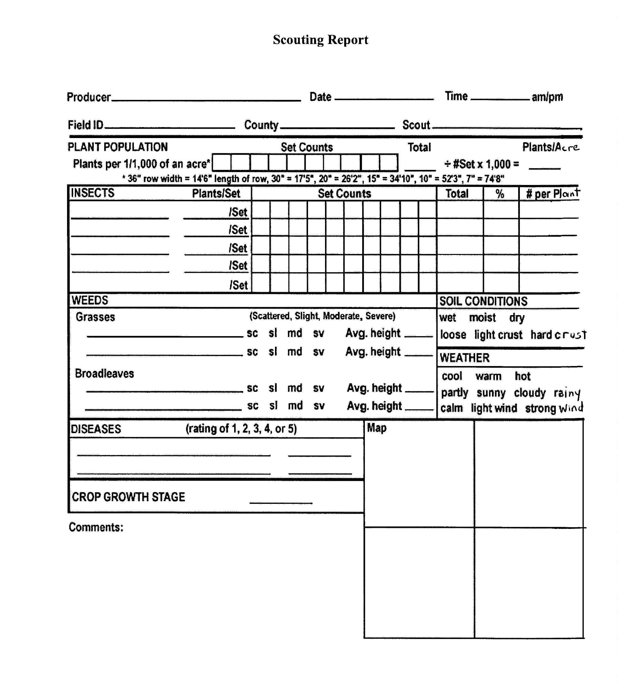

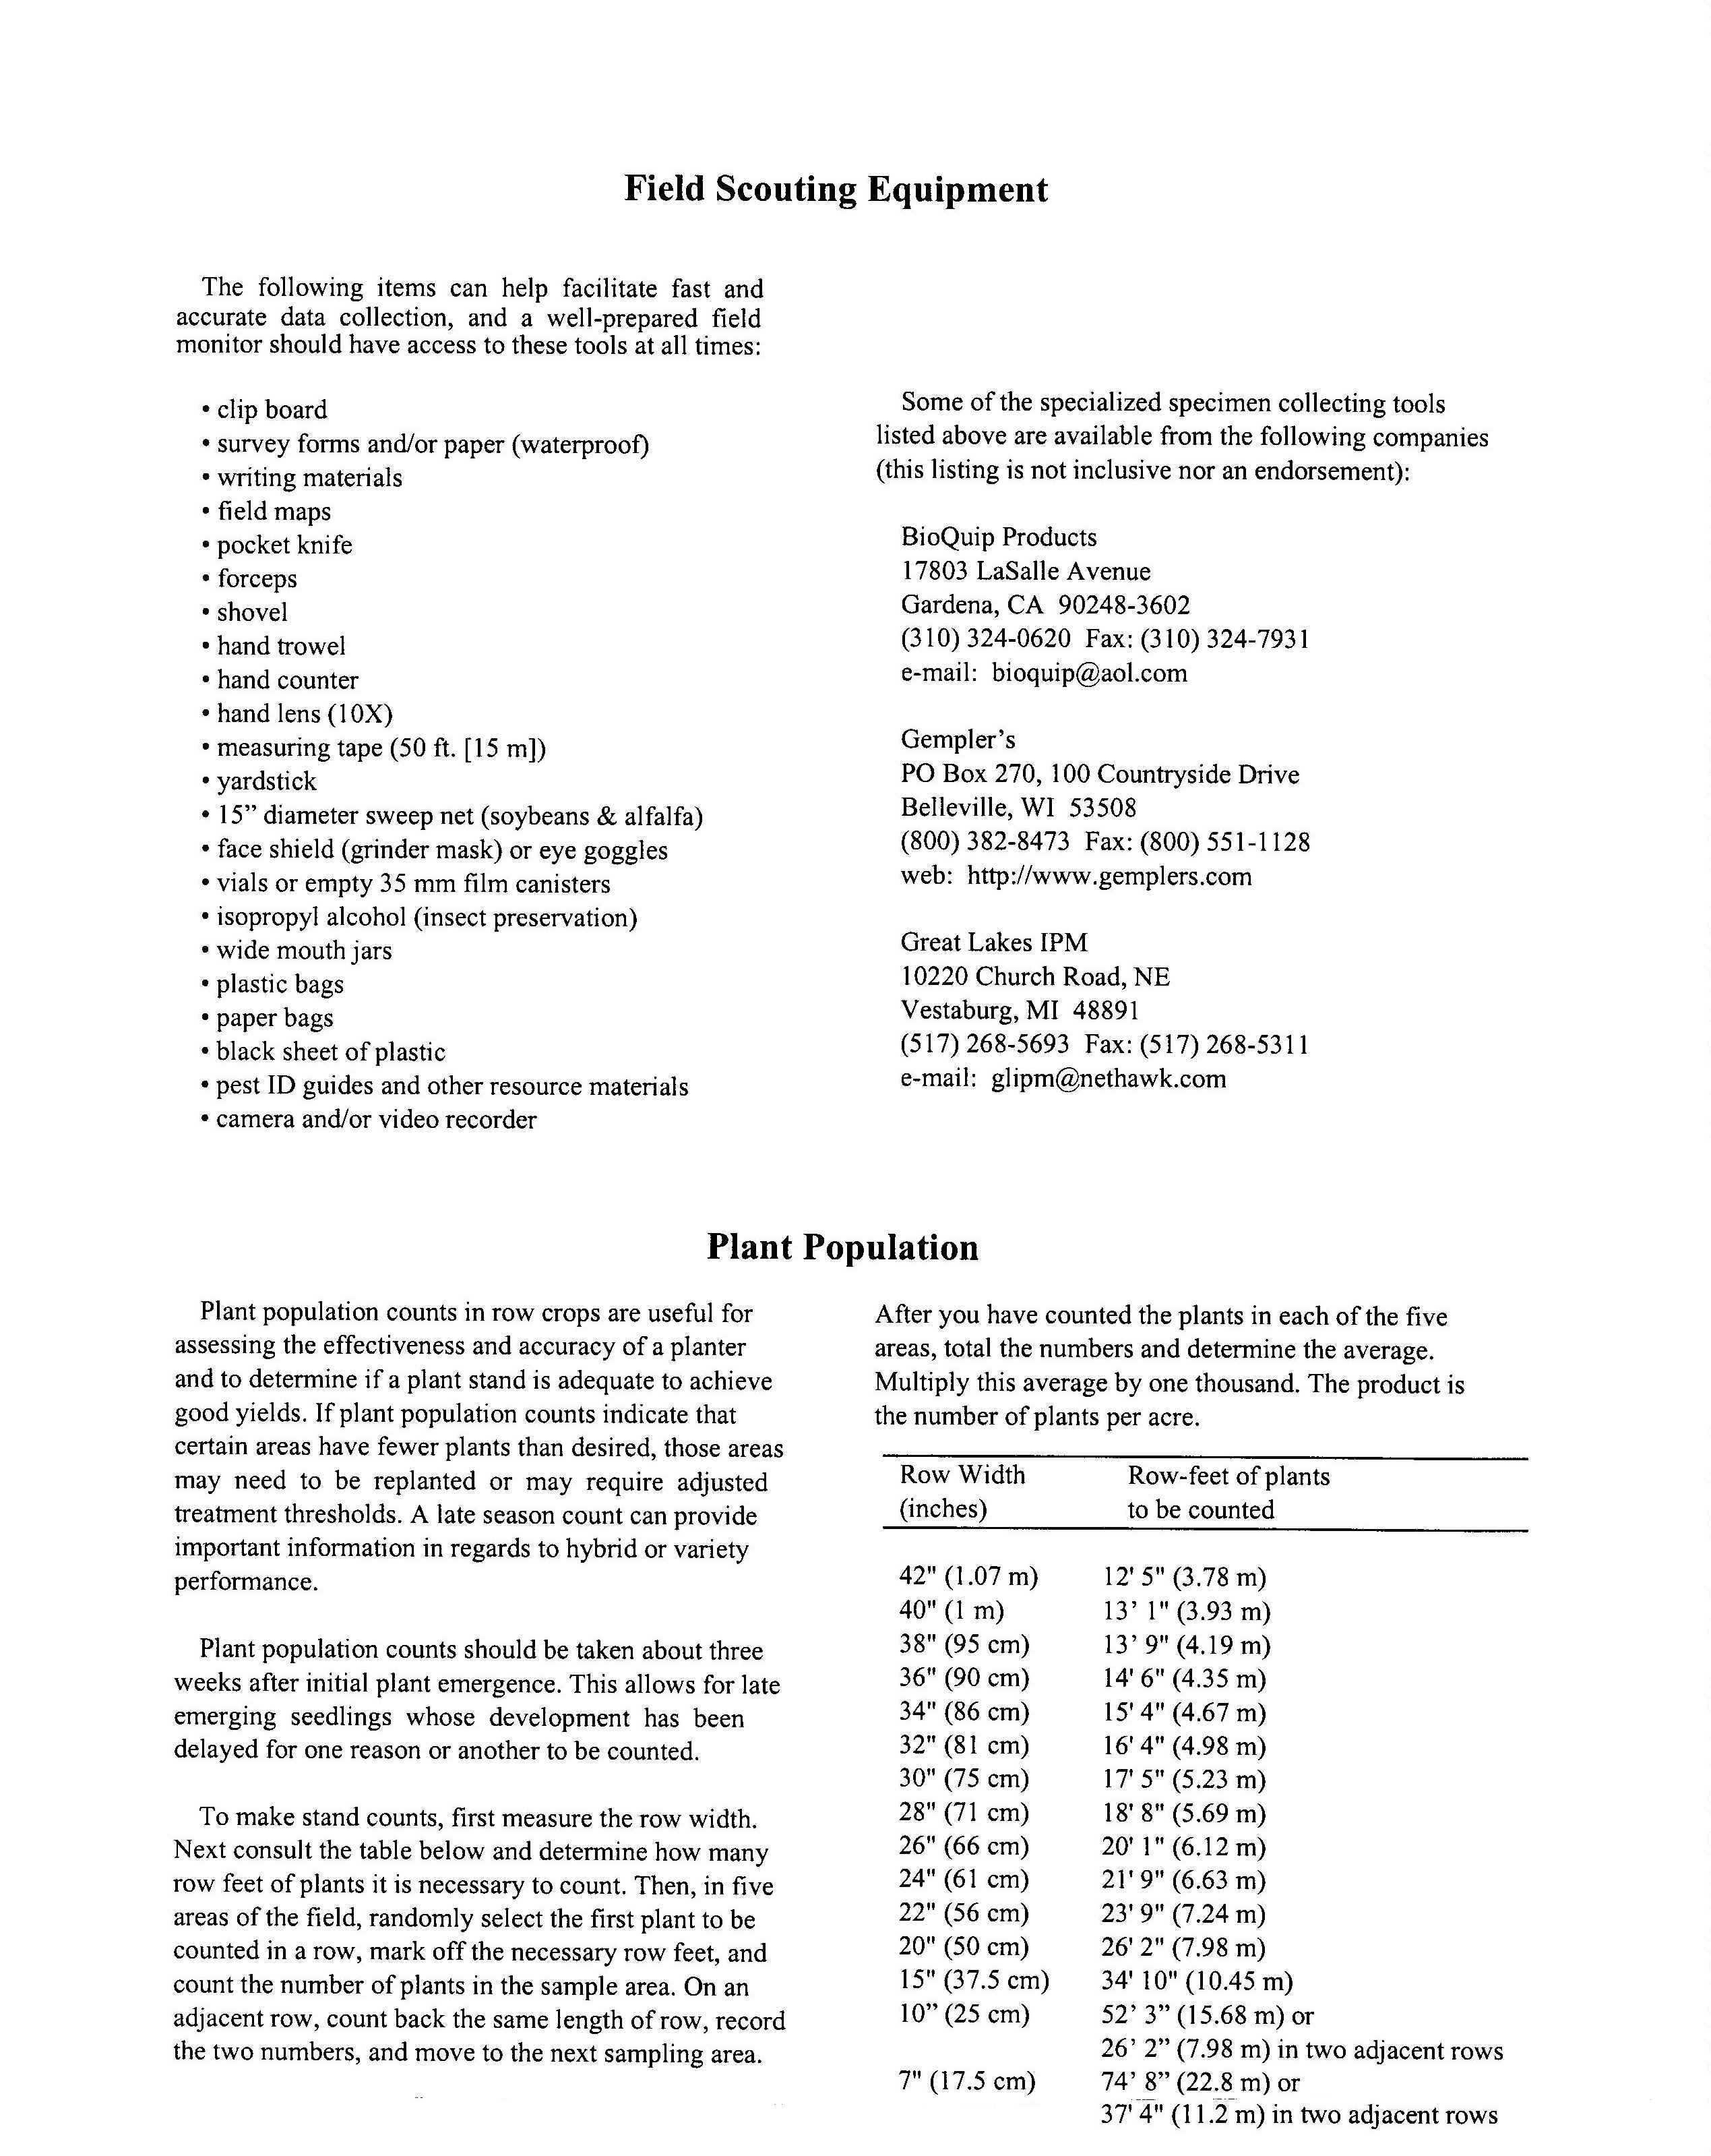
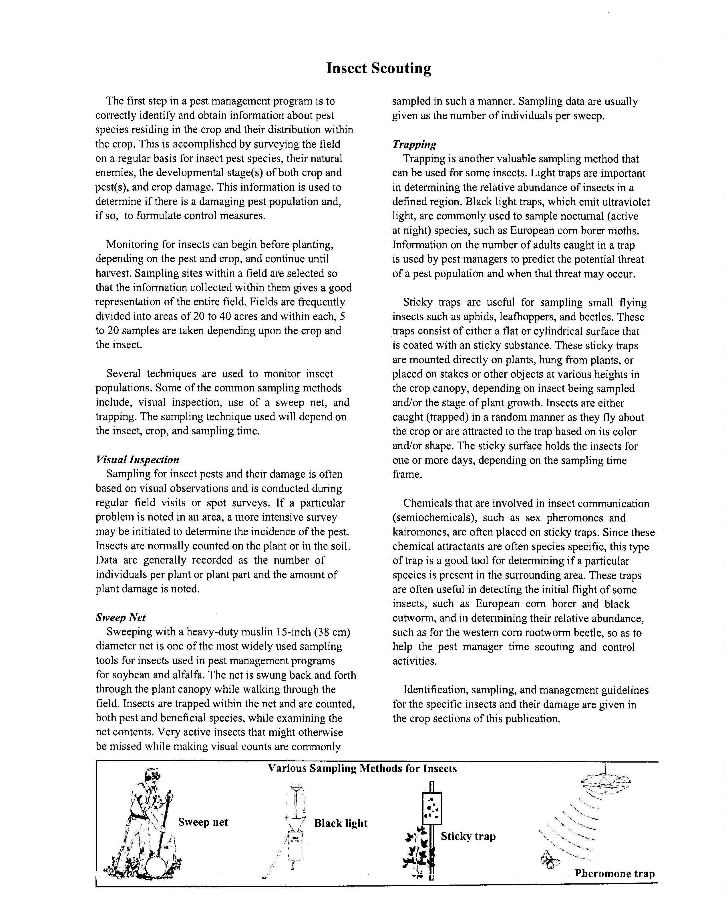

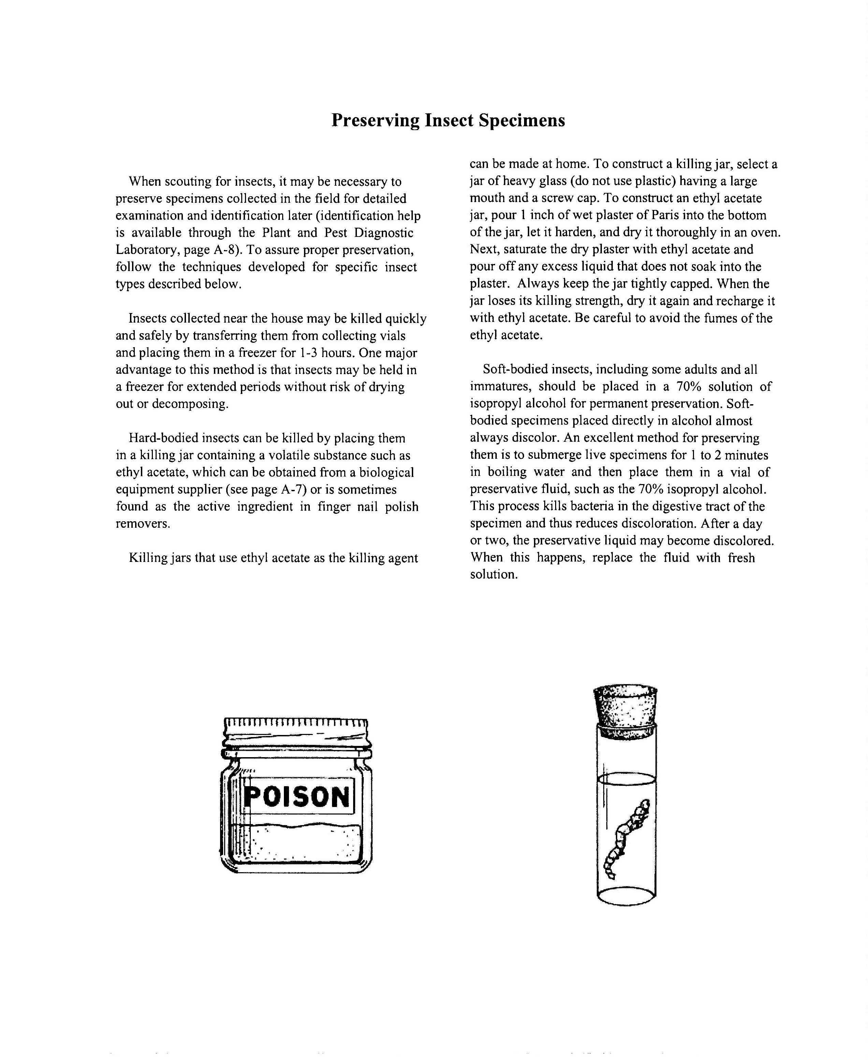

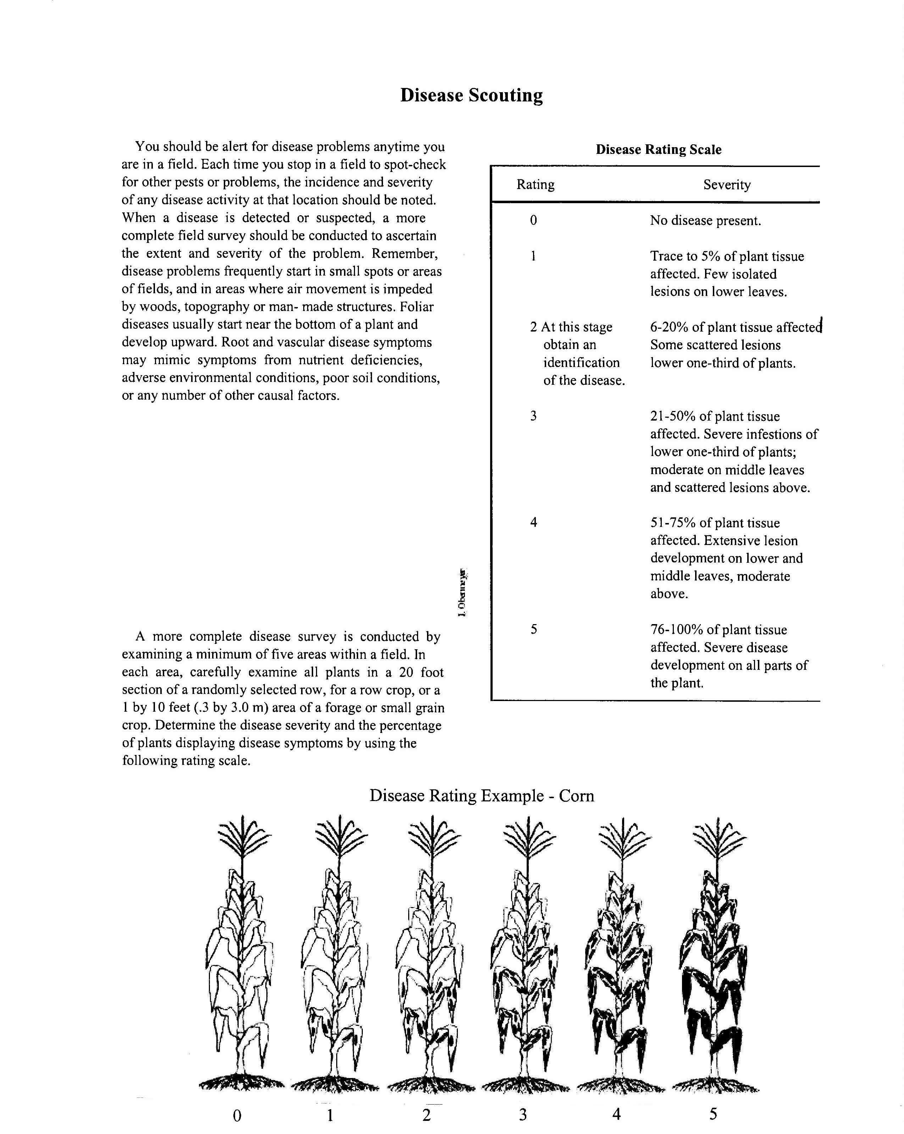
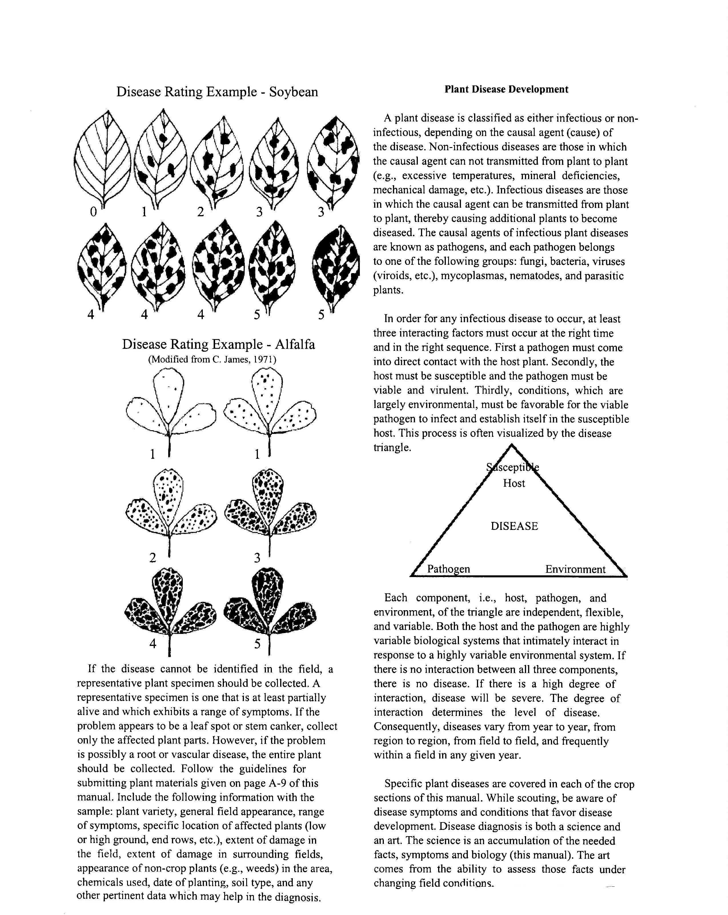

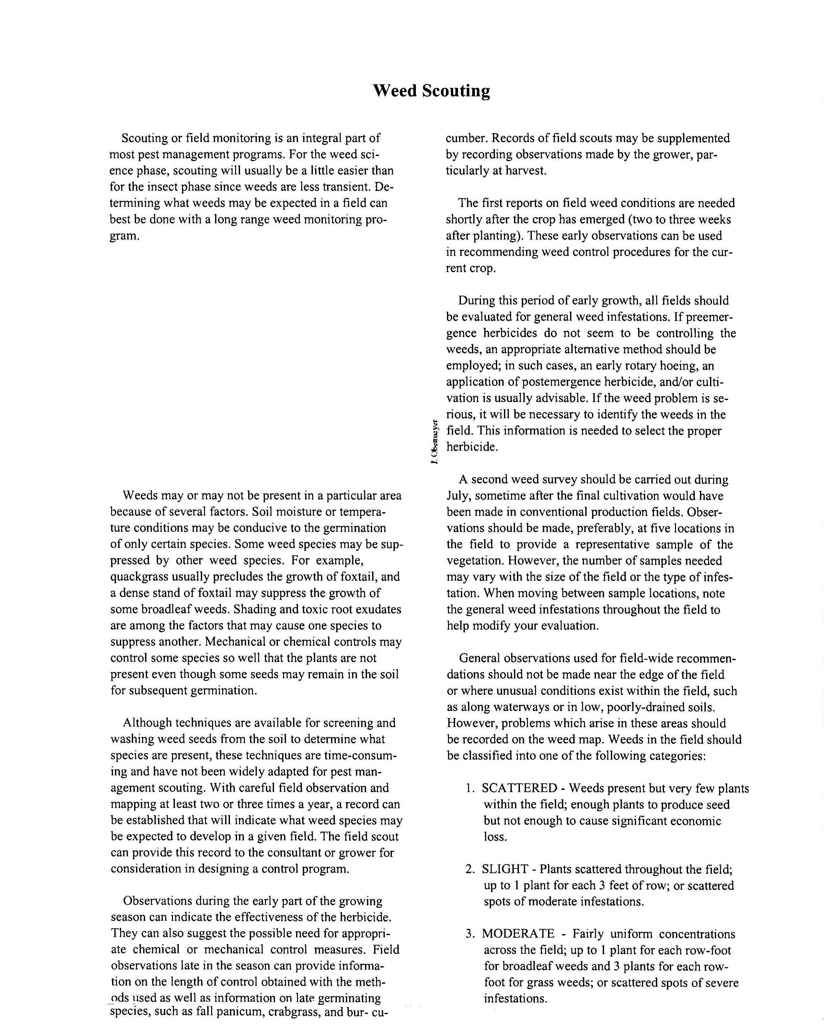
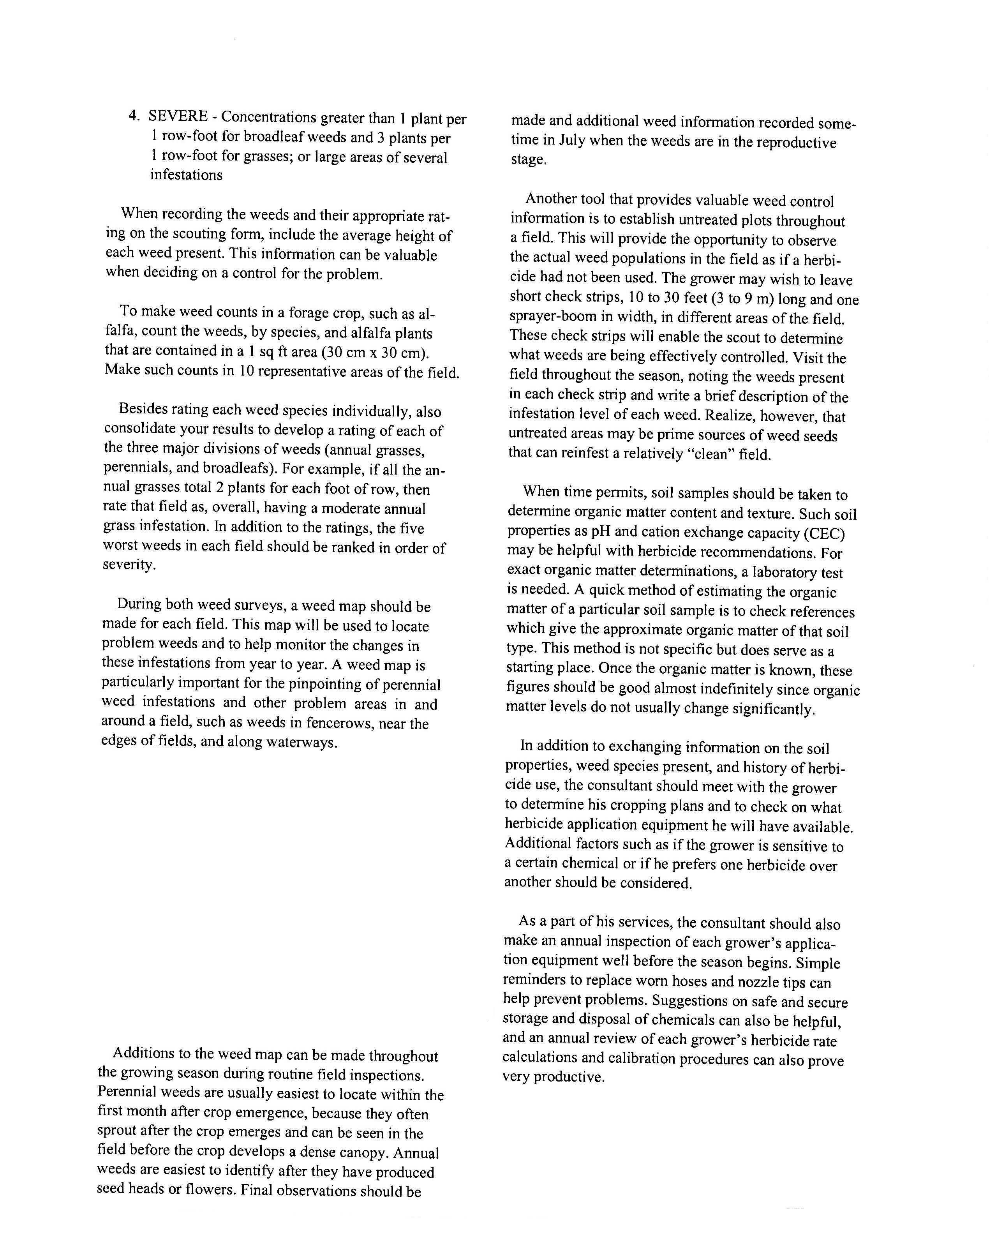

Attachment 2: Economic Threshold – Definition and Example

Scouting, Forecasting, and Economic Threshold

Scouting: Field examination using different techniques to classify the status of a pest population for decision-making purposes. Use scouting guidelines established for the specific pest and crop combinations. If no guidance is available, field sampling should be done randomly, with samples taken from across the entire field. Take at least 5 samples and preferably 25 – 30 samples per field.

Forecasting: Using information or data to predict pest problems early. Regional pest monitoring systems can complement scouting. Idaho’s BEACON program, for instance, uses a regional monitoring network of insect traps that provides bean and sweet corn growers advanced warning of damage expected from the western bean cutworm. PNW Pest Alert system also provides current information on pest problems in the region. There are also models that have been developed, like the degree-day approach, which can help determine when scouting should begin, or when pesticide application will have the maximum control.

Economic Threshold: Guideline that helps identify when pesticide use is and is not necessary. The threshold is based on the cost of the control action vs. the cost of the yield loss that pest populations would inflict on the crop without control. It is also referred to as the action threshold. Control action is needed once this level is reached to prevent the pest population from increasing to a point where economic injury will occur.

Example 1: Russian Wheat Aphid in Wheat (ID)

Statewide networking provides producers with valuable aphid population information in advance of problems. Symptoms of injury include rolling of leaf edges and purple-reddish streaks in leaves. Winged aphids require 284 degree days to complete development. Severe infestations do not typically occur every year at all locations. In fall, 10% of seedlings infested is the economic threshold. Once plants begin to tiller, treatment is not required until 20% of tillers are infected. In the spring, a 5-10% infection rate warrants treatment. Following heading, treatment may be needed if 20% of tillers become infected. No treatment is needed after the soft dough stage. Note that delaying planting until late September helps avoid infestation, and planting in March reduces spring infestation.

Attachment 3: New Mexico’s Cooperative Weed Management Areas

Source: New Mexico Department of Agriculture, Noxious Weed Program, http://www.nmda.nmsu.edu/animal-and-plant-protection/noxious-weeds

What is a Cooperative Weed Management Area (CWMA)?
A Cooperative Weed Management Area (CWMA) is a partnership of federal, state, and local government agencies, tribes, individuals, and various interested groups to manage noxious weeds or invasive plants in a defined area of a distinguishable hydrologic, vegetative, or geographic zone based upon geography, weed infestations, climatic or human-use patterns. A CWMA may be composed of a portion of a county, a county, portions of several counties, or portions of more than one state. CWMAs are formed when the landowners and land managers of a given area come together and agree to work cooperatively to control weeds. For a CWMA to be recognized by the New Mexico State Department of Agriculture (NMDA) and an Integrated Weed Management Plan (IWMP) must be developed and submitted. County Weed Superintendents are often heavily involved in CWMAs and local activities.
For more information on CWMAs in your area, contact Jim Wanstall, NMDA, State Noxious Weed Coordinator, jwanstall@thuntek.net, 505/269-7761 or Mark Renz, NMSU Extension Weed Specialist, markrenz@nmsu.edu, 505/646-2888.

Attachment 4: Beneficial Insects

Source: PNW Insect Management Handbook (http://pnwpest.org/pnw/insects)

Target Pests and Commercially-Available Beneficial Organisms

Target pests |  | Commercially-available beneficial organisms |  |  | Scientific name
Aphids  See also soft-bodied arthropods.) |  | predatory midge  parasitoid wasps  big-eyed bugs  ladybird beetles (“ladybugs”)  lacewings  minute pirate bugs |  |  | Aphidoletes aphidimyza  Aphidius ervi, A. matricariae, A. colemani  Aphelinus abdominalis  Lysiphlebus testaceipes  Trioxys pallidus  Geocoris spp.  Hippodamia convergens  Harmonia axyridis  Coleomegilla maculata  Chrysopa spp., Chrysoperla spp.  Orius spp.
Armyworms  See also Butterfly and moth.) |  | Braconid parasitoid wasp |  |  | Chelonus texanus
Black fly larvae |  | bacterial endotoxins Bti |  |  | Bacillus thuringiensis var. israelensis (e.g., Bactimos, Teknar, Vectobac)
Brown garden snails/slugs  (Mollusca) |  | predatory decollate snail |  |  | Ruminia decollata
Butterfly and moth larvae and eggs of beetle pests in stored grain products, such as:  almond moth  Indian meal moth  grain weevil |  | parasitoid wasps  warehouse pirate bug |  |  | Bracon hebeter  Cotesia plutellae  Xylocoris favipes
Butterfly and moth eggs and young larvae:  cabbage looper  imported cabbage worm  diamondback moth  corn earworm  beet armyworm  cutworm  tomato fruitworm  gypsy moth  codling moth and other orchard  moths  pink bollworm  sod webworm  tobacco budworm |  | viral pathogen  bacterial endotoxins Btk, Bta  parasitoid wasps of eggs |  |  | Nuclear polyhedrosis virus (NPV)  Bacillus thuringiensis  *var. kurstaki (e.g., Dipel, Javelin, Attack, Thuricide, Bactospeine, Safer's Caterpillar Killer)  *var. aizawai (e.g., Certan)  Trichogramma minutum, T. bactrae  Trichogramma platne, T. brassicae  Trichogramma pretiosum  Trichogramma platneri
Cockroach egg case (ootheca) |  | Eulophid parasitoid wasp |  |  | Tetrastichoides spp.
Codling moth larvae |  | granulosis virus pathogen |  |  | Baculovirus carpocapsae
Fire ants |  | parasitic mite |  |  | Pyemotes tritici
Fleas |  | parasitic nematodes |  |  | Steinernema carpocapsae, S. feltiae
Flies  (garbage- and manure-breeding) |  | parasitoids of puparia  Histerid beetle predator |  |  | Tachinaephagus zealandicus  Sphegigaster spp.  Spalangia cameroni, S. endius  Muscidifurax raptor  Muscidifurax zaraptor  Muscidifurax raptorellus  Nasonia vitripennis  Pachcrepoideus vindemiae  Carcinops pumilio
Fungus gnat (larvae) |  | predatory mite  parasitic nematodes  bacterial endotoxin Bti |  |  | Hypoaspis miles, H. aculiser  Heterorhabditis megidis, H. spp.  Steinernema carpocapsae  S. feltiae, S. spp.  Bacillus thuringiensis var. israelensis
General pests in the garden |  | praying mantid predator |  |  | Tenodera spp.
Grasshoppers (nymphs and adults) |  | protozoan |  |  | Nosema locustae
Gypsy moth larvae |  | Braconid parasitoids of the larvae  viral pathogen  bacterial endotoxins Btk and Bta |  |  | Cotesia marginiventris  Casinaria arjuna  Nucleopolyhedrosis virus  Bacillus thuringiensis
Larvae and grubs that pupate in the soil:  wireworms  root weevils  flea beetles  cucumber beetles  dampwood termites |  | parasitic nematodes of larvae |  |  | Steinernema feltia, S. riobravis  S. carpocapsae  Heterorhabditis heliothidis,  H. megidis, H. spp.  H. bacteriophora
Leafminers |  | Braconid parasitoid of larvae  Chalcid parasitoid of larvae |  |  | Dacnusa sibirica  Diglyphus isaea
Mealybugs:  citrus  citrophilus  longtailed and other mealybugs  other soft-bodied insects, all stages |  | ladybird beetle (“mealybug destroyer”)  parasitoid wasp |  |  | Cryptolaemus montrouzieri  Leptomastix spp.
Mites:  twospotted mite  Tetranychus urticae | predatory mites  predatory six-spotted thrips  minute pirate bugs  big-eyed bug |  |  |  |  | Neoseiulus californicus, N. fallacis  Amblyseius hibisci  Phytoseiulus persimilis, P. macrophililis, P. longipes  Metaseiulus) Galendromus occidentalis  Scolothrips sexmaculatus  Orius spp.  Geocoris
Mosquitos  (that breed in water) | predatory fish  bacterial endotoxin Bti |  |  |  |  | Gambusia affinis spp.  Bacillus thuringiensis var. israelensis (e.g., Dunks, Bactimos, Vectobac, Teknar)
Navel orangeworm Paramyelois transitella in almonds and walnuts | parasitoid wasp of larvae  parasitoid wasp of eggs |  |  |  |  | Goniozus legner  Pentalitomastrix plethoricus
Pink bollworm larvae | Braconid larval wasp parasite |  |  |  |  | Microchelonus blackburni
Scales:  citrus red scale  citrus yellow scale  armored scale  oleander scale  San Jose scale  ivy scale | Chalcid parasitoid wasps  ladybird beetles |  |  |  |  | Aphytis melinus  Aphytis lingnanensis  Comperiella bifasciata  Chilocorus nigritus  Lindorus lophathae
Soft scales:  citrus black scale  black/brown hemispherical nigra  scales  See also soft-bodied arthropods.) |  |  | parasitoid wasp  ladybird beetle | Metaphycus helvolus  Lindorus lopanthae
Soft-bodied arthropods:  thrips  scales  aphids  spider mites  whiteflies  eggs of harmful pests |  |  | lacewing larva (in larval stage)  fungal pathogen  ladybird beetles  minute pirate bugs | Chrysopa carnea (green lacewing)  Beauveria bassiana  Chilocorus nigritus, C. baileyii  Hippodamia convergens  Harmonia axyridis  Orius spp./Xylocoris flavipes
Thrips larvae  See also soft-bodied arthropods.) |  |  | predatory mites  lacewings  minute pirate bugs | Amblyseius cucumeris, A. mckenziei, A. barkeri, A. degenerens  Chrysoperla spp., Chrysopa spp.  Orius spp.
Wax moth larvae (in honeycombs) |  |  | bacterial endotoxin Bta | Bacillus thuringiensis var. aizawai (e.g., Certan)
Weevils in landscape plants |  |  | parasitoid wasps of larvae  parasitic nematodes | Anisopteromalus calandrae  Steinernema carpocapsae, S. feltiae, S. riobravis  Heterorhabditis heliothidis, H. megidis
Whitefly nymphs  See also soft-bodied arthropods.) |  |  | parasitoid wasps of eggs  ladybird beetles | Encarsia formosa  Eretmocerus eremicus  Delphastus pusillus

Flowering Plants that Attract Beneficial Insects

Common name (botanical name) | Natural enemies*
Apiaceae (Carrot Family)
Angelica Angelica | ladybird beetles (“ladybugs”), lacewings
Anise Pimpinella anisum | parasitoid wasps
Blue Lace Trachymene caerulea | parasitoid wasps
Caraway Carum caryi | hoverflies, minute pirate bugs and big-eyed bugs, lacewings, parasitoid wasps
Chervil Anthriscus cerefolium | parasitoid wasps
Coriander Coriandrum sativum | hoverflies, parasitoid wasps, parasitoid tachinid flies
Dill Anethum graveolens | hoverflies, ladybird beetles, parasitoid wasps
Fennel Foeniculum vulgare | hoverflies, parasitoid wasps, parasitoid tachinid flies
Lovage Lovisticum officinale | parasitoid wasps
White Lace Flower Ammi majus | hoverflies, predatory bugs, ladybird beetles, parasitoid wasps, parasitoid tachinid flies
Wild Carrot Daucus carota | hoverflies, predatory bugs, ladybird beetles, lacewings, parasitoid wasps
Asteraceae (Daisy Family)
Blazing Star, Gayfeather Liatrus sp.) | minute pirate bugs, big-eyed bugs, parasitoid wasps
Chamomile Anthemis nobilis | ladybird beetles
Cosmos Cosmos bipinnatus | hoverflies, lacewings, minute pirate bugs
Golden Marguerite Anthemis tinctoria | ladybird beetles, parasitoid wasps, parasitoid tachinid flies
Goldenrod Solidago altissima | soldier beetles, predatory bugs, ladybird beetles, parasitoid wasps
Marigolds, signet Tagetes tenuifolia | minute pirate bugs, parasitoid wasps
Mexican sunflower Tithonia tagetifolia | hoverflies, minute pirate bugs
Sunflower Helianthus annuus and H. debilis | hoverflies, ladybird beetles, parasitoid wasps
Tansy Tanecetum | hoverflies, ladybird beetle larvae, parasitoid wasps
Yarrow, milfoil Achillea millefolium | hoverflies, parasitoid wasps
Yarrows Macrophylla, taygetea, etc.) | hoverflies, parasitoid wasps
Common name (botanical name) | Natural enemies*
Brassicaceae (Cabbage Family)
Broccoli Brassica oleracea | hoverflies, parasitoid wasps
Sweet alyssum Lobularia maritima | hoverflies, parasitoid wasps, parasitoid tachinid flies
Candytuft Iberis umbellata | hoverflies
Mustards Brassica hirta and B. juncea | hoverflies, minute pirate bugs, big-eyed bugs
Dipsaceae (Scabiosa Family)
Cephalaria Cephalaria giganitica | hoverflies, parasitoid wasps
Dipsacus Dipsacus spp.) | hoverflies
Pincushion flower Scabiosa caucasica | hoverflies, parasitoid wasps
Scabiosa Scabiosa atropurpurea | hoverflies
Fabaceae (Legume Family)
Alfalfa Medicago sativa | bees, predatory bugs, lacewings, ladybird beetles, parasitoid wasps
Clover Trifolium spp.) | bees, predatory bugs, lacewings, ladybird beetles
Vetch Vicia spp.) | bees, predatory bugs, lacewings, ladybird beetles
Hydrophyllaceae (Waterleaf Family)
Fiddleneck/Phacelia Phacelia tanacetifolia | bees, predatory bugs, hoverflies
Polygonaceae (Buckwheat Family)
Buckwheat Eriogonum spp. and  Fagopyrum spp.) | hoverflies

* - Ladybird beetles include many species in the Family Coccinellidae, Order Coleoptera.
- Lacewings include many species in the Families Chrysopidae and Hemerobiidae, Order Neuroptera.
- Parasitoid wasps include a large number of species in Families such as Aphelinidae, Aphidiidae, Braconidae, Chalcidae, Encyrtidae, Eulophidae, Ichneumonidae, Mymaridae, Pteromalidae, Scelionidae, and Trichogrammatidae, Order Hymenoptera.
- Hoverflies include many species in the Family Syrphidae, Order Diptera.
- Predatory bugs include many species in Families such as Anthocoridae, Lygaeidae, Nabidae, Pentatomidae, and Reduviidae, Order Hemiptera.
- Minute pirate bugs include many species in the Family Anthocoridae, Order Hemiptera.
- Big-eyed bugs include many species in the Family Lygaeidae, Order Hemiptera.
- Parasitoid tachinid flies include many species in the Family Tachinidae, Order Diptera.
- Bees include many species in Families such as Anthophoridae, Apidae, Halictidae, and Megachilidae, Order Hymenoptera.

Research citations for Flowering plants that attract beneficial insects:
Bugg, R.L. and B. Quinney. 1986. “Habitat Enhancement in Home Gardens.” New Alchemy Quarterly, Massachusetts.
Bugg, R.L. and C. Waddington. 1994. “Using Cover Crops to Manage Arthropod Pests of Orchards: A Review.” Agriculture, Ecosystems & Environment. Vol. 50, pp. 11–28.
Bugg, Robert L. Feb. 1994. “Beneficial Insects and their Associations with Trees, Shrubs, Cover Crops, and Weeds.” Sustainable Ag Research & Education Program. Univ. of California at Davis, 95616.
Colley, Micaela R. 1998. Enhancement of Biological Control with Beneficial Insectary Plantings. Oregon State University.
Long, R.F., A. Corbett, L. Lamb, C.R. Horton, J. Chandler, M. Stimmann. 1998. “Beneficial Insects Move from Flowering Plants to Nearby Crops.” California Agriculture. Sept-Oct. issue.
Maltas, Michael. 1994. Organic Ag Advisors—Plants for Beneficial Insect Habitat. PO Box 1622, Colfax, CA 95713. 916-637-5990.
Merril, Richard. 1995. “Beneficial Insectary Plantings.” Shepherd’s Garden Seeds Newsletter, California.
Pickett, C.H. and R.L. Bugg. 1998. Enhancing Biological Control: Habitat Management to Promote Natural Enemies of Agricultural Pests. Univ. of California Press, Berkeley, CA.
Reynolds, William. 1994. “Attracting Beneficial Insects to the Farm Field.” Grower—New England Vegetable & Small Fruit Newsletter. Vol 94-7. Eastern Rhode Island Cooperative Extension.

Attachment 5: Biological Control Agents

Source: USDA-ARS
http://www.ars.usda.gov/SP2UserFiles/Place/53254300/Reports/USA-BCW(forpdf)v5.pdf

Biological Control Agents

Weeds – Approved Biological Agents

Invasive Weed | Biological Agent | Type | Result
Bachelor’s button | Chaetarellia australis | Seed head fly | Widespread over host range
Scotch broom | Bruchidius villosus | Seed beetle | Released, unknown coverage
Halogeton | Coleophora parthenica | Stem boring moth | Failed
Brown knapweed | Urophora quadrifasciata | Seed head gall fly | Released, unknown coverage
Diffuse knapweed | Bangastermus fausti | Seed head weevil | Released, unknown coverage
 | Pterlonche inspirsa | Root boring moth | Failed
 | Sphenoptera jugoslavica | Root boring beetle | Widespread over host range
 | Urophora offinus | Seed head gall fly | Widespread over host range
 | Urophora quadrifasciata | Seed head gall fly | Widespread over host range
Spotted knapweed | Agapeta zoegana | Root boring moth | Limited coverage over host range
 | Bangesternus fausti | Seed head weevil | Released, unknown coverage
 | Cyphocleonus achates | Root boring weevil | Established over host range
 | Larinus minutus | Seed head weevil | Limited coverage over host range
 | Larinus obtusus | Seed head weevil | Released, unknown
 | Metzneria paucipunctella | Seed head moth | Widespread over host range
 | Urophora affinus | Seed head gall fly | Widespread over host range
 | Urophora quadrifasciata | Seed head gall fly | Widespread over host range
Purple loosestrife | Galerucella calmariensis | Defoliating beetle | Limited coverage over host range
 | Galerucella pusilla | Defoliating beetle | Limited coverage over host range
 | Hylobius transversovittatus | Root weevil | Released, unknown
 | Nanophyes marmoratus | Flower bud weevil | Established over host range
Puncture vine | Microlarinun lareynii | Stem boring weevil | Failed
 | Microlarinun lypriformis | Seed weevil | Failed
Mediterranean sage | Phrydiuchus tau | Crown/root weevil | Widespread over host range
St. Johnswort | Agrilus hyperici | Root boring beetle | Widespread over host range
 | Aplocera plaginata | Defoliating moth | Widespread over host range
 | Chrysolina hyperici | Defoliating beetle | Widespread over host range
 | Chrysolina quadrigemina | Defoliating beetle | Widespread over host range
 | Chrysolina varians | Defoliating beetle | Failed
 | Zeuxidplosis giardia | Bud gall midge | Failed
Rush skeleton weed | Bradyrrhoa gilveolella | Root boring moth | Released, unknown
 | Cystiphora schmidti | Stem/leaf gall midge | Widespread over host range
 | Eriophyes chondrillae | Bud gall mite | Widespread over host range
 | Puccinia chondrillae | Leaf rust fungus | Widespread over host range
Leafy spurge | Aphthona cyparissiae | Root/defoliating beetle | Limited coverage over host range
 | Aphthona czwalinae | Root/defoliating beetle | Limited coverage over host range
 | Aphthona flava | Root/defoliating beetle | Limited coverage over host range
 | Aphthona faceitosa | Root/defoliating beetle | Limited coverage over host range
 | Aphthona nigriscutis | Root/defoliating beetle | Limited coverage over host range
 | Chamaesphecia crassicornis | Root boring moth | Failed
 | Chamaesphecia empiformis | Root boring moth | Failed
 | Chamaesphecia tenthrediniformis | Root boring moth | Failed
 | Hyles euphorbiae | Defoliating moth | Established over host range
 | Oberea erythrocephala | Root boring beetle | Released, unknown
 | Spurgia esulae | Shoot tip gall midge | Limited coverage over host range
Yellow starthistle | Bangesternus orientallis | Seed head weevil | Widespread over host range
 | Chaeforeillia australis | Seed head fly | Widespread over host range
 | Eustenopus villosus | Seed head weevil | Widespread over host range
 | Larinus curtus | Seed head weevil | Widespread over host range
 | Urophora jaculata | Seed head gall fly | Failed
 | Urophora sirunaseva | Seed head gall fly | Widespread over host range
Canada thistle | Altica carduroum | Defoliating beetle | Failed
 | Ceutorhynchus litura | Crown/root weevil | Limited coverage over host range
 | Rhinocyllus conicus | Seed head weevil | Limited coverage over host range
 | Urophora cardui | Stem gall fly | Released, unknown
Musk thistle | Rhinocyllus conicus | Seed head weevil | Widespread over host range
 | Trichosirocalus horridus | Crown/root weevil | Widespread over host range
Plumeless thistle | Rhinocyllus conicus | Seed head weevil | Widespread over host range
Russian thistle | Colephora klimeschiella | Leaf mining moth | Widespread over host range
 | Colephora parthenica | Stem boring moth | Widespread over host range
Dalmatian toadflax | Brachypterolus pulicarius | Flower beetle
 | Calophasia lunula | Defoliating moth
 | Mecinus janthinus | Stem boring weevil

Typical Biological Control Agents for Insects – “Beneficials”

Parasitoid
Certain types of wasps
Certain types of flies

Predators
Lady beetles, various types
Lacewings
Bigeyed bug
Pirate bug
Soldier bug
Certain midges
Certain mites

Pathogens
Various bacteria, fungi, viruses, nematodes

Attachment 6: Integrated Pest Management – Example

Source: University of Idaho Extension, The Role of Integrated Pest Management, E. J. Bechinski, R. L. Mahler, and H. W. Homan

http://www.uidaho.edu/wq/wqpubs/cis938.html

Russian Wheat Aphids
Pest management for Russian wheat aphids starts at planting time with cultural methods. Idaho farmers break the aphid infestation cycle by planting fall-seeded wheat and barley as late as feasible. This tactic allows the crop to escape pest colonization by avoiding incoming flights of aphids that occur when summer crops are harvested. The reverse (plant as early as possible) is true for spring-seeded crops. Early plantings allow wheat and barley plants to develop beyond the highly susceptible seedling stage before aphids arrive.
Field selection also can contribute to Russian wheat aphid suppression. Here the idea is to avoid planting cereal crops in fields immediately adjacent to rangeland or large grassy expanses. These areas can serve as reservoirs where aphids survive and multiply during the summer dry season from crop harvest until the next crop is planted.
Aphid-resistant wheat and barley varieties are still in the research and development phase. In addition, work is continuing on the importation and release of exotic parasitic wasps and lady beetles for Russian wheat aphid control and on use of aphid-killing fungi as a biological insecticide.
Insecticides for Russian wheat aphid control can be applied according to two strategies; by incorporating insecticides into the soil at planting time or by spraying them over the top of rows later during the growing season. Rather than automatically apply pesticides, Idaho wheat and barley growers use scouting and forecasting to decide if pesticides really are needed. The need for insecticides at planting time can be gauged from a statewide network of traps that monitor aphid flights. Use of insecticides at planting is recommended only if aphid flights are heavy and planting dates cannot be changed to avoid incoming aphids.
Later during the growing season farmers can scout fields using a system of decision cards that quickly and accurately identify fields requiring treatment. Since Russian wheat aphid infestations often begin at field edges, spot-spraying a 50-foot-wide strip along the fencerow (versus broadcast application over the entire field) may be all that is required. Spot spraying has the added benefit of allowing biological control agents to survive in unsprayed portion of the field.

