Ohio - Natural Resources Conservation Service June 2002

For: | Farm #:
Field(s): | Tract #:
Designed By: | Approved By:  Signature:
Date: | Date:

Definition
Windbreaks or shelterbelts are plantings of single or multiple rows of trees or shrubs that are established for environmental purposes. The height of the tallest row and overall density of foliage and branches of an individual planting greatly influence the size of the nearby area that is protected or sheltered.

Purposes (check all that apply)

To reduce soil erosion from wind.
To protect plants from wind related damage.
To alter the microenvironment for enhancing plant growth.
To manage snow deposition.
To provide shelter for structures, livestock, and recreational areas.
To enhance wildlife habitat by providing travel corridors.
To provide living noise screens.
To provide living visual screens.
To provide living barriers against airborne chemical drift.
To delineate property and field boundaries.
To improve irrigation efficiency.
To enhance aesthetics.
To increase carbon storage.

Condition where practice applies
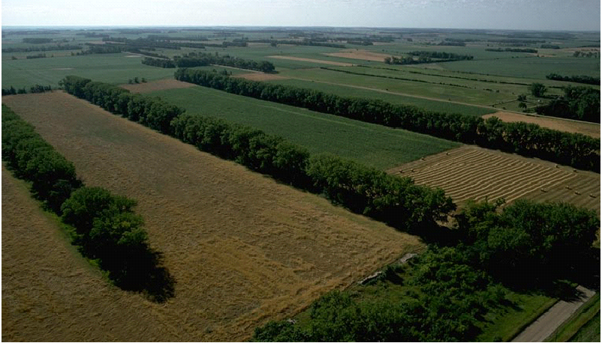
Windbreaks are “environmental buffers” that are planted in a variety of settings, such as on cropland, pasture, along roads, farmsteads, feedlots, and in urban areas.

Specifications
Species by Row Number | Type of Stock | Planting  Dates | Length of  Row  Ft. | In-Row  Spacing  Ft. | Row  Spacing  Ft. | Number  Trees In  Row
1.
2.
3.
4.
5.
6.

Storage and Preparation of Seedlings
Store seedlings in cool but not freezing conditions (35º to 50º air temperatures). Seedling roots should be kept moist, but not wet. Avoid damage to roots during storage.

If seedlings need to be stored for over one week and cold storage is not available, the seedlings should be heeled in. This done by digging a slightly sloping trench, placing the seedlings in the trench and covering the roots with moist soil. Do not allow the roots to dry out.

Top-prune, as needed, to provide adequate top-to-root ratio. The preferred ratio is 1:1 to 2:1.

If needed, root-prune seedlings that have excessively long main roots (roots longer than the effective depth capacity of planting tools or machines). Usually this is about 8 inches. No more than one-quarter of the root system should be removed.

Planting Methods
Bare-rooted trees or shrubs may be planted with a mattock, dibble or planting bar or mechanical tree planter. Container and balled-and-burlapped plants are typically planted by digging a hole big enough for the plant’s roots. With all methods, the following measures are to be followed:

- Plant the tree at the same depth it was growing in the nursery. The seedling root collar should line up with the soil surface.

- Plant the tree upright. Make sure the roots are hanging downward in a natural position and not doubled or sharply bent.

- Press the soil so that it is firmly packed around the roots so that the tree is held in place and there is good soil-root contact.

- Plant only one tree per spot.

- Do not allow plant roots to dry out while planting.

Care after Planting
Watering Typically, large plantings are not watered. However, specialized or smaller plantings such as windbreaks may be watered to increase survival and growth. If trees are watered, the water should be applied gradually through sprinklers, soaker hoses, drip buckets or other means. If water is to be applied in large amounts or dumped on the plants, this should be done in two passes to increase irrigation effectiveness. Watering should be discontinued after July to allow trees to properly harden off in the fall.

Weed Control Elimination of competing vegetation is normally carried out for one to five years after planting. Weed control may be the most important factor in tree and shrub seedling survival, especially for hardwood species. Weed control may be accomplished through mulching, cultivation, mowing or herbicide usage. In all cases, the vegetation should be controlled in a band 12 to 18 inches along each side of the tree row or in a 2 to 3 foot diameter circle around each tree.

Mechanical or hand cultivation should be kept at least 6 inches from the seedling and no deeper than 3 inches to avoid damage to the seedling. Additional methods may be needed to control weeds closer to the seedling. Mowing generally does not provide as good of control since the weeds are still competing for nutrients and water; also potential damage to seedlings is high. Mulching provides good control but may be impractical on large plantings. The use of herbicides usually provides good weed control.
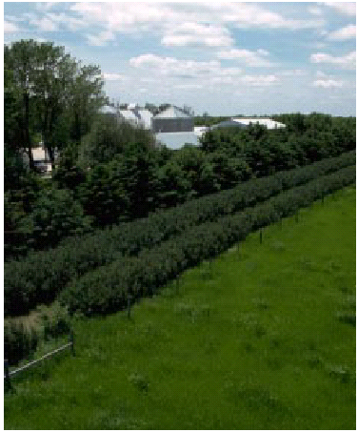
Pest Management Plant injury or death should be controlled through preventative measures. Domestic animals that might graze on seedlings should be excluded. Control of weeds (which may hide rodents or rabbits), repellants or poisons, hunting and the use of tree shelters should be considered to reduce damage from wild animals. New plantings should be monitored for potential insect and disease problems and appropriate control measures taken if significant problems are found.

Replanting Some plants will be lost over time to a variety of causes. The decision to re-plant for some or all of the losses will be based on whether or not the remaining trees and shrubs will likely provide the desired functions. For some specialized uses (windbreaks, high-value lumber) the need to re-plant will be made even for relatively low losses; more general purposes may allow for higher losses.

Operation and Maintenance
- If needed, competing vegetation will be controlled until the trees and shrubs are established. Noxious weeds will be controlled.

- Replanting will be required when survival is inadequate.

- Supplemental water will be provided as needed.

- The trees and shrubs will be inspected periodically and protected from adverse impacts including insects, diseases or competing vegetation, fire and damage from livestock or wildlife.

- Periodic applications of nutrients may be needed to maintain plant vigor.

Questions regarding the planting or maintenance of the tree planting should be directed to (phone)
_____.

