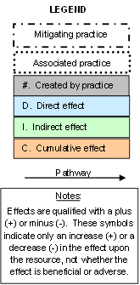
I.12 (-) Peak flows (flooding)
Irrigation Reservoir (436)
C.1 (+/-) Income and income stability
(individuals and community)
Initial setting: Areas of previously disturbed land in proximity to cropland where additional water storage is needed for irrigation or tailwater recovery, generally less than 1 acre in size for short-term storage used to collect and regulate available irrigation water supplies and less than 10 acres in size for longer term storage of diverted waters for later use or reuse

I.5 (-) Wetland ecological functions
Start
D.3 (-) Wetland/ other land
D.1 (+) Water source
D.4 (-) Downstream flow
I.8 (+) Open water ecological functions
I.11 (-) Other water uses downstream
I.1 (+) Plant vigor and crop production
C.2 (+/-) Habitat suitability, populations of fish, migratory birds and other wetland wildlife, health for humans, domestic and wild animals
Irrigation Water Management (449)
D.2 (+) Cost of installation and maintenance
I.4 (+/-) Net return
I.2 (+) Income potential
I.6 (-) Chemical transformations, groundwater recharge, and other functions
I.3 (+) Management flexibility and efficiency
I.10 (+) Water lost to evaporation
Irrigation Water Management (449)
Irrigation System (441/442/443)
Irrigation Water Conveyance, Pipeline (430 series)
Pumping Plant (533)
1. Constructed embankment, excavated pit, or tank for storage of water
Pond (378)
Dam (402)
I.7 (+/-) Fish and wildlife habitat
I.9 (+) Retention;
(-) Contaminants, pathogens, sediments to receiving waters

