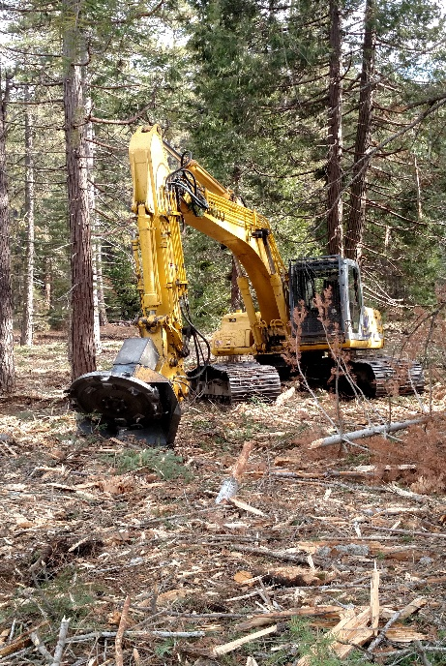
I. Definition
Treating woody plant residues created during forestry, agroforestry and horticultural activities to achieve management objectives.
II. PURPOSES
- Reduce hazardous fuels and wildfire risk of harm to humans and livestock.
- Reduce the risk of harmful insects and disease.
- Protect/maintain air quality by reducing the risk of wildfire.
- Improve access to forage for grazing and browsing animals.
- Improve the soil organic matter and maintain or improve soil health and soil quality.
- Improve the site for natural or artificial regeneration.
Figure 1. Woody Residue Treatment reconfigures and often reduces the amount of forest slash.

- Enhance aesthetics.
II. WHERE USED
This practice applies on areas with quantities of woody slash and debris requiring treatment to meet objectives. The major locations in California where the practice is used are in conifer forests, mixed hardwood forests, rangelands with substantial woody shrubs, and agro forestry orchards settings.
III. CONSERVATION MANAGEMENT SYSTEM
Woody Residue Treatment is a practice that is part of an overall conservation management system for forest lands or other lands that create woody debris from management actions or catastrophic natural events. If left alone, the debris creates a hazardous condition(s) that places the remaining trees and/or shrubs, ecosystem functions, and human life and assets at risk. Woody Residue Treatment in forest settings is often associated with tree or brush silvicultural cuttings or cleanup of excess woody debris from natural accumulations or catastrophic events such as wildfire, pests and wind. The most common use of Conservation Practice Standard (CPS) 384 in EQIP forestry projects is when CPS 666 Forest Stand Improvement is used for tree or shrub thinning.
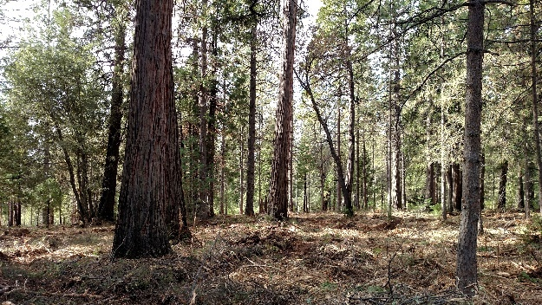
In California’s forested setting, the practice is mainly used to “treat” excess woody plant material to reduce fuel loads/fire hazards to acceptable levels, aid in wildfire control, protect human infrastructure and prepare sites for desired regeneration. “Treat” or “Treatment” in this context means a purposeful action to modify debris quantity and arrangement or disposal of the vegetation from the location where it was generated.
Figure 2. Thinning debris - Slash produced from the mastication of materials during a pre-commercial thinning usually requires no further treatment.

IV. Planning and Specifications
Plans and specifications will be developed on each management unit where the practice will be applied. The Implementation Requirement (IR) sheet will state the objective, treatment method, timing, protection
measures/Best Management Practices, and acceptable completion level.

Planning and inventories are required for determining need, condition and extent of woody debris treatment. Planning will lead to information on intensity, method, and timing of woody residue treatments. Timing of treatment coincides with achieving intended purposes and minimizing impact on other resources.
In planning for treatment, consideration should be given to leaving some debris for biological diversity (Figure 3). Consider retaining small vegetated areas that coincide with unique features such as wet areas, rocky or steep terrain, down logs and snags, or other valuable habitat elements.
Residual slash and debris left on the site after treatment will be in a condition and amount that will not present an unacceptable fire, safety, environmental, or pest hazard nor interfere with other on-going or planned management activities. A post-treatment assessment is usually needed to determine if desired conditions were achieved and if future treatment is needed.
Figure 3. Biodiversity debris - Conifer forest area where some woody debris was left for biological diversity.

V. Woody Debris Treatment Assessment
As part of the planning and specification process, an assessment must be made to determine the need, intensity and suitable methods of woody debris treatment. Consider the following information about existing conditions:
- Soils and Appropriate Soils Interpretations: Identify soil map unit descriptions, erosion hazards, suitability for mechanical equipment, soil compaction resistance and potential damage by fire. Choose the slash treatment method that is appropriate for the purpose, soil, volume of material to be treated, condition of the material, and site factors. For example: some soils have low suitability for equipment use or high soil compaction risk. For soils like these, the planner’s specifications will focus on hand treatments or mitigate for the use of equipment.

- Fuel Load: Estimating the amount of woody debris on the site contributes to determining need and type of treatment. A variety of methods and combination of methods are acceptable
for estimation of residue quantity. These include USFS photo series, down wood transects (GTR-INT- 16, 1974, Brown), or for quick field estimations using Forestry Clipboard tables.
- Fuel loading estimation provides information on whether fuel treatment is necessary and the intensity of the level of treatment.
- Fuel loading as low as 2 bone dry tons (BDT) per acre can contribute to flame lengths and fireline heat intensity that diminishes wildfire suppression efforts.
- When the woody debris is less than 8-10 dry ton/acre and it is unevenly distributed and non-continuous, lop and scatter may be an appropriate method of treating this slash.
- In critical road side areas, WUI areas, fuel breaks, or other fire suppression access areas, residual slash should be much lower, often less than 2 BDT/acres and highly rearranged (e.g. chipped) to reduce fire behavior and spread to other vegetation.
- Steeper terrain will require more intense treatments.
- Past experience shows that typical overstocked second growth Sierra Mixed Conifer forests result in 20 to 30 BDTs/acre of slash following tree thinning.
- When high-levels of slash treatment are needed, chipping and masticating of thinned trees and shrubs is the preferred method for woody debris disposal when heavy ground equipment is suitable.
USFS Photo Series for Quantifying Forest Residues – Below are photo series from USDA-Forest Service General Technical Report PNW-52 1976. They show accumulated tonnage of slash. Tonnage computations are based on oven-dry weights and air-dry volume. Use these as ways to estimate the amount of woody debris that will result from a project.

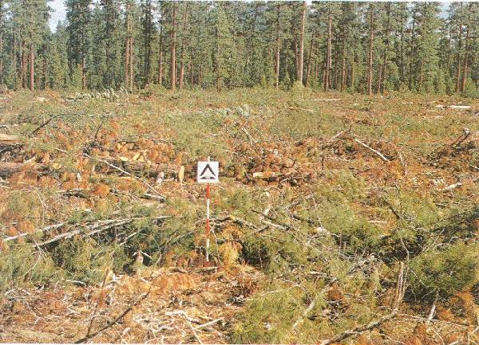

Figure 4. Complete stand removal - Total slash accumulation after a block harvest is 38.2 tons/acre (8.1 tons/acre for size class 1.1-3.0 inches in diameter; 6.3 tons/acre for 3.1-9.0 inches; 17.2 tons/acre for 9.1-20.0 inches and 6.6 tons/acre for 20.1+ inches). Slash treatment could involve piling and burning, broadcast burning, and/or chipping followed by removal, or removal. To achieve a 9 ton/acre criterion, approximately 30 tons/acre of slash is considered excess.

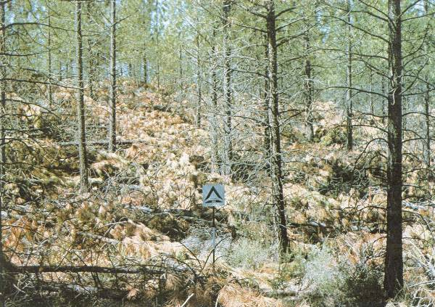

Figure 5. Heavy fuel load PCT: - Total slash accumulation after a precommercial thinning (PCT) is 23.0 tons/acre (6.7 tons/acre for size class 1.1-3.0 inches in diameter; 12.8 tons/acre for 3.1-9.0 inches; and 3.5 tons/acre for 20.1+ inches). Slash treatment could involve piling and burning, and/or chipping followed by removal, or removal. To achieve a 9 ton/acre criterion, approximately 14 tons/acre of slash is considered excess.

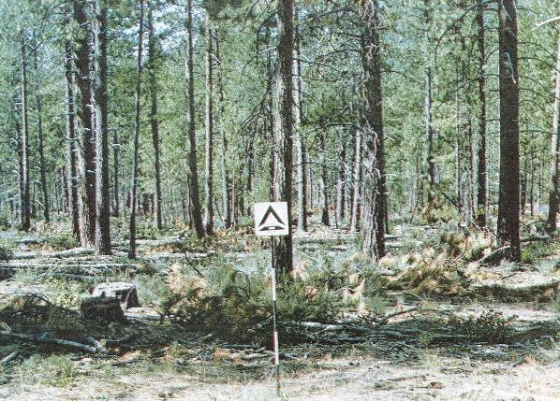

Figure 6. Light Thinning - Total slash accumulation after a partial harvest is 6.3 tons/acre (3.4 tons/acre for size class 1.1-3.0 inches in diameter; 2.9 tons/acre for 3.1-9.0 inches). Because slash is less than the 9 tons/acre criteria and inconsistently distributed, slash treatment could consist of lopping and scattering to meet the less than 18” to 30” height criteria.

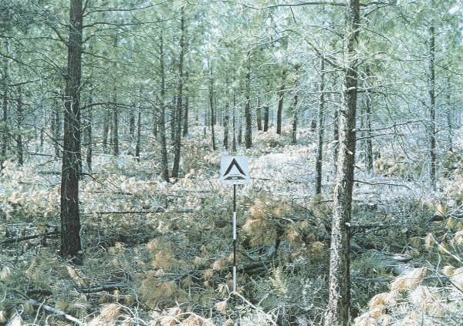

Figure 7. Moderate fuel load thinning - Total slash accumulation after a precommercial thinning is 7.8 tons/acre (5.5 tons/acre for size class 1.1-3.0 inches in diameter; 2.3 tons/acre for 3.1-9.0 inches). Although slash is less than the 9 tons/acre criteria, lop and scattering of slash is not recommended due to the consistent distribution of the slash.
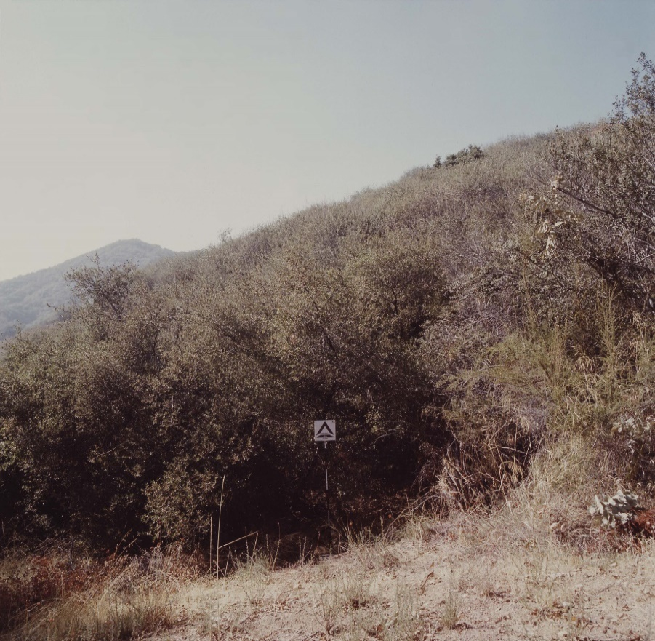
Figure 8. Heavy fuel load, Ceanothus Mixed Chaparral, Angeles National Forest. Total standing biomass 39.7 tons/ac (26.8 live/12.9 dead)

- Site Factors - Site factors are physical, climatic, or regulatory circumstances in the forest that may affect equipment, treatment method choice, and/or timing of treatment. Examples of site factors are steep slopes, average annual precipitation, rock outcrops, sensitive areas, broken terrain, condition and quantity of fuel on adjacent stands, and state or local regulations and required permits.

- High Fire Hazard Areas and Public Roads and Building - When fuels reduction/wildfire risk reduction is the purpose, focus on treatment methods that result in intense slash treatment or removal/disposal of slash from the site. These areas are the most common/frequent locations where NRCS-CA EQIP forestry projects occur:
- High to extreme fire hazard areas,
- Wildland Urban Interface areas in Communities at Risk,
- (i) Areas within 100' of public or private roads; ii) 100-500 feet from permanent buildings maintain for human habitation; iii) within 200-500' of public use areas; (iv) fuel breaks, and (v) priority fuel hazard reduction areas identified in a local fire plan,
- Tier I Tree Mortality areas as designated by the Governor’s Tree Mortality Task Force, and
- Low precipitation zones of less than 36" per year.

- Safety and Aesthetics - Remind the participant of the safety and aesthetics considerations for the selected methods. Mechanical slash treatment can be very disturbing and highly change the forest conditions. Landowners may not be familiar with this type of action. Treatment conditions are not long lasting and disturbed soil and surface slash should be restored to more natural conditions in a few years.
VI. Slash treatment Methods and treatment SpecifIcationS
Slash treatment methods used in NRCS-CA consist of the following:
CPS 384 Woody Residue Treatment Methods
Treatment Method | Uses and Characteristics
Lop and Scatter | Suited to areas with lower slash accumulations; low cost; labor intensive; residual debris after Lop/Scat can be a fire hazard concerns.
Hand and Tractor Piling and Burning | Suited to areas with heavy slash accumulations; hand piling is used in steeper, inaccessible areas. Tractor piling very commonly used; very thorough treatment method but can have substantial impacts on soil health. Pile burning presents air quality and GHG emissions issues.
Chipping/Mastication | Preferred method for treating slash and thinning vegetation; thorough treatment; limited to <35% slopes; costly.
Windrows | Not used much in forested settings. Similar concerns as tractor piling.
Crushing | Limited use; for situations with low fuel volumes.
Prescribed Fire | Limited use in NRCS-CA. Effective in reducing low to moderate fuel loads with well configured slash; useful in areas where other treatments are impractical; relatively inexpensive; associated with risk of fire escape and smoke emissions; Fire Plan required and should be prepared by National Wildfire Coordinating Group (NWCG) qualified burn boss personnel or CAL FIRE, or consistent with amendments to NRCS-CA Prescribed Burn policy.
Air Curtain Burner (ACB) | An alternative to open pile burning. Requires special (ABC) equipment. Benefit is lower smoke emissions. Limited number of equipment available.
Biochar | An alternative to open pile burning. Requires special techniques and often “burn kilns” and water quenching to slowly/anaerobically burn woody debris. Techniques can reduce smoke emission and create a charcoal-like end product that may be useful for on/off-site soil amendment.
Removal | Most thorough level of slash treatment; requires specialized equipment; expensive; when slash is utilized at a biomass plant, permits required.

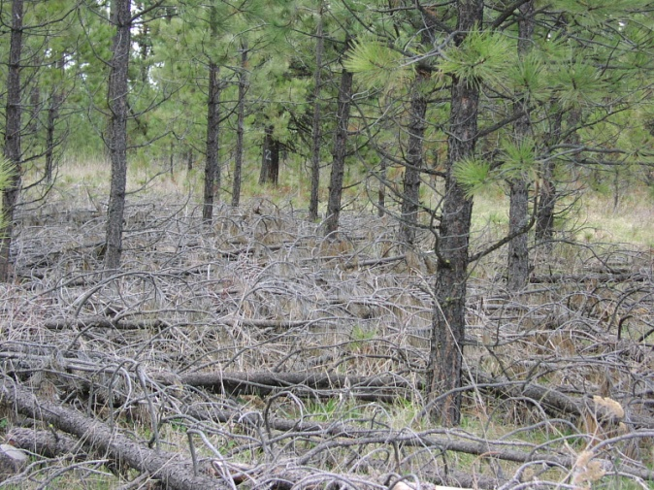
A. Lop and Scatter
Lopping is the cutting of limbs, branches, treetops, small diameter trees, or other woody plant residue into lengths so that the remaining slash will lie close to the ground. Scattering is the spreading of lopped slash evenly over the ground so that the remaining slash will lie close to the ground. This method is suited to areas with lower slash accumulations or steep areas where equipment cannot treat slash more thoroughly.
The treatment can result in reduced fire behavior due to decreasing vertical ladder fuels and increasing the space between surface fuels and live crown base. It also improves aesthetics and distributes material more uniformly and closer to the forest floor for faster decomposition.
Figure 9. Lop and scattering - Lop and scattering cuts slash and spreads it evenly across the ground. Untreated vegetative debris creates a fire hazard, pest breeding habitat, and impediments to revegetation and grazing.

1. Maximum Allowable Height from Soil Surface: 30 inches (18 inches in high fire hazard areas) (80% of material is 30”/18” or less from the ground.)
2. Maximum Allowable Residue Lengths: 30 inches (80% of material is 30 inches or less in length.)
3. Ground Contact Optimized: 80% of material is in contact with the ground.
4. Special Protection Measures/Requirements: include in the IR all that apply:
Any slash generated within 100 ft. of habitable structures or public and private roads open for use will be hauled away, chipped, or piled and burned.
Watercourses present - Do not place any slash in any watercourse channel, seasonal stream, or riparian buffer zone.

Steep slopes with large woody debris - Large tree boles/logs greater than 6 inches diameter of any length may decked or left in place when in contact with the ground. Cutting of boles to ensure ground contact may be needed.

B. Chipping/Shredding
Chipping/Shredding (aka mastication) is the processing of slash through a mobile mechanical chipper to produce chipped or shredded material that is distributed on site or utilized offsite as landscape mulch or biomass energy. For safety purposes, humans and animals must be excluded from areas being treated by equipment that flails and throws chips and chunks. Care must be taken to operate the machinery to minimize bark damage to the residual trees.
Mastication is the preferred woody residue treatment methods because it highly reconfigures slash into a minimum fire hazard condition; adds organic material to the soil to improve soil health; cushions heavy equipment movement over the soil; and provides GHG emission reduction benefits by avoiding pile burning of slash. It is also very “selective”, in that a skilled operator can select each individual tree/shrub to treat and highly customize the post treatment forest condition.
Figure 10. Front end masticator - Mastication is the preferred choice for woody residue treatment
There are a variety of mastication equipment configuration. Shown above in Figure 9 is equipment with from mounted rotating drum with cutting blades. Other equipment uses a mechanical arm (see page 1) with rotating heads that can stay stationary and reach a shrub or tree to chip. This results in the ability to highly select a piece of vegetation to be treated and reduce the “footprint” of the equipment on the forest floor.
The method has limitations. The equipment can typically not be used on slopes over 35%. It can only treat woody debris that is a maximum diameter size of 10-12 inches diameter. In projects with large sized logs resulting bark beetle or catastrophic fire damage, other logging equipment must be used. The treatment is very expensive ranging $1,000 to over $2,000 per acre. Contractors are in high demand and it is often difficult to implement treatments in a timely manner. As with all heavy equipment in forest operations, heavy equipment cannot be used during wet/saturated soils periods to avoid erosion and soil compaction.
- Maximum Allowable Mulch Depth: 4 inches (80% of mulched areas are 4” deep or less) or 6 inches depth when chipped/masticated material is placed in an isolated cleared area such as a landing.
- Maximum Allowable Residue Lengths: Mastication operations will leave residues where 80% are less than 18 inches in length, 60% are less than 12 inches in length, and 40% are less than 8 inches in length. 20% of the material may be longer lengths.
- Special Protection Measures/ Requirements:
Chips will not be applied or distributed to areas where migration to surface waters is likely in high precipitation events. Spread chips evenly away from the base of any crop tree.
Materials for chipping or shredding are free of chemically treated wood and other contaminates.
Large logs (e.g. greater than 10 inches DBH deteriorated material often resulting from wildfire or bark beetles), may be decked on site. All limbs and all tops to a 10-inch diameter will be chipped, shredded, or burned to reduce fuel accumulations.

Logs will be decked in isolated areas where they will not create fuel hazards or other environmental resource concerns, such as impacts to water or soil quality.
Do not damage boles (remove bark) of live, standing, residual trees during equipment operations.
No new tractor trails or heavy equipment operations on slopes greater than 35%, except for limited distances on up to 45% slopes.
Operations with heavy equipment shall not occur during periods of wet weather with saturated soil conditions as defined by the California Forest Practice Rules.
C. Pile and Burn
Piling is placing, laying, heaping or stacking of slash into piles which may or may not be burned. Burning is igniting piled slash under prescribed conditions to reduce the amount and continuity of fuels. These methods are suited to areas with adequate spacing between residual trees or areas with few or no residual trees.
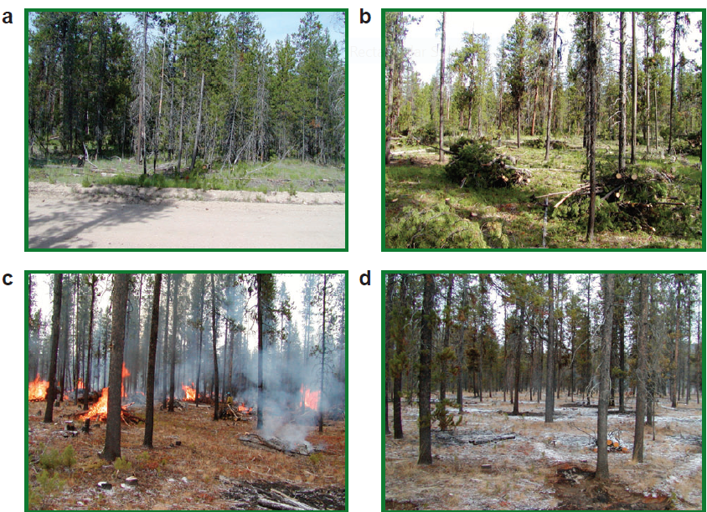

Figure 11. Piling and burning - A combination of hand slashing, piling, and burning the piles were used to accomplish objectives. The figure shows (a) before treatment, (b) hand slashed piles, (c) pile burning, and (d) after treatment (RMS GTR 292.)
- General requirements for all piling and burning
When slash and other debris will be burned onsite use NRCS CPS Code 338, Prescribed Burning (when CPS 338 pile burning scenarios are available).

Landowner is responsible for obtaining and possessing, prior to ignition, a valid burn permit from a fire protection and/or an air quality agency having the authority for issuing burn permits. The landowner is responsible for following all conditions on the burn permit and applying appropriate smoke management practices to minimize air pollution impacts on the public. Follow any burn plan written specifically written for pile burning.

Compliance with State fire protection statutes (Public Resource Code 4427) is required regarding equipment needed during open burning (sharp point shovel and fire extinguisher etc.) and fire suppression tools when operating internal combustion engine equipment (Public Resource Code 4428).
Use appropriate control measures to ensure fire is contained within piles. Measures include bare mineral soil clearing around piles, on-site presence of appropriate suppression tools (shovels, McCloud, rake, etc.), trenching to catch rolling debris, and water to extinguish fire escapes.

Do not place piles on top of large rocks, logs, stumps, or within watercourses, dry seasonal watercourse swales, ditches, and roads subject to vehicular traffic.

Burning should be performed under low risk weather conditions, preferably in winter months, during rain or snow or when fuels and vegetation are wet, relative humidity is high, and winds are light.

Piles that will be burned later may be “teepeed” to shed water or, if small, temporarily covered with water-resistant paper or plastic to allow material beneath to dry.

Synthetic materials (e.g. old tires, petroleum products) will not be incorporated in piles.

Slash will not be piled or burned in any watercourse channel, buffer zone, or ephemeral drainage carrying seasonal runoff.

Any slash generated within 100 ft. of habitable structures or public and private roads open for use will be hauled away, chipped, or piled and burned.

  - Handpile-Burning
Maximum Allowable Pile Height: 4 ft.
Maximum Allowable Pile Diameter: 4 ft.
Maximum Density Per Acre: 90 piles or less per acre.
Special Hand Piling Protection Measures/Requirements:
Handpiles have a minimum 10-foot width of clearing to mineral soil around the pile.
Construct piles slash/woody debris at least 15 feet from retained trees.
Note: Size and density per acre of hand piles are not critical factors for many situations and can vary from the above specifications. Piles size can often be increased where there is suitable space for burning. Suitable piling burning space includes locations which avoid tree scorching, live tree basal cambium intense heat exposure, and ignition of other flammable vegetation.

Figure 12. Hand pile - Hand piles are used with low amounts fuel or when equipment is not suited for the area.

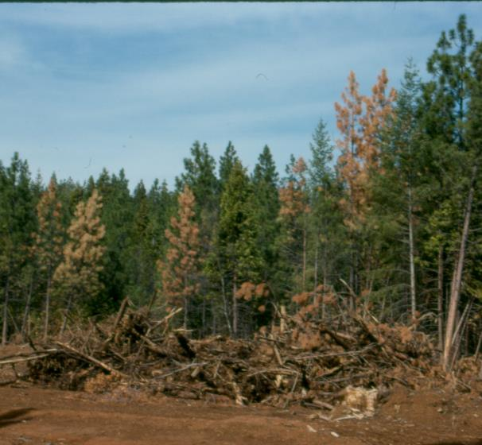
  - Tractor Piling-Burning
Maximum Allowable Pile Height: 10 ft
Maximum Allowable Pile Diameter: 30 ft
Maximum Density Per Acre: 30, or less as needed to avoid residual tree scorching.
Maximum Slash Length: 8-foot sections or less with occasion longer lengths.
Figure 13. Tractor pile - Tractor piling and burning is useful where there are large amounts of slash and adequate space to pile slash and burn piles. Insect tree mortality projects typically use tractor piling and burn.
Tractor Piling Special Protection Measures and Requirements:
Tractor piling equipment may be used on slopes greater than 35%, except for limited distances on up to 45% slopes.
Construct piles of slash/woody debris a sufficient distance from retained trees to avoid fire or heat scorch to residual tree.
Piles shall be in openings outside, drainages riparian buffers, and at least 30 feet from snags.
Areas of uncleared live and dead grass/forbs, shrubs, and trees are recommended to be retained on the site for biodiversity and erosion control purposes. When size of an individual untreated areas exceeds 2% of the size of the treatment area, it is excluded from payment.
Do not damage boles (remove bark) of live, standing, residual trees during piling. Slash and vegetation may be left in place where vegetation is so close to leave trees that the removal of the vegetation would cause damage to the leave trees. Leave trees and vegetation not specified to be treated shall be left undisturbed.
Limited amounts of woody debris which are less than 3 inches in diameter and less than 18 inches in length may be left for ground cover. If the slash cover exceeds 50%, pile the smaller fuels to meet the slash piling requirements.
Large logs (e.g. greater than 10 inches DBH, deteriorated material often resulting from wildfire or bark beetles), may be decked on site. All limbs and all tops to a 10-inch diameter will be chipped, shredded, or burned to reduce fuel accumulations. Logs will be decked in isolated areas where they will not create fuel hazards or other environmental resource concerns, such as impacts to water or soil quality.
Piles shall be compact and be as free of dirt as possible. When machine piling or windrowing, a “brush rake” (blade with tines) or grapples will minimize pushing surface soil into slash accumulations. Use of piling equipment with brush rakes or grapple tools are preferred instead of straight dozer blades.
Avoid to the greatest extent possible actions which remove duff layer from soil and create bare mineral soil (except for fire breaks around piles).
In areas where no remaining trees are live, use fewer and larger piles to facilitate burning.

All materials partially pushed over, hung up, left in an unsafe position, shall be either reworked with the tractor or felled by hand.

Operations will occur during dry soil conditions to the greatest extent possible. Soils will not rut greater than 6 inches in depth over distances greater than 25 feet. Displacement will not affect more than 10% of any acre.
Soil disturbance caused by the operations which may cause erosion shall be cross raked on the contour or mitigated with waterbars.

The dozer line for fire control around the tractor piles shall be "one blade wide" (approx.10 feet). It shall be cleared to mineral soil. Waterbars are to be constructed as needed and completed before rain events. When possible, roads and other natural barriers may be incorporated with the line.

Grapple piling shall adhere to the same specifications as stated for tractor piles.

Consideration for nearby Pine Beetle Infestations - In areas with pine bark beetles, piles containing green material will be burned within two months if conditions permit. If residues are green and cannot be burned within two months of pile creation, it will remain scattered on the ground until a burn window is available. Slash must be piled or chipped before practice can be certified.
When pine beetle activity is low (normal), a limited number of deck logs and slash piles isolated from other slash or live vegetation may be left (approximately 2-3 moderately sized piles per acre) unburned for wildlife habitat. Refer to Conservation Practice Specifications, Structures for Wildlife (Code 649), for details on piles left for wildlife, number of piles, and size of piles.

D. Air Curtain Burning
An alternative to pile burning is use of “air curtain burning” equipment. ACB machines operate by blocking various air pollutant emissions including greenhouse gases and PM by using a high velocity airflow from the air blower part which is referred to as “air curtain”. ACBs are divided into two main types, stationary (positioned at the centralized landing area) and mobile applications (half-ton pick-up truck mounted system).
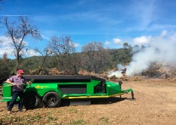
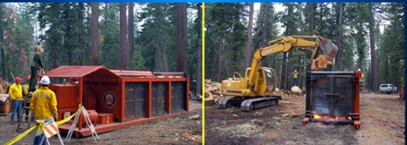
Past studies show that ACBs can reduce CO2 and PM emission by 80% compared to open pile burning and reduce smoke opacity. In additional it also minimizes escaping ember, soil damage and burn scars by creating the air curtain across the box. This residue treatment method is considered a clean air pollution control burning method to dispose of forest residue. Burning consumption rates, availability of equipment, and operating cost of disposals vary among ACB systems. CAL FIRE has purchased in 2018 10 ACBs and experience will be gained from their use.
Figure 14. Air curtain burners treating forest slash on a landing.

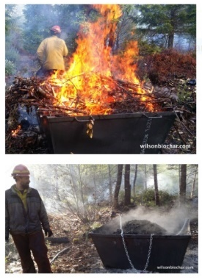
- Biochar
Burning slash to create biochar is an alternative method to open pile burning. Biochar is a modern technology that returns carbon to the soil in the form of long-lasting charcoal. It’s made by baking biomass (such as tree wood, plants, manure, and other organic materials) without the oxygen that could cause it to burn completely to ash.

It requires special techniques and often “burning kilns” and water quenching to slowly/anaerobically burn woody debris. Techniques can reduce smoke emission and create charcoal-like end product that may be useful for on/off-site soil amendment.

In this process, woody debris is retrieved from forest locations, cut in appropriate size pieces, piled, and burned in kilns designed to create biochar. A plan for quenching biochar will be in place prior to lighting kilns, and the capability for quenching will be maintained during firing and while the char is cooling. Woody debris of sizes not appropriate for biochar processing will be decked, burned, or treated using another disposal method.
Figure 15. The Forestry Flame Cap Kiln. Designed by Wilson Biochar Associates for use in forestry to convert burn piles to biochar. Newer model will have fork pockets for lifting and unloading. .Biochar for Forest Restoration in the Western United States – 9-18-15 (rev.3-15-16)

Contact the State Forester for information needed for Implementation Requirements when choosing to use biochar burning process.

F. Crushing

Crushing breaks and presses slash on or into the ground surface. This occurs when harvest or thinning equipment drives over slash created during the operation. This method involves the use of heavy ground-based equipment that crush slash to a depth not exceeding 2 feet. The closer crushed material is to the forest floor, the quicker decomposition occurs and the less chance of fire reaching into the above canopy layers.

  - Maximum Allowable Height from Soil Surface: 2 feet (80% of material shall be 2 feet or less).
  - Maximum Allowable Residue Lengths: 48 inches
  - Ground Contact Optimized: Maximize material contact with soil for rapid breakdown.
  - Special Protection Measures/Requirements; include in IR all that apply:
Any slash generated within 100 ft. of the habitable structure or public and private roads open for use will be hauled away, chipped or piled and burned.
Potential for Watercourse Delivery - Do not place any slash generated in any watercourse or seasonal stream.
- Windrows
Windrowing is piling slash on the contour of the terrain using equipment. It used very little in forest settings and is typically associated with forest restoration projects where brush is being removed to reforest.

- Maximum height of pile: 4 feet
- Maximum width of windrow: 10 feet
- Windrows longer than 200 feet will have wildlife openings.
- Windrows will be placed on the contour (perpendicular to the slope).
- Windrows will be placed far enough apart as to not interfere with required planting density.
- Windrows shall not create a fire hazard and be isolated from live or dead vegetation.
- Any slash generated within 100 ft. of a habitable structure or public and private roads open for use will be hauled away, chipped, or piled and burned.

- Prescribed (Broadcast) Burning
This method consumes and alters slash by prescribed fire minimizing the risk of wildfire. It is suited to areas with low to moderate fuel loads, reliable fire control lines, and locations where smoke emissions are not a significant factor to nearby receptors. The practice is typically called broadcast burning as fire is intentionally set to burn throughout a secured area. Smoke management, production of air pollutants, and risk of fire escape are concern with this method.
Treatments of excess woody debris using prescribed burning will be implemented using CPS 338 Prescribed Burning. CPS 384 may not be needed when slash is treated using prescribed burning.
Figure 16. Prescribed or “broadcast” burning - Used in highly secured area, must be implemented in accordance to NRCS CA policy and in accordance with Practice 338.
In some cases, CPS 384 may be a facilitating practice for CPS 338.
All prescribed burning will comply with CPS 338 Prescribed Burning, NRCS National Prescribed Burning policy, and NRCS-CA Technical Guidance. Foremost among these is the need to have a prescribed burn which covers specific items and is written by a qualified person. For NRCS-CA, it is recommended that burn plans and burning implementation be conducted by National Wildfire Coordinating Group (NWCG) certified persons or CAL FIRE. The practice is not widely used in NRCS-CA and must involve conservation planning by persons with 338 Job Approval Authority (JAA) and review of all plans from a NRCS State Office Team consisting of the State Forester, State Range Conservationist, and other State Office specialists and Area Foresters with CPS 338 JAA.
Other facilitating practices for CPS 338, in additional to CPS 384, may be used for preparing fuels for burning and creating fire control lines (CAP 112 Prescribed Burn Plan, CPS 666 Forest Stand Improvement, 660 Tree/Shrub Pruning and CPS 394 Firebreak).

- Removal
Slash is removed from the site. This method is suited to areas with higher accumulations of slash where other methods do not sufficiently reduce undesired materials. It is suited to locations where commercial biomass utilization is economically feasible or where there is a local county disposal site. The practice often involves logging equipment such skidders, high powered chipper, and chip vans. Road access with wide radius curves and large chip processing landings are critical factors necessary for this treatment.
Figure 17. Removal by chipping -One method to remove slash from the site is to use high powered chippers and trucks to haul material to utilization or disposal sites.

In some tree mortality situations, high levels of large dead logs require removal from the property to meet resources concerns. Leaving these levels of large logs creates fire hazard or access barriers if left on site. Use CPS Practice 384 Log Disposal when planning indicates removal of large logs will be needed. CPS 500 Obstruction Removal can be used when logs have already been decked (e.g. post fire utility line clearing) and solely need removal from the site. (Consult with your engineering staff regarding use this practice.) Use these practices only when there is a demonstrated environment benefit or resource concern to be accomplished for off-site to disposal.
When slash or large dead trees are removed for commercial utilization (“biomass”), add the Biomass Removal Checklist into the Implementation Requirements (IR):
Biomass Removal Checklist:
☐ Project will dispose of biomass from soils capable of growing commercial tree species (A or B list species) at a utilization facility.
☐ Appropriate CAL FIRE forest practice permit (e.g. permits per 14 CCR 1038 Exemptions or 1052 Emergency Notice) of the Forest Practice Rules has been filed with CAL FIRE by a Registered Professional Forester or Licensed Timber Operator as applicable.
☐ Appropriate landing and skid trail, spacing, construction, and closure requirements are provided and implemented consistent with standards in CPS 655-Forest Trails and Landings.
☐ Project will utilize the biomass material as feedstock for:
☐ Fuel to generate renewable electricity at a biomass-fueled power plant
☐ Renewable fuel production (e.g. renewable diesel or syngas)
☐ Mulch ☐ Animal Bedding ☐ Biochar
☐ Treating unpaved roads and surfaces as a dust suppressant
☐ Other:
VII. FACILITATING PRACTICES
Woody Residue Treatment is commonly used with other practices to effectively and economically achieve silvicultural objective. Facilitating practices include Forest Stand Improvement (666), Tree/Shrub Pruning (660), Tree/Shrub Establishment (612), Tree/Shrub Site Preparation (490), Windbreak and Shelterbelt Renovation (650), Prescribed Grazing (528), Fuel Break (383), Prescribed Burning (338), Critical Area Planting (342), and Obstruction Removal (500).

VIII. SpeCial REQUIREMENTS
Permitting and Environmental Compliance
All activities associated with applying this practice shall comply with federal, state, tribal and local forestry and related laws and regulations. It is the landowner’s responsibility to obtain appropriate permits and/or applications prior to commencing an activity. Typical permits that may be needed include slash burning from an air quality control district, commercial harvesting permit from CAL FIRE when vegetation is used for commercial purposes, Pesticide Control Advisors Report when herbicides are applied, archeological protection review by NRCS, TES protections, and stream bed alteration permits.
Compliance with State fire protection statutes (Public Resource Code 4427) is required regarding equipment needed during open burning (sharp point shovel and fire extinguisher etc.) and fire suppression tools when operating internal combustion (Public Resource Code 4428). Advise clients to contact local CAL FIRE Office for information. Also, CAL FIRE will advise on periods of
no/curtailed operations of equipment use and post operations fire patrols during extreme fire conditions such as Red Flag Warnings or Fire Weather Watch when issued by the National Weather Service.
Watercourse and Meadow Protection Standards
The Implementation Requirements (IR) shall include information on watercourses, riparian areas, wetlands, including a map, in the project area.
Protection measures/treatment limitations must be provided when the project affects any Class I or II perennial watercourses, or Class III seasonal/intermittent watercourses. Refer to the Table1 below for watercourse protection zones in non-anadromous water bodies. If slopes are greater than 40%, the buffer will extend to the topographic break above the stream. All watercourse riparian stream buffer areas exclude entry by heavy equipment, except at existing crossing or designated locations.
Vegetation treatment and heavy equipment is generally excluded in watercourse buffer zones, particularly in remote areas that are not associated with WUI areas or presence of public safety infrastructure. These exclusions are needed to continue large snag/wood recruitment and avoid impacts to species that utilize aquatic and riparian areas such as fish, red-legged and yellow-legged frogs, Pacific fisher, and great gray owl.

Table 1 – Protection measures/treatment limitations for watercourse protection zones (Buffer Zones)
 | Class 1  wet | Class II  wet | Class III dry | Class III wet | Wet meadow
Work Exclusion Zone (from channel edge or edge of meadow) | 25 ft. | 25 ft. | None | 25 ft. | 100 ft.
Heavy Equipment Exclusion Zone (Hand work only) | 75 ft. | 25 ft. | 25 ft. | 25 ft. | N/A
Total Buffer for Limited Work | 100 ft. | 50 ft. | 25 ft. | 50 ft. | 100 ft.

Vegetative treatments and equipment entry within watercourse buffer zones can be included when an assessment is made that the buffer treatment is needed to protect human life, structures Protection measures/treatment limitations, or public safety or commercial infrastructure assets that are at risk to damage from wildfires. Vegetative treatments and equipment entry to address post wildfire and insect mortality resource concerns can also be included following an assessment and consultation with a NRCS biologist. Contact a NRCS biologist early in the planning process if working in the buffer zones. Consultations may be required with USFWS, NOAA Fisheries, or other state or federal regulatory agencies (i.e. Lake, Streambed Alteration Permit, 401 Water Quality Certification, 404 Clean Water Act.)
Forest management operations outside the watercourse buffer zones will ensure tree falling and other operations will not fell trees into buffer zones so that no part of the tree enters buffer. Slash will not be placed, piled or burned in any watercourse channel, buffer zone, or ephemeral drainage carrying seasonal runoff. Additional operating restrictions around ponds will apply, contact below NRCS Biologist for specification.
Migratory and Threatened, Endangered, or Sensitive (TES) Birds and Other Species
Project activities will not commence until a biologist concurrence is received.
Migratory Birds: Work will not occur during the migratory bird nesting season unless an assessment is conducted to determine active nesting or breeding behavior. Assessments will be completed by NRCS staff persons knowledge on migratory birds. Assessments shall be conducted within ten days prior to the start of work. The nesting season varies by region. Below are the nesting season dates by region. Refer to Technical Note TN-Biology-CA-23 for complete information on measures to minimize disturbance migratory birds.
Generally, projects less than 10 acres in size are not required to conduct migratory bird assessments, as well as projects implemented after July 15. These projects are not expected to have migratory bird population level adverse effects. Consider conducting surveys on <10-acre projects when they are adjacent to other areas planned for treatment in the same year.
TES: No known threatened, endangered, sensitive (TES) or rare plants or animals, including migratory birds, will be disturbed or harmed. Measures to avoid disturbance to TES may be required if known species are present or suitable habitat is found on-site in areas accessible to TES. In consultation with NRCS Biologist, develop a project alternative that avoids or minimizes these potential effects. Avoidance and/or minimization measures may include:
- Buffer zones around nests and dens,
  - Limitations to types of equipment and/or times used,
  - Limited operating periods,
  - TES monitoring prior to or during activities,
- Additional snag and downlog retention.
- Any requirements when provided from ESA consultation with USFWS, NOAA Fisheries, or requirements of a state or federal permit (i.e. Lake, Streambed Alteration Permit, 401 Water Quality Certification, 404 Clean Water Act.)
Snags
Projects shall be designed and implemented to retain standing dead and dying trees (snags) as wildlife trees. Snag shall be retained where they pose a minimal hazard to human safety and do not affect infrastructure such as roads, buildings, utilities or public safety or commercial features. Desirable wildlife trees/snags for retention include dead or dying trees and live “culls”; and larger trees with large forked or horizontal branches, broken tops, or existing cavities.
Snag requirements:
- Retain all snags, >15” dbh and >15’ tall, within Class I and II perennial watercourse protection zones and within 500’ of meadows.
- Retain an average of 1-2 snags per acre for all other areas.
- Exceptions to the above requirements:
Exception (a): Snags that can fall on roads and structures.
Exception (b): Where required for insect or disease control.
Exception (c): Where it is a threat to human health and safety (hazard).
Exception (d): When a biologist recommends a greater quantity for protection of TES habitat.
Exception (e): Fuelbreaks.
Exception (f): When the forester and biologist agree the quantities may be reduced, such as to address post wildfire or insect mortality excess biomass/wildfire hazard resource concern in buffer zones.
- Snags shall be designated prior to operations to ensure a sufficient number are retained, suitable snags are selected, and appropriate locations are sited.

Large Down Wood
Retain all pre-existing large wood on the forest floor, ≥ 12 inch dbh and 15’ length. Where debris is smaller diameter, retain at least six of the largest down logs per acre, with the following exceptions:
- Exception (a): When it is serving as brood habitat for beetle infestation.
- Exception (b): Where the density is such that it would contribute significantly to ground fuels, spread of wildfire, or hinders fire suppressions efforts.
- Exception (d): When a biologist, in consultation with the forester recommends a certain quantity for protection of TES habitat.
- Exception (e): When it hinders required maintenance.

Biological Diversity Retention areas
Consideration should be given to leaving some debris for biological diversity. Consider retaining small vegetated areas that coincide with unique features such as wet areas, riparin buffer zones, rocky or steep terrain, down logs and snags, or other valuable habitat elements. Target retaining 15% of the vegetation in the project area.

Archeology
No operations may begin until archeological clearance is provided by NRCS. No operations will occur in known archeology or historical sites.

Pest Control
- Pine Beetle Infestations: When feasible, delay cutting live trees until the end of the bark beetle breeding period is completed, typically late fall. Avoid long time delays (2 months during breeding season) between green vegetation piling and burning. When lps bark beetle species are a major problem, all slash > 9 inches diameter will be lopped to a maximum of 18-inch length.

- Sudden Oak Death (SOD) and Goldspotted Oak Borer In areas with known infections of pathogen or insects, specific sanitation precaution will be implemented including no transport of woody outside the State designated Zone of Infestation, covering vegetative debris moved by vehicles, and equipment sanitization measures. Sanitation of equipment entering and leave these zones of infection is recommended.
See: BMP for SOD: http://www.suddenoakdeath.org/wp-content/uploads/2014/12/forestry-08-10-with-new-2014-map.pdf
Goldspotted Oak Borer: http://ipm.ucanr.edu/PMG/PESTNOTES/pn74163.html
Maintaining Soil Quality/Soil Health
All operations will be planned and executed in a manner that maintains or improves soil quality. This includes using machinery that minimizes compaction, displacement, rutting and other disturbances to the forest floor. Surface organic material will be retained or improved throughout the treatment process.
Soils, site factors, and timing of application must be suitable for any ground-based equipment utilized for woody reside treatment to avoid excessive compaction, rutting, or damage to the soil surface layer.
Operations with heavy equipment shall not occur during periods of wet weather with saturated soil conditions as defined by the California Forest Practice Rules.

No new tractor trails or heavy equipment operations on slopes greater than 35%, except for limited distances on up to 45% slopes.
IX. basis of acceptance
Upon completion of the work conducted by the owner/client, a field inspection will be made to determine if at least 85 percent of the planned work as described within the IR has been satisfactory completed. Individual untreated areas should not exceed 2% of the entire treatment unit. Untreated areas greater in size should be excluded from payment.
X. operation and maintenance
Access by vehicles or people will be controlled during treatment for safety. See CPS Access Control (Code 472).
Once a year after the completion of the work, the owner/client will conduct a field inspection to determine if the area requires additional attention.
Monitor populations and the potential of damage to site resources by harmful pests and take controlling actions as necessary. See CPS Pest Management Conservation System (Code 595).
Monitor vegetation growth. Unwanted vegetation or excessive regrowth may occur, requiring treatment
Identify locations that need work to reduce soil erosion.
XI. REFERENCES
Agee, James K.; Bahro, Berni; Finney, Mark A.; Omi, Philip N.; Sapsis, David B.; Skinner, Carl N.; van Wagtendonk, Jan W.; Weatherspoon, Phillip C. The Use of Shaded Fuelbreaks in Landscape Fire Management. 2000. Forest Ecology and Management 127, pages 55-66.
Bennett, Max; Fitzgerald, Stephen; Parker, Bob; Main, Marty; Perleberg, Andy; Schnepf, Chris; Mahoney, Ron. 2010. Reducing Fire Risk on Your Forest Property. PNW 618.

Brennen, T.J., and Keeley, J.E., 2015, Southwest U.S. Mechanically Treated Chaparral Photo Series: U.S. Geological Survey Data Release, http://dx.doi.org/10.5066/F7D798F9. Southwest U.S. Mechanically Treated Chaparral Photo Series
California Forest Practice Rules. 2017. https://calfire.ca.gov/resource_mgt/downloads/2017%20Forest%20Practice%20Rules%20and%20Act.pdf
California Oak Mortality Task Force. 2014.Sudden Oak Death Guidelines for Forestry. http://www.suddenoakdeath.org/wp-content/uploads/2014/12/forestry-08-10-with-new-2014-map.pdf
Fuelbreaks and Other Fuel Modification for Wildland Fire Control. USFS. 1977.
Graham, Russel; Jain, Theresa. 2010. Fuel Management in Forests of the Inland West, in Cumulative Watershed Effects of Fuel Management in the Western States, Chapter 3.USDA Forest Service RMRS-GTR-231.
Graham, Russell T.; Jain, Theresa B.; Loseke, Mark. 2009. Fuel treatments, fire suppression, and their interaction with wildfire and its impacts: the Warm Lake experience during the Cascade Complex of wildfires in central Idaho, 2007. Gen. Tech. Rep. RMRS- GTR-229. Fort Collins, CO: U.S. Department of Agriculture, Forest Service, Rocky Mountain Research Station. 36 p.
Graham, Russell T.; McCaffrey, Sarah; Jain, Theresa B. (tech. eds.) 2004. Science basis for changing forest structure to modify wildfire behavior and severity. Gen. Tech. Rep.RMRS-GTR-120. Fort Collins, CO: U.S. Department of Agriculture, Forest Service, Rocky Mountain Research Station. 43 p.
Jain, Theresa B., Mike A. Battaglia, Han-Sup Han, Russell T. Graham, Christopher R. Keyes, Jeremy S. Fried, and Jonathan E. Sandquist. 2012. Comprehensive Guide to Fuel
Management Practices for Dry Mixed Conifer Forests in the Northwestern United States. General Technical .Report RMRS-GTR-292 https://www.fs.fed.us/rm/pubs/rmrs_gtr292.pdf

Maxwell, W. G. and . Ward, F.R.. Oct 1979..USFS photo series for quantifying forest residues in the:sierra mixed conifer type sierra true fir type. USDA FOREST SERVICE GENERAL TECHNICAL REPORT PNW-95. https://www.fs.fed.us/pnw/pubs/pnw_gtr095.pdf
Peterson, David L.; Johnson, Morris C.; Agee, James K.; Jain, Theresa B.; McKenzie, Donald; Reinhardt, Elizabeth D. 2005. Forest structure and fire hazard in dry forests of the Western United States. Gen. Tech. Rep. PNW-GTR-628. Portland, OR: U.S. Department of Agriculture, Forest Service, Pacific Northwest Research Station. 30 p.
Schnepf, Chris; Graham, Russell T.; Kegley, Sandy; Jain, Therese B. 2009. Managing Organic Debris for Forest Health, Reconciling fire hazard, bark beetles, wildlife, and forest nutrition needs. Pacific Northwest Extension PNW 609. University of Idaho, Oregon State University and Washington State University. 66 p.
University of California Agriculture and Natural Resource Publication 8245. Wildfire and Fuels Management. https://anrcatalog.ucanr.edu/pdf/8245.pdf
University of California Integrated Pest management. Goldspotted Oak Borer. http://ipm.ucanr.edu/PMG/PESTNOTES/pn74163.html
USFS Pacific NW Research Station. Pacific Wildland Fire Science Laboratory. Fire and environmental Research Applications Team. Digital Photo Series. https://depts.washington.edu/nwfire/dps/
USFS Pacific Southwest Forest and Range Experiment Station. https://www.fs.fed.us/psw/publications/documents/usda_series/usda_ah499.pdf
Wilson, Kelpie. 2015. Biochar for Forest Restoration in the Western United States. Wilson Biochar Associates, for South Umpqua Rural Community Partnership.2015. https://greenyourhead.typepad.com/files/biochar_for_forest_restoration_wba_rev.pdf
Winford, Eric M. California Fire Science Consortium; Stevens, Jens T, UC Davis;
Safford Hugh D., U.S. Forest Service and UC Davis . 2015. Effects of fuel treatments on California mixed-conifer forests. http://calag.ucanr.edu/Archive/?article=ca.v069n03p150.

Photo series examples are PNW-GTR-51, 52, 95, 105, 231, 258), fuel hazard estimator for post-Pre commercial thinning (PNW-57, 1968, Fahnestock.
See NRCS-WA 384 Practice Specification https://efotg.sc.egov.usda.gov/api/CPSFile/17987/384_WA_GD_Woody_Residue_Treatment-Specification_Guide_2018
See California Forest Practices rules section 14 CCR 895.1

