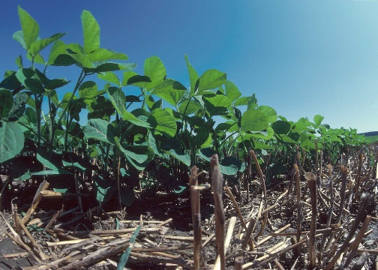
What is Residue Management-No-Till

Limiting soil disturbance to manage the amount, orientation
and distribution of crop and plant residue on the soil surface
year around.
Purposes
Reduce sheet, rill, and wind erosion-(SOIL EROSION –
Sheet, rill, & wind erosion)
Reduce tillage induced particulate emissions-
Resource Concern (AIR QUALITY IMPACTS -
Emissions of Particulate Matter - PM –and PM
Precursors)
Maintain or increase soil quality and organic matter
content-Resource Concern (SOIL QUALITY
DEGRADATION – Organic matter depletion)
Reduce energy use – Resource Concern INEFFICIENT
Photo courtesy of NRCS
ENERGY USE – Farming/ranching practices and field
operations)

Increase water use and precipitation storage efficiency – Resource Concern (INSUFFICIENT WATER – Inefficient
moisture management)
Provide food and escape cover for wildlife – Resource Concern (INADEQUATE HABITAT FOR FISH AND WILDLIFE
–Habitat degradation)

Conservation Benefits

Crop residue and tillage management practices reduce soil erosion by wind and water. Crop residue can maintain or increase soil tilth, add organic matter, improve water infiltration, and reduce soil moisture loss when left at or near the soil surface. Less tillage reduces soil compaction.

No-Till and Strip-Till (Practice Code 329)

No-till crops are planted into the previous crop residue that has not been tilled (no-till) or into narrowly tilled strips that leave the rest of the field untilled (strip-till). The width of the tilled strip must not exceed one third of the row width. Fertilizer can be applied either in the fall or in the spring either in a band, broadcast, or injected. Weeds are typically controlled before planting with burn down and/or pre-emerge herbicides. Post emergence herbicides are often used during the growing season. Cultivation can also be used for emergency or rescue weed control only.

Crop residue and tillage management effects on soil erosion and organic matter can also be predicted using the Revised Universal Soil Loss Equation, Version 2 (RUSLE 2). RUSLE 2 is a software program available to the public. The software and database files can be obtained at the following website. http://fargo.nserl.purdue.edu/rusle2_dataweb/

Attach RUSLE 2 and/or WEPS printouts that show planned crop sequence, all soil engaging field operations, SCI and STIR values. Include the RUSLE2/WEPS printouts with fuel usage for the benchmark condition and the planned condition where the practice is implemented to address Inefficient Energy Use.

OPERATION AND MAINTENANCE

Evaluate/measure the crop residues cover and orientation after each crop to ensure the planned amounts and orientation are being achieved. Adjust management as needed to either plan a new residue amount and orientation or adjust the planting equipment, and if applicable, the harvesting equipment.

Limited tillage is allowed to close or level ruts from harvesting equipment. No more than 10 percent of the field may be tilled for this purpose.

If there are areas of heavy residue accumulation (because of movement by water or wind) in the field, spread the residue prior to planting so it does not interfere with planter operation.

I certify that this practice, as implemented, meets NRCS standards and specifications.

_____________________________________________ __________________________
Planner Signature Date

Note: Attach supporting documentation (e.g. before and after RUSLE2 runs, residue measurements, photos, etc.) to the Job Sheet. All deliverables as shown in the statement of work are to be documented.
Helping People Help The Land.
An Equal Opportunity Provider and Employer

