Natural Resources Conservation Service
Residue and Tillage Management-Reduced Till
Illinois Conservation Practice Job Sheet 345

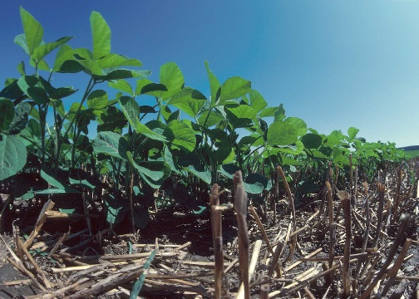
What is Residue Management-Reduced Till

Manage the amount, orientation and distribution of crop and plant residue on the soil surface year around where full width tillage is used.
Purposes

Reduce sheet, rill, and wind erosion-(SOIL EROSION
– Sheet, rill, & wind erosion)
Reduce tillage induced particulate emissions-
Resource Concern (AIR QUALITY IMPACTS –
Emissions of Particulate Matter - PM - and PM
Precursors)
Maintain or increase soil quality and organic matter
Photo courtesy of NRCS
content – Resource Concern (SOIL QUALITY
DEGRADATION – Organic matter depletion)

Reduce energy use – Resource Concern (INEFFICIENT ENERGY USE – Farming/ranching practices and
field operations)

Conservation Benefits
Crop residue and tillage management practices reduce soil erosion by wind and water. Crop residue can maintain or increase soil tilth, improve water infiltration, and reduce soil moisture loss when left at or near the soil surface. Less tillage reduces soil compaction.

Reduced Till (Practice Code 345)

Crop residue and tillage management effects on soil erosion and organic matter can also be estimated using the Revised Universal Soil Loss Equation, Version 2 (RUSLE 2). RUSLE 2 is a software program available to the public. The software and database files can be obtained at the following website. http://fargo.nserl.purdue.edu/rusle2_dataweb/

OPERATION AND MAINTENANCE
- Evaluate/measure the crop residue cover and orientation for each crop to ensure the planned amounts and orientation are being achieved. Adjust management as needed to either plan a new residue amount or orientation; or adjust the planting, tillage, or harvesting equipment.

- If there are areas of heavy residue accumulation (because of movement by water or wind) in the field, spread the residue prior to planting so it does not interfere with planter operation.

Attach RUSLE 2 and/or WEPS printouts that shows planned crop sequence, all soil engaging field operations, SCI and STIR values. STIR values shall not exceed 80.

Include the RUSLE2/WEPS printouts with fuel usage for the benchmark condition and the planned condition where the practice is implemented to address Inefficient Energy Use.

I certify that this practice, as implemented, meets NRCS standards and specifications.

____________________________________________ _____________________________________________
Planner Signature Date

Note: Attach a revised RUSLE 2 print out in cases where the tillage system is revised and supporting documentation (e.g. residue measurements, photos, etc.) to the job sheet. All deliverables as shown in the statement of work are to be documented.


Helping People Help The Land.
An Equal Opportunity Provider and Employer

