United States Department of Agriculture
Indiana Job Sheet (340)
Cover Crop
Indiana – July 2012 (ver. 1.0)
Cover Crop-Nitrogen Management

Landowner: |  |  |  |  |  |  |  | County:
Farm: | 1 |  | Tract: | 2 | Field(s): |  | Acres: | 12.0 |  |  | Date:
Soil Type(s): |  |  |  |  | Purpose: |  |  |  | Soil Drainage Class:

Cover Crop Species  (from selector and seeding tools) | Rate  Units/acre | Pure Live Seed  Units | Total =  (Rate X Acres) | Preceding Crop
 |  |  | 0.0
 |  |  | 0.0
 |  |  | 0.0
 |  |  | 0.0
 |  |  | 0.0
 |  |  | 0.0

Site Preparation - BEFORE Planting in Year:
Herbicide (per label): |  |  | non selective | Dates:
Herbicide (per label): |  |  |  | Dates:
Manure Application: |  |  |  | Dates:
Tillage:
Other:

Planting Year:
Planting Method: |  | Date:
NOTES:
If unforeseen circumstances prohibit planting by this date, please contact the local NRCS office as soon as possible.

Cover Crop Termination
Mowing: Note: Harvest for grain or forage is not a purpose of this practice standard.
Herbicide* (per label):
Other:
When applicable, ensure cover crops are managed and are compatible with crop insurance and /or USDA Program criteria.

Additional Information

Cover Crop – Nitrogen Management

Major Purposes
Reduce Nitrate Loss: Nitrate losses from Indiana cropland can find its way to surface waters through surface runoff and tile. Studies show that as much as 80% of these losses can occur during the winter fallow period and into the spring. Many cover crops are good scavengers of nitrogen and will take up excess nitrogen and store it in plant tissues through the winter and early spring. Studies at Purdue University and USDA Agricultural Research Service have shown that a winter cover crop of Cereal Rye can reduce the total nitrate loading in drainage systems by 60%. Most of this nitrogen will be available to the following crop or stored in the soil organic matter.
Drought conditions may have a significant effect on corn utilization of Nitrogen. Nitrogen either moves to the roots in solution as nitrate or roots grow through moist soil to intercept the nitrogen. Under drought conditions many roots never fully access the applied nutrients. There is consensus among Purdue Scientists and NRCS Agronomists that a greater amount of the nitrogen applied to corn will go unused when drought occurs early in the growing season. Additionally, the nutrients that are normally biologically cycled from soil and released to be taken up in solution had no water to form a solution.
This is precisely the type of year we need a cover crop, to trap the much larger residual N pool that will be present after a poor (corn) crop. Numerous studies have shown the highest N losses occur after a dry year.
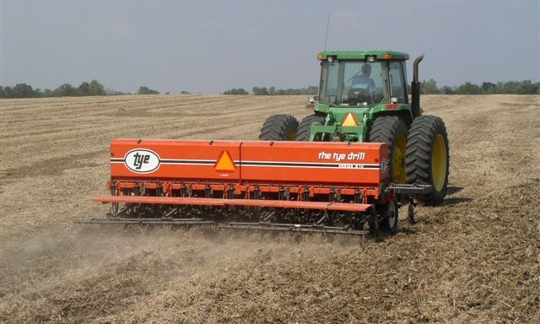
Planners and producers should refer to the Midwest Cover Crop Council -Cover Crop Decision Tool (see references) to select cover crop species that have the greatest potential for sequestering Nitrogen and can be successfully established within the cropping windows available. Table 1 below contains the approved species and rate ranges, however for a more precise rate especially for mixes to optimize planting and cropping conditions with the IN-NRCS-FOTG Seeding Tool (see references).
Fix Atmospheric Nitrogen into the Soil: Legume cover crops have potential to produce most or all of subsequent crop nitrogen needs. Assure the specific strain of rhizobium bacteria inoculant is applied to the seed just before planting. Use only fresh inoculant (check the date). See Reference: (SARE) “Managing Cover Crops Profitably, 3rd edition", page 122, Nodulation and page 70, chart 3B Planting. Fixation is maximized from more growth through earlier planting dates and/ or later termination.
Improve Soil Health and Function: Cover crops have the potential to increase soil organic matter, penetrate compaction layers and increase the biodiversity of organisms in the soil. This increase is greater where less tillage is used to establish the cover crop and more growth is allowed prior to spring termination. Studies show that tillage prior to seeding may cause a greater net loss of carbon than the cover crop can regain. Increased bio- diversity from cover crops can increase populations of beneficial organisms such as earthworms and fungi which greatly increase nutrient cycling, aeration and improve soil structure. Select cover crop species to achieve one or more of the following: a species mix with different growth curves, maturity dates and/ or physiology.

SITE PREPARATION AND WEED CONTROL

Preceding crop residues should be spread evenly before seeding or following aerial seeding. Existing weeds should be eliminated by applying herbicide if sufficient pressure exists to hinder the establishment and growth of the cover crop or perennial weeds are present. Work with a local consultant or Purdue Extension Specialist to determine the best herbicide combination and timing. Follow the manufacturer's label rates and guidelines when applying herbicides.

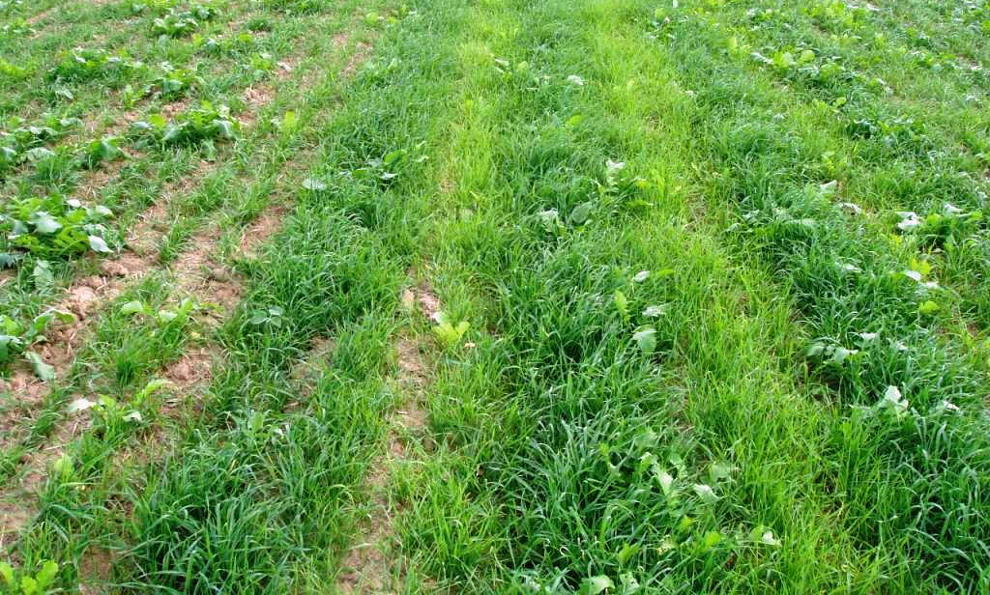
Herbicide residue or carryover from previous crop can cause problems with cover crop establishment. Refer to the Ohio and Indiana Weed Control Guide-Pub WS-16 for Guidelines to avoid carryover problems. (See references)

Seeding
Selection of Plant Materials: Use certified (Tested) seed that has been cleaned and is free from noxious weeds. Select a species that is adaptable to the desired planting date with ample time to germinate and reach an acceptable growth stage prior to a killing freeze or adequate root growth to survive the winter. See Table 1 “Typical Cover Crops”. Select a species or mix which will meet the intended purpose and maximize the desired benefits. (See references).
No-till Seeding: Ensure the drill or planter (15” rows or less) is designed to handle the crop residues and seed being planted (especially important for small seeds or mixture with varying size and/or density). Set and operate the drill/planter to provide an ideal planting depth. Since a planter is capable of much more precise spacing and depth control, it is possible to reduce overall seeding rates by up to 50%. To meet criteria for soil erosion and soil quality at least two species of cover crops should be planted either in alternating rows or combined together.
Broadcast Seeding: Seed may be broadcast using a broadcast seeder if capable of spreading seed in a uniform manner. Pre-mixing the seed with needed fertilizer or pelletized lime and utilizing an airflow applicator can also be effective.
Aerial Seeding: Over seeding into existing crop in August through September can be an effective method of establishment to acquire more fall growth. Seed spread on the surface is more rain dependant and generally requires a higher seeding rate. Applying cover crop just ahead of soybean leaf drop will aid in mulching the seed and conserving moisture. Results are dependent on adequate rainfall.

Lime and Fertilizer: Fertilizer is not recommended (this includes nitrogen) for the establishment of the cover crop, but may be used to increase biomass production on poor or damaged sites. The cover crop may be used to sequester or trap nutrients from manure or fertilizer applied for the subsequent crop. Lime application in conjunction with a cover crop is advantageous to improve soil quality benefits where pH is less than 6.4. Apply all soil amendments where possible, prior to seedbed preparation, or before planting if a no-till drill is used.

termination

For most cropping systems, it is not desirable to allow the cover crop to produce seed. Harvest for grain or forage is not a purpose of this practice standard. When applicable, ensure cover crops are managed and are compatible with crop insurance and /or USDA Program criteria.

Use of Herbicides: If the cover crop is to be terminated with herbicides, assure that timing and selection of herbicides achieve a complete kill. Translocated herbicides will normally perform better under conditions that are ideal for active growth. A minimum daytime temperature above 55° and night time temperature above 45° is needed for good translocation. During cool weather periods, application should be made during the warming time of day (i.e. 9:00am-3:00pm). Avoid tank mixing herbicides that are antagonistic to translocation. Follow all federal, state, and local guidelines as well as the manufacturer's label rates and guidelines when applying herbicides. For additional information on herbicide controls, contact a local consultant or Purdue Extension Specialist.

Always apply herbicides according to labeled directions. (See references).

Mechanical: Most cereal grains are easily terminated by mowing, crimping, or tillage once the cover crop has reached a reproductive growth stage.
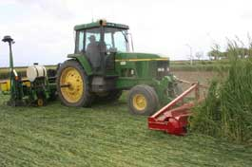

OPERATION AND MAINTENANCE
The cover crop should be integrated as a part of a conservation cropping system with practices such as: Continuous No-till/Strip-till, Mulch-Till, Nutrient Management, Pest Management and Waste Utilization.

Table 1 – Cover Crop Species

Typical Winter Cover Crops
Plant Species | Seeding Rate  For Pure Stands  (lbs/Ac of PLS^{1,3}) | Seeding Dates (see also tools in references)  North of I-70 South of I-70
Annual Ryegrass 12 - 20 8/15 to 10/1 8/15 to 10/10
Cereal Grains
Cereal Rye 45 - 64 8/1 to 10/31 8/15 to 11/10
Winter Wheat² 50 - 70 FFD² to 10/15 FFD² to 10/31
Spring Oats 40 - 50 8/15 to 9/15 8/15 to 9/30
Winter Triticale 45- 70 8/1 to 10/15 8/15 to 10/31
Legumes⁴:
Hairy Vetch 30-40 8/1 to 9/15 8/1 to 9/30
Field Peas/ Winter Peas 50 drilled, 70 broadcast 8/1 to 9/15 8/1 to 9/30
Cow Peas 40 drilled, 70 broadcast 7/1 to 9/1 7/1 to 8/15
Crimson clover 8 drilled, 10 broadcast 7/1 to 9/10 7/1 to 9/15
Other:
Brassicas-Rape/Canola/Turnips 2-4 drilled, 6 broadcast 8/15 to 9/15 8/1 to 9/30
Oil Seed (Daikon type) Radish 8 drilled, 10 broadcast 8/15 to 9/15 8/1 to 9/30
Mixtures: See References for Tools
Typical Summer Cover Crops
Plant Species | Seeding Rate  For Pure Stands (lbs/Ac of PLS^{1,3}) | Seeding Dates  North of I-70 South of I-70
Spring Oats 40-60 3/15 to 5/31 3/1 to 5/15
Annual Ryegrass 12 - 20 3/15 to 6/15 3/1 to 5/31
Sudangrass & Sorghum- Sudangrass 17-20 5/15 to 6/15 5/1 to 5/31
Red Clover⁴ (spring seeded) 3 - 6 3/15 to 5/31 3/1 to 5/15
Red Clover⁴ 4 - 6 12/15 to 3/15 12/15 to 2/15
(Frost-seeded into fall planted small grains)
Buckwheat 25 - 30 6/15 to 7/15 7/1 to 8/1
Millet 2-4 5/15 to 7/15 5/1 to 8/1
¹ Pure Live Seed (PLS)
² Not to be planted prior to Fly Free Date (FFD).
³ Use the upper seeding rates for aerial application and as low as 50% of the lowest rate for narrow row planters.
⁴ Seed size within a species can vary greatly. Rate can be adjusted up for large seed and down for small. Inoculate seed.
More detailed mixes can be tailored using NRCS Seeding Tool for Cover Crops. See references.

REFERENCES
Midwest Cover Crop Council – Selector Tool http://www.mccc.msu.edu/SelectorTool/2011CCSelectorTool.pdf
Cover Crop Field Guide http://www3.ag.purdue.edu/agry/dtc/Pages/CoverCropsFG.aspx

Sustainable Agriculture Research and Education (SARE) “Managing Cover Crops Profitably" explores how and why cover crops work and provides all the information needed to build cover crops into any farming operation. http://www.sare.org/publications/

USDA-Natural Resources Conservation Service, Field Office Technical Guide (FOTG) Section IV, Seeding Tool http://www.nrcs.usda.gov/technical/efotg/

Purdue University- “Weed Control Guide for Indiana and Ohio” http://btny.purdue.edu/Pubs/WS/WS-16/

