Natural Resources Conservation Service
Cover Crop
Illinois Conservation Practice Job Sheet 340

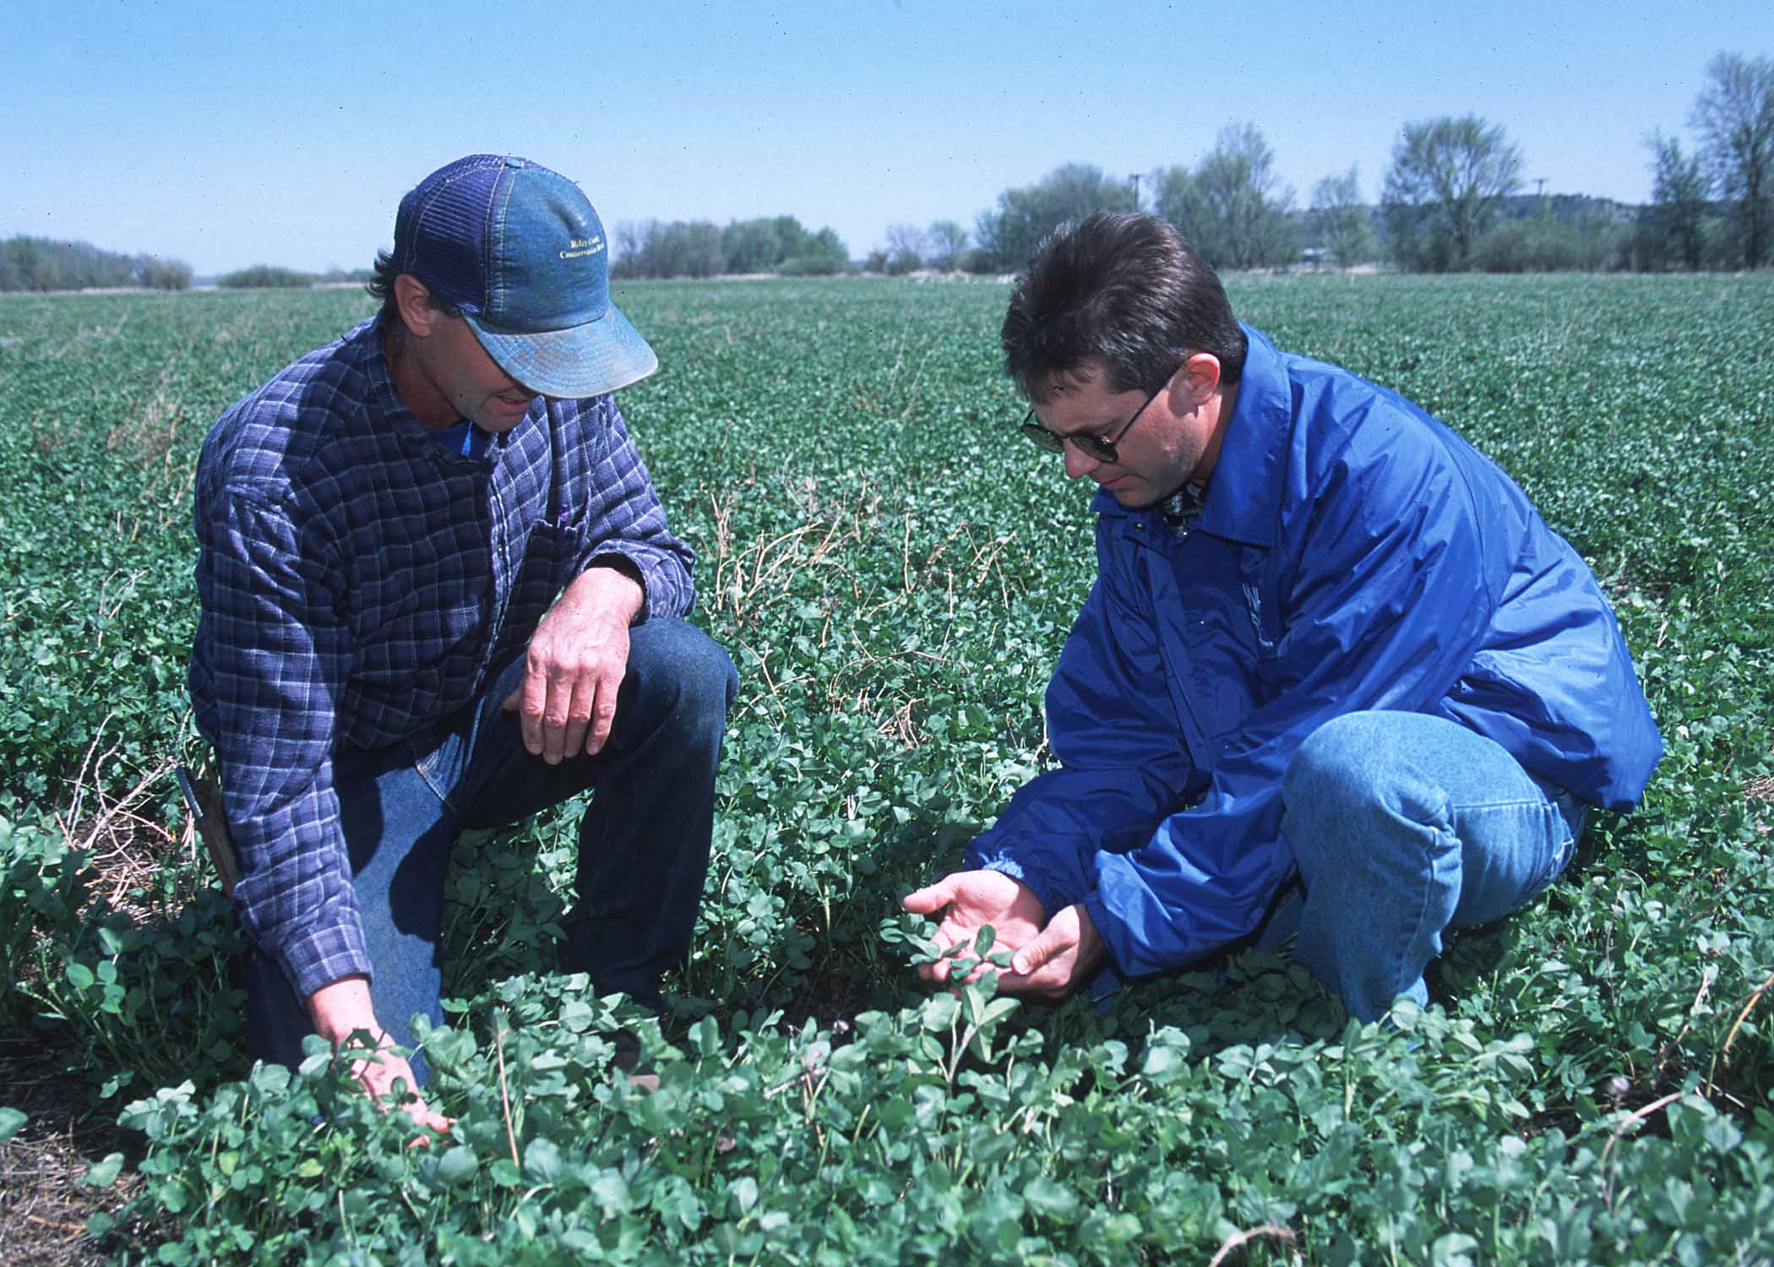

Definition
Crops including grasses, legumes, and forbs for seasonal cover and other conservation purposes.

Purpose (Check all Planned Purposes)

Reduce erosion.
Increase soil organic matter.
Capture, recycle, or redistribute nutrients in
the soil profile
Promote biological nitrogen fixation and
reduce energy use.
Increase biodiversity.
Suppress weed growth.
Manage soil moisture.
Manage and reduce soil compaction.
Where Used

Cover crops are most often used in conjunction with annual cropping systems along with other practices such as Conservation Cropping Rotation (Practice Code 328), Residue Management (Practice Codes 329, 345) and other practices. The practice is used to control erosion, absorb excess plant nutrients, improve soil structure, and suppress weed growth. The Illinois Cover Crop Selection Tool can be used to determine suitable cover crops for the selected purpose(s). https://www.midwestcovercrops.org/covercroptool/

For: | Date:
Field(s): | Farm #: Tract #:

Seeding and management or attach output from the Illinois Cover Crop Selection Tool
https://www.midwestcovercrops.org/covercroptool/

Field | Species | Seed Rate  lb./ac  PLS | Seeding Date(s) | Method of Seeding:  D=Drill  B=Broadcast  A=Aerial | Date or Growth Stage to terminate  Cover Crop | Termination Method:  H=Herbicide  T=Tillage  W=Winter Kill

OPERATION AND MAINTENANCE:
- Control growth of the cover crop to reduce competition from volunteer plants and shading.
- When seeding legumes, ensure the proper inoculate is used at planting time. It is best to inoculate just prior to planting.
- Establish the cover crop within the stated time period and maintain until the stated time/growth stage.

Additional Guidance:

I certify that this practice, as implemented, meets NRCS standards and specifications.

_____________________________________________ __________________________
Planner Signature Date

Note: Make pen and ink changes to any specifications that were changed during implementation and attach supporting documentation (e.g. seed bills, cover crop selector toll printouts, photos, etc.) to the Job Sheet. All deliverables as shown in the statement of work are to be documented.

USDA – NRCS IS AN EQUAL OPPORTUNITY PROVIDER AND EMPLOYER
Helping People Help the Land

