***Ecological Site Description***

**Cherty Limestone/Dolomite Exposed Backslope Woodland F115BY046MO**

* (*Quercus stellata - Quercus marilandica /Rhus aromatic/Schizachyrium scoparium*)
* (post oak-blackjack oak/aromatic sumac/little bluestem)

An Ecological Site Description (ESD) is a reference document of ecological knowledge regarding a particular land area (ecological site). An ESD describes ecological potential and ecosystem dynamics of land areas and their potential management. Ecological sites are linked to soil survey map unit components, which allows for mapping of ecological sites. (***NOTE:*** *This is a “provisional” ESD, and is subject to change. It contains basic ecological information sufficient for conservation planning and land management in Missouri. After additional information is developed and reviewed, a “Certified” ESD will be published and will be available via the Web Soil Survey* [*http://websoilsurvey.nrcs.usda.gov*](http://websoilsurvey.nrcs.usda.gov) *.*)

**Major Land Resource Area:** 115B – Central Mississippi Valley Wooded Slopes, Western Part

**Introduction**

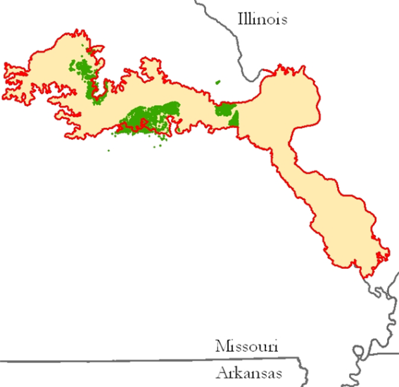The Central Mississippi Valley Wooded Slopes, Western Part (area outlined in red on the map) consists mainly of the deeply dissected, loess-covered hills bordering the Missouri and Mississippi Rivers as well as the floodplains and terraces of these rivers. It wraps around the northeast corner of the Ozark Uplift, and constitutes the southern border of the Pre-Illinoisan-aged till plain. Elevation ranges from about 320 feet along the Mississippi River near Cape Girardeau in the south to about 1,020 feet on the highest ridges near Hillsboro, MO in the east. Local relief varies from 10-20 feet in the major river floodplains, to 50-100 feet in the dissected uplands, with bluffs of 200 to 350 feet along the Mississippi and Missouri Rivers. Underlying bedrock is mainly Ordovician-aged dolomite and sandstone, with Mississippian-aged limestone north of the Missouri River.

Chert Limestone/Dolomite Exposed Backslope Woodlands are within the green areas on the map. They occupy the southerly and westerly aspects of steep, dissected slopes, and are mapped in complex with the Chert Limestone/Dolomite Protected Backslope Forest ecological site. These sites are in scattered upland locations in the Missouri River watershed. Soils are typically moderately deep over limestone/dolomite bedrock, with gravelly surfaces. Limestone/Dolomite Exposed Backslope Glade/Woodlands are often found associated with this ecological site.

**Physiographic Features**

This site is on backslopes with slopes of 15 to 70%. It is on exposed aspects (south, southwest, and west), which receive significantly more solar radiation than the protected aspects. The site receives runoff from upslope summit and shoulder sites, and generates runoff to adjacent, downslope ecological sites. This site does not flood.

**Soil Features**

These soils are underlain with limestone and/or dolomite bedrock at 20 to 40 inches deep. The soils were formed under woodland vegetation, and have thin, light-colored surface horizons. Parent material is slope alluvium over residuum weathered from limestone and dolomite, overlying limestone bedrock. They have gravelly to very gravelly silt loam surface layers, with clayey subsoils that have moderate to high amounts of chert gravel and cobbles. These soils are not affected by seasonal wetness. Soil series associated with this site include Bardley and Gatewood.

**Ecological Dynamics**

The shallow and droughty soils (20-40” to bedrock) of Cherty Limestone/Dolomite Exposed Backslope Woodlands limits the growth of trees and supports an abundance of native grasses and forbs in the understory. Wild fires played an important role in the maintenance of these ecological sites with these sites, along with adjacent glades and woodlands burned at least once every 5 years.

These periodic fires kept woodlands open, removed the litter, and stimulated the growth and flowering of the grasses and forbs. They also further limited the growth and dominance of trees, especially Eastern redcedar. Rather short (35-50’) post oak dominated an open overstory, with occasional blackjack and black oak. Shrubs were scattered within a dense matrix of native grasses and forbs. During fire free intervals, woody species, such as especially eastern red cedar and black hickory, would have increased and the herbaceous understory diminished. But the return of wild fires would have opened the woodlands up again and stimulated the abundant ground flora.

Cherty Limestone/Dolomite Exposed Backslope Woodlands were also subjected to occasional disturbances from wind and ice, as well as grazing by native large herbivores. Wind and ice would have periodically opened the canopy up by knocking over trees or breaking substantial branches off canopy trees. Grazing by native herbivores would have effectively kept understory conditions more open, creating conditions more favorable to oak reproduction and sun-loving ground flora species.

Domestic grazing has also impacted these communities, further diminishing the diversity of native plants and introducing species that are tolerant of grazing, such as redcedar, buckbrush, gooseberry, and Virginia creeper. Grazed sites also have a more open understory. In addition, soil compaction and soil erosion due to uncontrolled grazing can be a problem and lower productivity. Timber harvest is very limited on these sites. Removal of the younger understory by chainsaw and the application of prescribed fire have proven to be effective restoration management practices.

**State and Transition Diagram**

**Cherty Limestone/Dolomite Exposed Backslope Woodland**

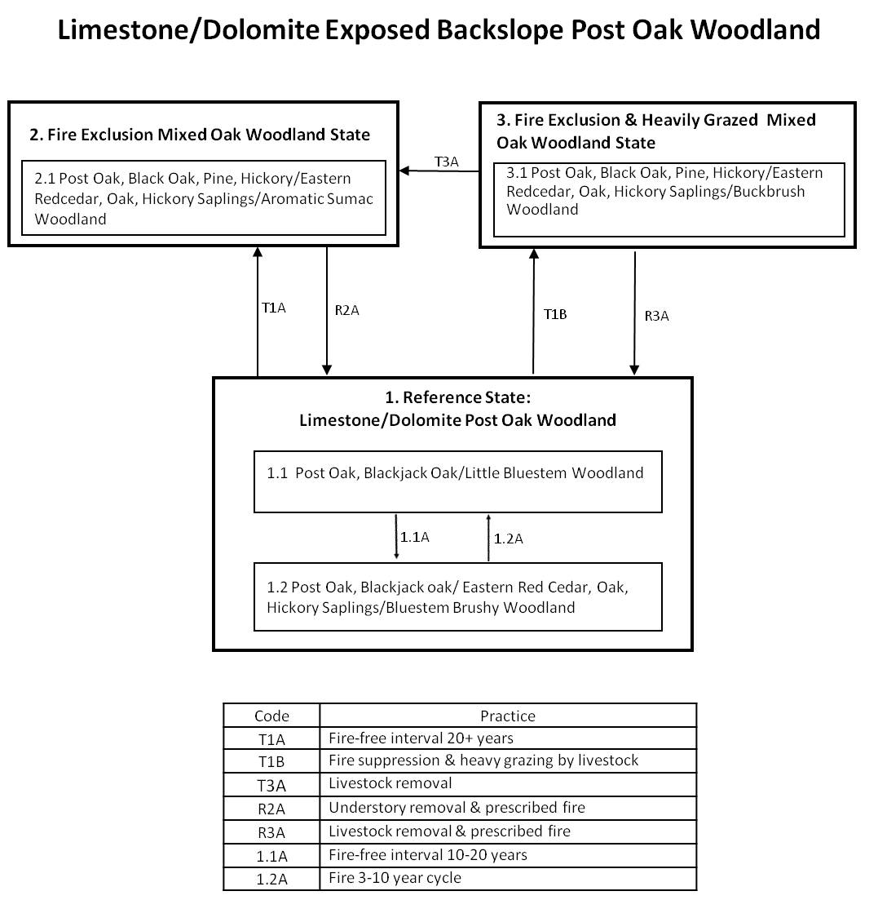

**Reference State 1**

Historically, these woodlands occurred in association with dolomite glades on exposed slopes in the valleys of most major rivers of the region. The restricted soil depth, droughty conditions, and native grasses made them susceptible to frequent fires, once every 3-5 years. Consequently, fire-tolerant post oak and blackjack oak dominated the open-canopy overstory, and the understory consisted of a dense cover of native grasses and forbs (community 1.1). Tree height was 30-50 feet, and canopy closure 20-80%. During fire-free intervals, eastern red cedar, along with hickories and oak sprouts, increased in abundance and competed with the herbaceous ground flora, creating brushy woodland (community 1.2). However, the return of fire would re-open the woodland and promote the ground flora.

**Fire Exclusion Mixed Oak Woodland State 2**

Fire suppression over the last 50 years has allowed these open woodlands to become dense with less fire-tolerant trees and saplings such as eastern red cedar, black oak, and hickory (and pine within its range). The dense, shaded conditions and lack of fire has caused the ground flora to decrease in cover and diversity. Aromatic sumac often forms a dense shrub understory under these conditions. However, many of the original herbaceous species persist as small plantlets or in the seed bank. Consequently, thinning of the woody species and the re-introduction of fire has shown these communities to be exceptionally resilient, and a return to the reference condition is possible.

**Fire Exclusion and heavily Grazed Mixed Oak Woodland State 3**

In addition to fire exclusion, many of these sites have been subjected to heavy grazing by domestic livestock. Like State 2, these areas are dense and shady with a diminished ground flora. In addition, grazed areas exhibit a lower diversity of native ground flora species and an increased abundance of eastern redcedar and other invasive natives such as buck brush. Like State 2, restoration using thinning and fire is possible, but will take longer and require more effort. Restricting livestock access will be necessary for successful restoration.

**Reference State Plant Community**

Canopy Trees

|  |  |  |  |
| --- | --- | --- | --- |
| **Common Name** | **Botanical Name** | **Cover % (low-high)** | **Canopy Height (ft)** |
| CHINKAPIN OAK | *Quercus muehlenbergii* | 10-40 | 40 |
| BLUE ASH | *Fraxinus quadrangulata* | 10-20 | 30 |
| POST OAK | *Quercus stellata* | 10-20 | 40 |
| BLACK OAK | *Quercus velutina* | 5-10 | 40 |

Shrubs

|  |  |  |  |
| --- | --- | --- | --- |
| **Common Name** | **Botanical Name** | **Cover % (low-high)** | **Canopy Height (ft)** |
| CAROLINA BUCKTHORN | *Rhamnus caroliniana* | 10-20 | 10 |
| FRAGRANT SUMAC | *Rhus aromatica* | 10-20 | 3 |
| DWARF HACKBERRY | *Celtis tenuifolia* | 10-20 | 5 |

Forbs

|  |  |  |
| --- | --- | --- |
| **Common Name** | **Botanical Name** | **Cover % (low-high)** |
| HOARY PUCCOON | *Lithospermum canescens* | 5-20 |
| BRISTLY SUNFLOWER | *Helianthus hirsutus* | 5-20 |
| MILK VETCH | *Astragalus distortus* | 5-20 |
| STARRY CAMPION | *Silene stellata* | 5-20 |
| GOLDEN ALEXANDER | *Zizia aurea* | 5-20 |
| BUTTERFLY WEED | *Asclepias tuberosa* | 5-20 |
| SCURFY PEA | *Psoralidium tennuiflorum* | 5-20 |
| BLAZING STAR | *Liatris aspera* | 5-20 |
| YELLOW STAR GRASS | *Hypoxis hirsuta* | 5-20 |
| NARROW-LEAVED BLUETS | *Hedotis nigricans* | 5-20 |
| PRAIRIE DOCK | *Silphium trebinthinaceum* | 5-20 |

Grasses and sedges

|  |  |  |
| --- | --- | --- |
| **Common Name** | **Botanical Name** | **Cover % (low-high)** |
| LITTLE BLUESTEM | *Schizachyrium scoparium* | 10-30 |
| WOODLAND BROME | *Bromus pubescens* | 10-20 |
| SIDEOATS GRAMA | *Bouteloua curtipendula* | 10-30 |
| CAREX | *Carex digitalis* | 10-20 |

**Site Interpretations**

***Wildlife Species***

Oaks provide hard mast; scattered shrubs provide soft mast; frequent bedrock outcrops provide reptile habitat and a more patchy ground flora; sedges and native cool-season grasses provide green browse; native warm-season grasses on dry sites provide cover and nesting habitat; and forbs provide a diversity and abundance of insects.

Birds associated with Limestone/Dolomite Woodland/Glades are Indigo Bunting, Red-headed Woodpecker, Eastern Bluebird, Northern Bobwhite, Summer Tanager, Eastern Wood-Pewee, Whip-poor-will, Chuck-will’s widow, and Red-eyed Vireo.

Reptiles and amphibians associated with this ecological type include: ornate box turtle, northern fence lizard, five-lined skink, coal skink, broad-headed skink, six-lined racerunner, western slender glass lizard, prairie ring-necked snake, flat-headed snake, rough earth snake, red milk snake, western pygmy rattlesnake, and timber rattlesnake.

**Glossary**

*Alfic* – soil that has a clay-dominated subsoil (argillic horizon) with moderate to high amounts of bases such as calcium, and were typically formed under woody vegetation.

*Backslope* – a hillslope profile position that forms the steepest and generally linear, middle portion of the slope.

*Backswamp –* marshy or swampy, depressed areas of flood plains between natural levees and valley sides or terraces

*Calcareous* – the presence of calcium carbonate in the soil parent material within the rooting zone; relatively alkaline

*Claypan* – a dense, compact, slowly permeable layer in the subsoil having much higher clay content than the overlying material

*Chert* – hard, extremely dense or compact crystalline sedimentary rock, consisting dominantly of interlocking crystals of quartz

*Cliff* – a significant vertical, or near vertical, rock exposure

*Dolomite* – a type of sedimentary rock that is a carbonate mineral composed of calcium magnesium carbonate

*Drainageway* – the upper most reach of a stream channel system characterized by little meandering

*Dry* – a site where soil moisture is limiting during the growing season; low available water capacity

*Dune* – a low mound, ridge, bank or hill of loose, wind-blown sand

*Exposed* – steep, south and west-facing slopes, which are warmer and drier than other slope aspects

*Flatwoods* – a type of woodland that occurs on soils with a root restricting subsoil layer within 20 to 30 inches, resulting in very slow runoff and ponding that remains saturated for most of the winter and early spring months but dries out and becomes very dry in the summer months; plants that grow there must be adapted to both conditions

*Floodplain* – the nearly level plain that borders a stream and is subject to inundation under flood-stage conditions

*Footslope* – a hillslope position at the base of a slope where hillslope sediment (colluvium) accumulates

*Forest* – a vegetative community dominated by trees forming a closed canopy and interspersed with shade-tolerant understory species

*Fragipan* – a dense, brittle subsoil horizon that is extremely hard and compact when dry

*Glade* – open, rocky, barren vegetative community dominated by drought-adapted forbs and grasses, typically with scattered, stunted woody plants

*Igneous* –bedrock formed by cooling and solidification of magma. Granite and rhyolite are typical igneous bedrocks in Missouri

*Limestone* – a type of sedimentary rock composed largely of calcium carbonate

*Loess* – material transported and deposited by wind and consisting predominantly of silt-size particles

*Loamy* – soil material containing a relatively equal mixture of sand and silt and a somewhat smaller proportion of clay

*Marsh* – a type of wetland that is dominated by herbaceous rather than woody plant species

*Moist* – a site that is moderately well to well drained and has high available water capacity, resulting in a well-balanced supply of moisture (neither too dry nor too wet).

*Mollic* – soil that has a thick, dark surface horizon and was typically formed under prairie vegetation

*Mudstone* – blocky or massive, fine-grained sedimentary rock in which the proportions of clay and silt are approximately equal

*Natric* – a soil horizon that displays a blocky, columnar, or prismatic structure and has a subhorizon with an exchangeable-sodium saturation of over 15%

*Outwash* – stratified sediments of sand and gravel removed or “washed out” from a glacier by melt-water streams

*Pinery* – a vegetative community within the historic pine range in Missouri that has shortleaf pine as a significant tree species

*Prairie* – a vegetative community dominated by perennial grasses and forbs with scattered shrubs and very few trees

*Protected* – steep, north- and east-facing slopes, which are cooler and moister than other slope aspects

*Residuum* - unconsolidated, weathered, or partly weathered mineral material that accumulates by disintegration of bedrock in place

*Riser* – a component of terraces and flood-plain steps consisting of the steep side slope; the escarpment

*Riverfront* – a vegetative community in the floodplain immediately adjacent and generally parallel to a river or stream channel

*River hills* – a geographic area characterized by thick, dissected loess deposits, formed immediately adjacent to the edges of the Missouri and Mississippi River floodplains

*Sandy* – a coarse-sized soil containing a large mixture of sand and gravels and a somewhat smaller proportion of silts and clays with excessive drainage

*Sandstone* – a sedimentary rock containing dominantly sand-size particles

*Savanna* – grasslands interspersed with open-grown scattered trees, groupings of trees, and shrubs

*Shale* – a sedimentary rock formed from clay, silty clay, or silty clay loam deposits and having the tendency to split into thin layers

*Shallow* – a site with bedrock within 20 inches of the surface

*Shoulder* – the slope profile position that forms the convex surface near the top of a hill slope; it comprises the transition zone from summit to backslope

*Sinkhole* – a closed, circular or elliptical depression, commonly funnel-shaped, characterized by subsurface drainage and formed either by dissolution of the surface of underlying bedrock or by collapse of underlying caves within bedrock

*Summit* – the top or highest area of a hillslope

*Swale* –shallow, closed depressions irregularly spaced across a floodplain or terrace with an irregularly undulating surface.

*Swamp* – an area of low, saturated ground, intermittently or permanently covered with water, and predominantly vegetated by shrubs and trees.

*Talus* – rock fragments of any size or shape (usually coarse and angular) derived from and lying at the base of a cliff or very steep rock slope.

*Terrace* – a step-like surface, bordering a valley floor that represents the former position of a flood plain

*Till* – dominantly unsorted and unstratified soil material deposited directly by a glacier

*Ultic* – soil that has a clay-dominated subsoil (argillic horizon) with low amounts of bases such as calcium, and were typically formed under woody vegetation

*Upland* – a general term for the higher ground of a region, in contrast with a low-lying, adjacent land such as a valley or floodplain

*Wet* – a somewhat poorly, poorly or very poorly drained site that has an oversupply of moisture during the growing season

*Woodland* – a highly variable vegetative community with a canopy of trees ranging from 30 to 100 percent closure with a sparse midstory and a dense ground flora of grasses, sedges and forbs