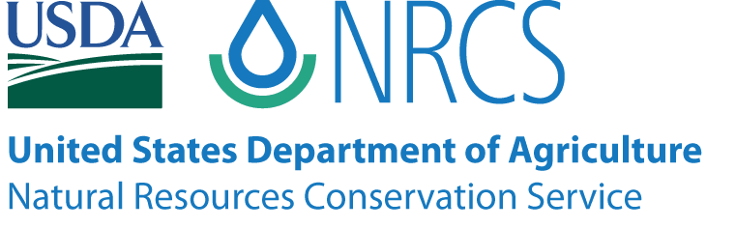

Maine NRCS
Off-Site Wetland Mapping Conventions

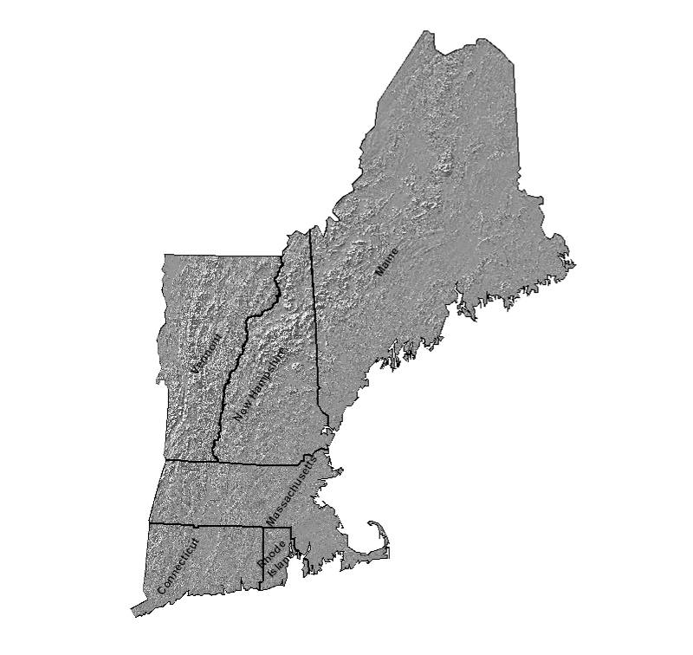

Revised February, 2010

Maine NRCS
Off-Site Wetland Mapping Conventions
for
Food Security Act Requirements

PURPOSE

These off-site mapping conventions outline the procedures and methods NRCS will use in Maine to prepare wetland determinations on agricultural lands and non-agricultural lands for the Wetland Conservation (swampbuster) provisions of the Food Security Act of 1985 or when providing financial or technical assistance through its programs. Mapping conventions are specific procedures developed to interpret off-site and remotely sensed data to assist in identifying wetlands. These mapping conventions were developed to ensure consistency among the NRCS field offices. All lands, regardless of size, on which NRCS makes wetland determinations, will have a label attached in accordance with these mapping conventions.

All certified wetland determinations will be verified onsite by a qualified professional unless the NRCS in that state determines an on-site visit is not needed.

GENERAL INFORMATION

Off-site wetland determination reference materials include: soil survey maps, hydric soil lists, National Wetlands Inventory (NWI) maps, State wetland mapping, USGS topographic maps, FEMA flood maps, Farm Service Agency (FSA) color slides, color infrared (CIR) aerial imagery, color or black and white aerial imagery, precipitation data to determine normal weather conditions at the time of aerial imagery, biological growing season maps, and personal knowledge of an area. Aerial imagery and soil survey maps will be the primary off-site data sources used. The other reference materials listed above will be used to: (1) support the soil survey information. (2) locate hydric inclusions in predominantly non-hydric soil mapping units, (3) provide information on past hydrology and cropping history, and (4) help identify wet signatures on imagery.

Certified wetland determinations will be made on a field basis and only under the following circumstances:
- In response to forms AD-1026 or NRCS-CPA-38 completed by a USDA participant for the CLU/field(s) identified.
- A potential wetland conservation violation has been reported and a FSA-569 has been requested/obtained from the FSA-CED. When a potential violation has been reported, an effort shall be made to identify the exact location of the alleged violation. A certified determination will be made only on that field.
- Other USDA program policies require a certified wetland determination.
- When a potential violation has been noted during an on-site technical review or other site visit and a FSA-569 has been requested/obtained from the FSA-CED.
- In response to financial and technical assistance available through NRCS programs authorized by law, including Executive Order 11990.

NRCS will document each certified wetland determination on form NRCS-CPA-026 and on an image-base maintained by USDA. A copy of the form and imagery will be provided to FSA, and all parties having a legal interest in the property. The written notification to landowner and operator will include all appropriate appeal rights.

OFF-SITE MAPPING PROCEDURES

All wetland determinations will begin by using the off-site procedures identified below.

Step 1. – Review the official Soil Survey for hydric soil map units, map units with inclusions of hydric soils, and conventional water feature symbols such as wet spot, stream, etc. Some soil surveys were done using very poor aerial imagery or at a small scale. Do not rely solely on the absence of mapped hydric soils as a non-indicator of potential wetlands; review all off-site wetland determination reference materials.

Step 2. – Review all available aerial imagery for cropping history and wetland signatures. Use the NRCS National Water and Climate Center’s wetland climate tables (http://www.wcc.nrcs.usda.gov/climate/wetlands.html) to help assess the wetland signatures on the imagery. Document on form NRCS-CPA-32. NOTE: a 1985 aerial photo must be reviewed to determine land use as of December 23, 1985 (or closest date available).

Step 3. – Review additional wetland determination tools such as NWI maps, State wetland mapping, FSA color slides, etc., as needed.

Step 4. – Based on the above assessments, use the following mapping conventions to determine the preliminary wetland label.

Step 5. – Verify the determination with an on-site visit, when on-site confirmation is required.

* * * * *
MAPPING CONVENTIONS

Agricultural Land - Cropland

Cropland refers to land which is used for the production of an agricultural commodity. Cropland also includes pasture or hayland in a commonly used rotation with an agricultural commodity.

Cropland which was planted to an agricultural commodity before 12/23/85 + as of 12/23/85 did not support woody vegetation + contains hydric soil map units + with or without wet signature on CIR imagery, color or black and white imagery, or other imagery or color slides + does not flood or pond for 15 consecutive days during the growing season in most years = PC.
Requires documentation that the site does not pond or flood for greater than 15 consecutive days during the biological growing season in most years. PC label is valid as long as the field remains in agricultural use, even though all 3 wetland criteria may return. If the land changes to a non-agricultural use, the PC determination is no longer applicable.

Cropland which was planted to an agricultural commodity before 12/23/85 + as of 12/23/85 did not support woody vegetation + contains non-hydric map units with hydric inclusions + wet signature on CIR imagery, color or black and white imagery, or other imagery or color slides + does not flood or pond for 15 consecutive days during the growing season in most years = PC.
Requires documentation that the site does not pond or flood for greater than 15 consecutive days during the biological growing season in most years. PC label is valid as long as the field remains in agricultural use, even though all 3 wetland criteria may return. If the land changes to a non-agricultural use, the PC determination is no longer applicable.

Cropland which was planted to an agricultural commodity prior to 12/23/85 + as of 12/23/85 did not support woody vegetation + contains hydric soil map units and/or non-hydric map units with hydric inclusions + wet signature on CIR imagery, color or black and white imagery, or other imagery or color slides + may pond or flood for at least 15 consecutive days during the growing season in most years = FW or PC.
PC requires documentation that the site does NOT pond or flood for greater than 15 consecutive days during the biological growing season in most years. PC label is valid as long as the field remains in agricultural use, even though all 3 wetland criteria may return. If the land changes to a non-agricultural use, the PC determination is no longer applicable.
FW requires documentation that the site ponds and/or floods for greater than 15 consecutive days during the growing season in most years to meet hydrology criteria. If baseline functions and values are documented, and the site remains in agricultural use, the label is valid even though all 3 wetland criteria may return.
FW + five years without annually planted crop + remains in agricultural use, managed as pasture or hayland at least once in five years = FWP.
FW + no documented baseline functions and values, + five years without annually planted crop + not managed as pasture or hayland at least once in last five years = W.

Cropland which was NOT planted to an agricultural commodity prior to 12/23/85 + contains hydric soil map units and/or non-hydric map units with hydric inclusions [OR non-hydric soil map units + wet signature on CIR imagery, color or black and white imagery, or other imagery or color slides] + no manipulation after 12/23/85 + was manipulated and was managed as pasture or hayland prior to 12/23/85 = FWP.

Cropland which was NOT planted to an agricultural commodity prior to 12/23/85 + contains hydric soil map units and/or non-hydric map units with hydric inclusions OR non-hydric soil map units + wet signature on CIR imagery, color or black and white imagery, or other imagery or color slides + no manipulation after 12/23/85 + herbaceous wetland farmed under natural conditions = W.

Cropland which was NOT planted to an agricultural commodity prior to 12/23/85 + contains hydric soil map units and/or non-hydric map units with hydric inclusions + no wet signatures + manipulated prior to 12/23/85 = NW (for Swampbuster only).

Cropland which was planted to an agricultural commodity prior to 12/23/85 + no hydric soil map units + no wet signature = NW.

Cropland which was NOT planted to an agricultural commodity prior to 12/23/85 + no hydric soil map units + no wet signature = NW.

Agricultural Land - Pasture and Hayland

Pasture and hayland are agricultural lands which are managed for grazing, hay or forage production. The term “permanent pasture or permanent hayland” refers to those fields which are not in a commonly used rotation with an agricultural commodity. These fields may be used to produce commodity crops if no further manipulations of a wetland occur.

Permanent pasture or permanent hay land + contains hydric soil map units + with or without wet signature on CIR imagery, color or black and white imagery or other imagery or color slides + has not been abandoned = FWP.
FWP + abandoned + no baseline functions and values documented =W.
FWP + abandoned + with baseline functions and values documented = FWP.

Permanent pasture or permanent hayland + contains non-hydric soil map units with possible hydric inclusions + wet signature on CIR imagery, color or black and white imagery, or other imagery or color slides + has not been abandoned = FWP.
FWP + abandoned + no baseline functions and values documented =W.
FWP + abandoned + with baseline functions and values documented = FWP.
Permanent pasture or permanent hayland + non-hydric soil map units with possible hydric inclusions OR non-hydric map units + no soil survey wetness symbols + no evidence of manipulation + no wet signature on CIR imagery, color or black and white imagery, or other imagery or color slides = NW.

Permanent pasture or permanent hayland + was planted to an agricultural commodity prior to 12/23/85 + contains hydric soil map units and/or non-hydric units with possible hydric inclusions + with or without wet signature + manipulation prior to 12/23/85 = PC.
PC label is valid as long as the field remains in agricultural use, even though all 3 wetland criteria may return. If the land changes to a non-agricultural use, the PC determination is no longer applicable.

Agricultural Land, Non-Forested

This category includes orchards, vineyards, areas which support wetland crops such as cranberries, and other lands used to produce or support the production of livestock, where the natural vegetation has been removed..

Other agricultural land-Non-Forested (excluding pasture, hayland and cropland) + contains hydric soil map units or non-hydric map units with possible hydric inclusions OR has wet signature on CIR imagery, color or black and white imagery, or other imagery or color slides = W.

Other agricultural land-Non-Forested (excluding pasture, hayland, and cropland) + non-hydric soil + no wet signature on CIR imagery, color or black and white imagery, or other imagery or color slides + no soil survey wetness symbols + no evidence of drainage = NW.

Non-Agricultural lands on hydric soils

This category includes lands which are not used for the production of food, fiber, or horticultural crops; used for haying or grazing; or, left idle in accordance with USDA program requirements. For the purposes of these off-site methods, forest land and abandoned agricultural lands (except Prior Converted cropland) are non-agricultural lands.

Forest land Forest land + hydric soil¹ or USGS "wet symbol" or NWI wetland = W

Idle land
Idle land + hydric soil¹ or USGS "wet symbol" or NWI wetland = W

Pond
Pond on non-hydric soil = AW

Pond on hydric soil¹ or USGS "wet symbol" or NWI wetland = W
Beaver Impoundment

Beaver impoundment on hydric soil¹ = W

Beaver impoundment on any soil + existing for five years = W

¹ Any soil map units that have hydric major components or hydric minor components; or, areas with soil survey special features symbols for marsh or swamp, miscellaneous water, wet spot, spring, or closed depression or sinkhole

Manipulated Wetlands

This category includes activities that do not violate the Swampbuster provisions of the Food Security Act although they may be regulated and may require permits from other agencies.

Any wetland that was manipulated after 12/23/1985, but the manipulation did not make production of an agricultural commodity possible = WX.

Converted Wetlands

A converted wetland occurs when a wetland is manipulated to the extent that production of an agricultural commodity is possible, even if such a crop is not actually planted. Manipulation may include removal of woody vegetation and/or modification of wetland hydrology by draining, filling, ditching, etc.

Any wetland that was manipulated between 12/23/1985 and 11/28/1990 with or without permanent grass, which made the production of an agricultural commodity crop possible = CW.
Any further conversion of a CW after 11/28/1990 will result in a CW+year.

Any wetland that was manipulated after 11/28/1990 which made the production of an agricultural commodity crop possible = CW+year.

Any wetland that was converted after 12/23/1985 where the conversion or production of an agricultural commodity was a consequence of an incorrect NRCS determination = CWTE.
Use of CWTE requires approval and input of State Conservationist for determining the degree of investment and subsequent authorized cropping. If a small investment was made to convert the wetland, then no agricultural production is allowed if site was formerly W. Production is allowed if site was formerly FW. If substantial investment has been made, no restrictions are placed on the converted wetland.

Any wetland that was converted after 12/23/1985 by a third party without the person’s collusion, fraud, scheme or device = TP.
Use of TP may be used in situations where the USDA applicant is leasing the land (application is not the landowner) and the landowner converts the wetland without the applicant’s knowledge or awareness of USDA benefit implications.

Any wetland that was manipulated prior to 12/23/1985 + has not been used for cropland + wetland criteria have not returned = NW.

Wetlands

Wetlands created by beaver activities, human activities or other natural events + any soil map unit + present for at least five years = W.

Wetlands created by human activities on non-hydric soil or in active (i.e., not abandoned) prior converted cropland, or in other non-wetland situations = AW.

Historical Labels

CC = Commenced Conversion. Historically used for labeling portions of tracts where conversion began before December 23, 1985, and was approved by FSA, and conversion was completed by January 1, 1995. This symbol is no longer used.

CWNA = Converted Wetland for Non-Agricultural Use. Historically used for labeling portions of tracts that were converted after November 28, 1990 for purposes other than for making agricultural production possible. This symbol is no longer used.

NI = Not Inventoried. Historically used for labeling portions of tracts that were not field checked for specific wetland labels. This symbol is no longer used.

OW = Other Waters of the US. Historically used for labeling concentrated flow within agricultural fields that were determined to be other waters of the US and thus subject to Section 404 of the Clean Water Act. In New England, the US Army Corps of Engineers determines Other Waters of the US. This symbol is no longer used.

KEY TO SYMBOLS

AW = Artificial Wetland
CC = Commenced Conversion (historical label)
CW = Converted Wetland
CW+year = Converted Wetland and year of conversion after 1990
CWNA = Converted Wetland for Non-Agricultural Use (historical label)
CWTE = Converted Wetland Technical Error
FW = Farmed Wetland
FWP = Farmed Wetland Pasture or Hayland
NI = Not Inventoried (historical label)
NW = Non-wetland
OW = Other Waters of the US (historical label)
PC = Prior Converted Cropland
TP = Third Party Conversion
W = Wetland
WX = Manipulated wetland after 1985

NOTE: The above wetland determination symbols will not appear on FSA digital maps. FSA uses red, yellow and green symbols to represent different categories of wetland determinations. For more information, refer to the fact sheet in the Appendix.

* * * * *
ADDENDUM

The following statement should be included in all written wetland determination documentation provided to USDA participants.

THIS CERTIFIED WETLAND DETERMINATION/DELINATION HAS BEEN CONDUCTED FOR THE PURPOSE OF IMPLEMENTING THE WETLAND CONSERVATION PROVISIONS OF THE FOOD SECURITY ACT OF 1985. THIS DETERMINATION/DELINEATION MAY NOT BE VALID FOR IDENTIFYING THE EXTENT OF THE CORPS OF ENGINEERS’ (COE) CLEAN WATER ACT JURISDICTION FOR THIS SITE. IF YOU INTEND TO CONDUCT ANY ACTIVITY THAT CONSTITUTES A DISCHARGE OF DREDGED OR FILL MATERIAL INTO WETLANDS OR OTHER WATERS, YOU SHOULD REQUEST A JURISDICTIONAL DETERMINATION FROM THE LOCAL OFFICE OF THE COE PRIOR TO STARTING THE WORK.

* * * * *
GLOSSARY

Agricultural Commodity: Any crop planted and produced by annual tilling of the soil, including tilling by one-trip planters, or sugarcane. (180-V-NFSAM, Fourth Ed., Amend. 4, Jan. 2008, Part 514.2)

Agricultural Land, Non-Forested: Land that is intensively used and managed for the production of food and fiber to the extent that the natural vegetation has been removed and cannot be used to determine whether the area meets applicable hydrophytic vegetation criteria in making a wetland determination.

Areas that meet the above definition may include intensively used and managed cropland, hayland, pasture land, orchards, vineyards, and areas which support wetland crops (e.g., cranberries, taro, watercress, rice). For example, lands intensively used and managed for pasture or hayland where the natural vegetation has been removed and replaced with planted grasses or legumes such as ryegrass, bluegrass, or alfalfa are considered agricultural lands, non-forested. Agricultural lands, non-forested do not include range lands, forest lands, wood lots, or tree farms.

Certified Wetland Determination: A wetland determination made by the Natural Resources Conservation Service that is of sufficient quality to make a determination of ineligibility for program benefits under the Food Security Act of 1985

Field: A part of a farm which is separated from the balance of the farm by permanent boundaries such as fences, roads, permanent waterways, woodlands, croplines (in cases where farming practices make it probable that such croplines are not subject to change), or other similar features. (180-V-NFSAM, Third Ed., Amend. 2, Nov. 1996, Part 525.0)

Non-Agricultural lands: Lands which are not used for the production of food, fiber, or horticultural crops; used for haying or grazing; or, left idle in accordance with USDA program requirements. For the purposes of these off-site methods, forest land and abandoned agricultural lands (except Prior Converted cropland) are non-agricultural lands.

Qualified Professional: A NRCS employee who, through training and experience, has demonstrated the knowledge and skill to conduct wetland determinations/delineations and whose name is listed on the roster of qualified employees in the state.

Wetland Delineation: Outlining the boundaries of a wetland determination on aerial photography, digital imagery, and other graphic representation of the area; or on the land. (180-V-NFSAM, Fourth Ed., Amend. 4, Jan. 2008, Part 514.2)

Wetland Determination: A technical decision regarding whether or not an area is a wetland, including identification of appropriate wetland labels and acres of each label. Wetland determinations are recorded on NRCS-CPA-026e. (180-V-NFSAM, Fourth Ed., Amend. 4, Jan. 2008, Part 514.2)

Wetland Hydrology Criteria: The hydrology criteria for wetlands is as follows:
- Inundation (flooding or ponding) occurs for 7 consecutive days or longer during the growing season in most years (50% chance or more); or
- Saturation at or near the surface occurs for 14 consecutive days or longer during the growing season in most years (50% chance or more). Soils may be considered to be saturated to the surface when the water table is within:
- 0.5 ft of the surface for coarse sand, sand or fine sandy soils; or
- 1.0 ft of the surface for all other soils.
(180-V-NFSAM, Third Ed., Amend. 2, Nov. 1996, Part 527.4)

Wetland Signature: the indication left in a field, recorded by imagery, of ponding, flooding or saturation for sufficient duration, during the biological growing season, to meet wetland hydrology criteria. Wetland signatures in New England include signs of a water-stressed crop, no crop growing, or standing water. A wet signature on a fallow or recently tilled field is identified by a darker reflection than the surrounding soil color reflection. Textural or color contrast against an otherwise uniform area may indicate wetness. Tire marks, mowing, and plowing patterns which show avoidance of a wet feature on the map are other signs that may be indicative of wetness. Stereoscopic aerial photography can show relief and vegetation strata.

* * * * *
APPENDIX

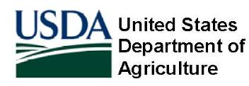 | Fact Sheet  Wetland Determination Identifiers | September 2007

Overview
As part of the U.S. Department of Agriculture's (USDA) continuous effort to use digital mapping technology to increase efficiency, the Farm Service Agency (FSA) and the Natural Resources Conservation Service (NRCS) have recently revised the symbols used to identify wetland determination locations on FSA maps. The NRCS makes wetland determinations based on landowners' requests. FSA marks these sites with symbols on the maps for producers' ease of use.

Revised Symbols
In the past, FSA maps contained labels and delineations of NRCS wetland determinations. When FSA started using digital geographic data for maps, blue dots were used to represent wetland determinations. Since May 2007, FSA and NRCS have updated map symbology to give producers a more detailed representation of the wetland determinations present on their land.

Now, USDA's wetland point symbols, called wetland determination identifiers, indicate on digital maps the approximate location of NRCS wetland determinations.

Red, yellow and green symbols (no longer blue dots) represent different categories of wetland determinations and a legend provides an explanation of the various levels of use that are allowed on these wetlands:
- Red octagons represent ‘Restricted Use’ determinations; upside-down yellow triangles represent ‘Limited Restrictions’ determinations; and green circles represent ‘Exempt from Conservation Compliance Provisions’ determinations.
- Restricted Use = W (Wetland); CW, CW+YR (Converted Wetland + Year); AW/W (Artificial Wetland/Wetland); GFW, GFW+YR (Good Faith Wetland + Year); RSW, RSW+YR (Restored Wetland + Year); RPW (Replacement Wetland)
- Limited Restrictions = FW (Farmed Wetland); FWP (Farmed Wetland Pasture); CWNA (Converted Wetland, Non-ag Use); AW/FW (Artificial Wetland/Farmed Wetland); CWTE (Converted Wetland Technical Error); TP (Third Party Conversion); WX (Manipulated Wetland) MW; CMW (Minimal Effect Wetlands); MIW, MWM (Mitigation Wetlands); NI (Not Inventoried); OW (Other Waters); Easement

Exempt from Conservation Compliance Provisions = PC (Prior Converted); NW (Non Wetland); PC/NW (Prior Converted/Non Wetland); CC (Commenced Conversion); NW/NAD (Non Wetland, National Appeal Decision); AW (Artificial Wetland)
Wetland Policy Unchanged
As noted on the producer maps, the change to the current wetland determination identifiers does not change the wetland determinations made by NRCS, nor does it change FSA or NRCS wetland policy or regulations. The wetland determination identifiers do not represent the size, shape, exact location or exact category of wetland determination. The maps are used primarily for producer information when producers make crop acreage reports, change field boundaries or request a map of their land from FSA. The maps are not used for wetland conservation compliance. USDA participants remain responsible for self-certifying compliance with USDA wetland conservation provisions

Examples of FSA Producer Maps with Varying Wetland Symbols

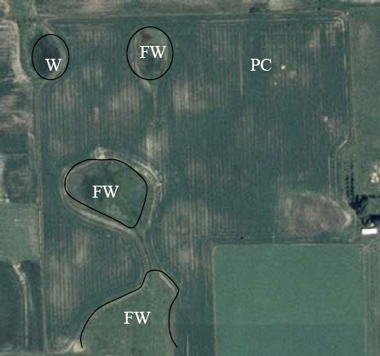
Initial FSA Map

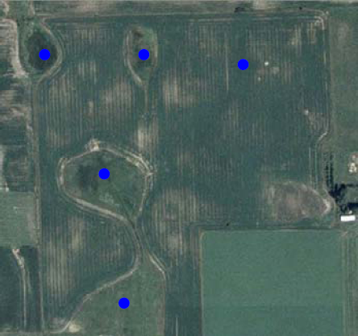
FSA Map with Blue Dots

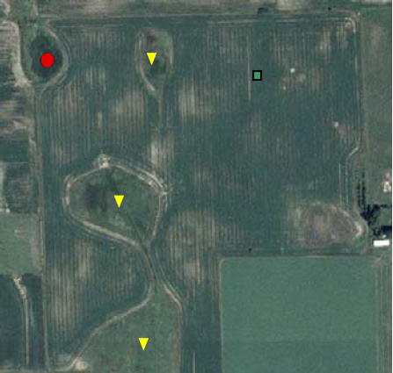
Current FSA Map

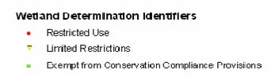
Sample Legend

For More Information
The maps with the new identifiers are not the official USDA wetland determination maps. Producers who have questions about the size, shape, exact location or exact category of the determination should refer to the determination information previously provided to them by NRCS on a form (CPA-026), or contact their local NRCS office. Both FSA and NRCS have the USDA wetland determination maps available for landowners and operators. Copies of these original maps have previously been provided to all producers. Producers may request a replacement copy through their local FSA or NRCS office if they no longer have the original.

The U.S. Department of Agriculture (USDA) prohibits discrimination in all its program and activities on the basis of race, color, national origin, age, disability, and where applicable, sex, marital status, familial status, parental status, religion, sexual orientation, genetic information, political beliefs, reprisal, or because all or part of an individual’s income is derived from any public assistance program. (Not all prohibited bases apply to all programs.) Persons with disabilities who require alternative means for communication of program information (Braille, large print, audiotape, etc.) should contact USDA’s TARGET Center at (202) 720-2600 (voice and TDD). To file a complaint of discrimination, write to USDA, Director, Office of Civil Rights, 1400 Independence Avenue, S.W., Washington, D.C. 20250-9410, or call (800) 795-3272 (voice) or (202) 720-6382 (TDD). USDA is an equal opportunity provider and employer.

