
Fence
Maine Conservation
Practice Job Sheet Code 382

General Criteria

Fencing materials and type and design of fence installed shall be of appropriate quality and durability to meet the practice lifespan. Materials will be new.
Exterior fences must be permanent. Based on intended use, interior fences may be permanent or temporary. The fence design and installation should be appropriate for management objectives and shall follow all federal, state and local laws and regulations. The lifespan of this practice is 20 years.
Fences shall be positioned to facilitate management requirements. Ingress/egress features such as gates and cattle guards shall be planned
Height, size, spacing and type of materials used will provide the desired control, life expectancy, and management of animals and people of concern.
Fences shall be designed in accordance with NRCS Code 382 Fence Specification Guide and Appendices. All fences shall be appropriately braced in accordance with the Guide.
Barbed wire shall not be electrified nor insulated for electrification.

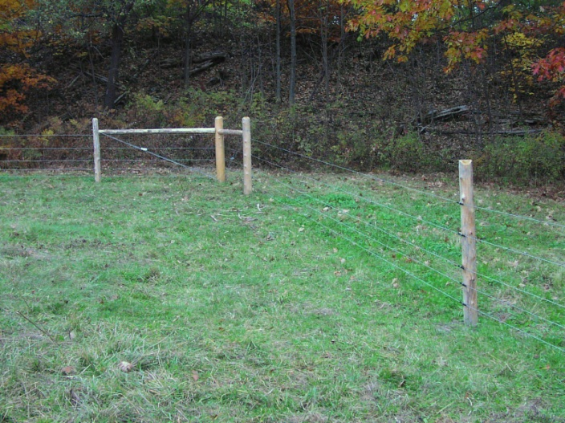

Manufacturers’ guidelines shall be adhered to during installation and shall meet the minimum construction specifications for each type of fence to ensure proper component assembly.
Plastic insulators used on electric fence shall be of high quality and have UV protection.
Considerations

Consider making accommodations for the passage of wildlife, particularly where known travel ways for species of concern exist.

Consider leaving a tractor/mower width around the outside of perimeter fence to facilitate operation and annual inspection and maintenance.

When planning fences that will control livestock in winter, consider depth (height) of normal snow pack and increase fence height accordingly as desired. Note: electric fence may not perform as desired in snow.

For most effective grounding and functioning of electric fence chargers, install ground rods in areas with moist soils.

Specifications

***Call 1-888-DIG-SAFE prior to beginning fence construction to ensure that work area is free of utilities.***

See attached plan map, Specifications, and standard drawings for more details. Specifications are prepared in accordance with NRCS Maine Fence (382) practice standard, and the Specification Guide.

Additional estimation and technical assistance may be acquired from NRCS and/or the fence manufacturer/supplier.

OPERATION AND MAINTENANCE
Regular inspection of fences will be part of an ongoing maintenance program. Inspection of fences after storms and other disturbance events is necessary to insure the continued proper function of the fence. Posts that heave over winter should be re-set.

Maintenance and repairs will be performed in a timely manner as needed, including tree/limb removal. Loose and lost staples and broken tie wires should be replaced during the fence inspections. Remove and properly discard all broken fencing material and hardware.

All necessary precautions should be taken to ensure the safety of construction and maintenance crews. Eye and hand protection should be worn during construction and maintenance.
At least once annually, remove brush and heavy grass and weeds growing near or on the fence line to reduce physical pressure on the fence, maintain visibility for fence maintenance, and in the case of electrified fence, prevent voltage loss. For electric fence with low wires, this task may need to be done several times throughout the growing season.
High Tensile smooth wire fences can be loosened in the fall and re-tightened in the spring to prevent excess pressure from shrinkage and snow loads. Tension in the fencing should be checked and the fence repaired when the sag in the wire is excessive.
Do not burn weeds and grasses under and around fences as fire destroys the galvanized coating and accelerates rusting.
Gates should be kept closed and latched to prevent swinging and sagging.
Electric Fences – Check the voltage regularly. If voltage is insufficient, determine the cause and correct it. During dry weather, ground rods may need water applied to the soil around them. Weeds and plants in contact with the fence will also reduce voltage.
Signs posted on the fence should be inspected to determine if they are still visible and legible. Damaged and illegible signs should be replaced with new signs.

Location of Brace Assemblies

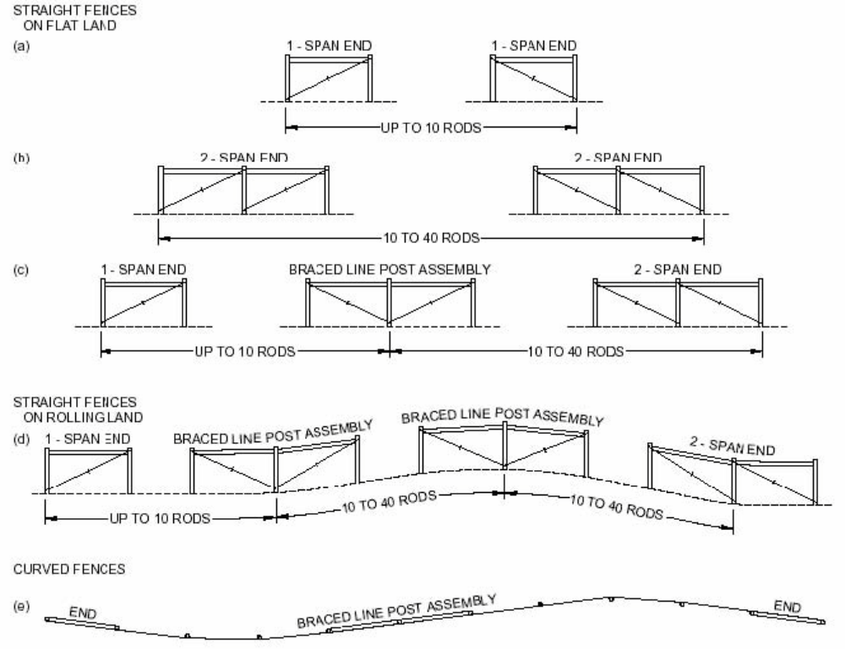

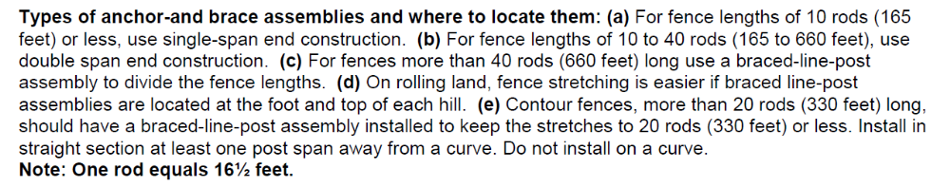

Client: | Purpose (Pasture Management, Resource Protection, Safety,etc):
Client: | Type of Livestock:
Tract: Field(s): | Function of Livestock Fence (use a separate sheet for each fence type if different materials will be used):
Designed By: Date: | Interior | Temporary
Approved By: Date: | Exterior | Permanent

Type of Fence: | Other Info: (see 382 Specification Guide for guidelines)
HT Smooth Electric Wire  HT Smooth Non-Electric  Woven Wire  Barbed Wire  Other : | Fence Height: inches  Number of Strands:  Wire Spacing (inches from ground):  Number of Gates Planned: |  | Fence Length: feet  Number of Corners:  Number of Ends/Gate Braces:  Number of In-Line (Pull) Assembly Braces:
Post Type: | Post Dimensions: | Post Spacing and Depth:
Black Locust  White Cedar  Tamarack  Pressure treated pine or other Preservative-treated wood  Steel “T” or “U” posts, min. 1.25 lbs per foot.  Live trees in line with fence are acceptable for use as line and/or corner posts in smooth wire fences. Trees must be healthy and a min. of 6 inches in diameter at breast height. Use pressure treated 2.x 4 on tree to attach insulators/staples.  Manufactured post, rod, or batten | Wood Line posts:  Diameter - min. 4 inches  Min. Length = fence height + 2 ft + 3in  L =  Wood Corner, Gate and brace posts:  Diameter - min. 5-6 inches  Min. Length = fence height + 4 ft + 3 in  L =  Steel posts: choose length that will allow for desired fence height when foot plate is buried (18 inches or more).  L = | Line posts maximum of 16 feet  Line posts maximum of 100 feet  Spacers/battens max. of 33 feet  Other – meets manufacturer recommendations (specify):  Wood posts shall be pounded or augered and tamped.  Line posts = 2 feet min. Depth  Corner/End/Brace posts = 4 feet min. Depth
Horizontal Brace Poles* | Diagonal Brace Wire | Electric Insulators
Length – 8-10 feet  Diameter – 4 inches min. | High Tensile, Galvanized Steel, 9 Gauge  OR  12-1/2 Gauge High Tensile, Galvanized, Double Wrapped | Molded plastic; UV light resistant  Manufactured tube type  High Density porcelain

Section Name/Number: | Length Planned:

Specific Requirements for Your Practice:

- Use materials as specified in attached Specification Guide Appendix specific to your fence type. Materials shall be new and of high quality.

- Fence location is indicated on attached map(s).

- Bracing is required at corners, ends, and changes of direction and slope. Locate appropriate bracing in accordance with your NRCS design and/or the Specification Guide.

- Other Notes:

Client: |  |  | Purpose (Pasture Management, Resource Protection, Safety,etc):
 |  |  | Type of Livestock:
Tract: Field(s): |  |  | Function of Livestock Fence (use a separate sheet for each fence type if different materials will be used):
Designed By: Date: |  |  | Interior |  |  | Temporary
Approved By: Date: |  |  | Exterior |  |  | Permanent
 | Type of Fence: | Other Info: (see 382 Specification Guide for guidelines)
 | HT Smooth Electric Wire  HT Smooth Non-Electric  Woven Wire  Barbed Wire  Other : | Fence Height: inches  Number of Strands:  Wire Spacing (inches from ground):  Number of Gates Planned: |  |  | Fence Length: feet  Number of Corners:  Number of Ends/Gate Braces:  Number of In-Line (Pull) Assembly Braces:
 | Post Type: | Post Dimensions: |  | Post Spacing and Depth:
 | Black Locust  White Cedar  Tamarack  Pressure treated pine or other Preservative-treated wood  Steel “T” or “U” posts, min. 1.25 lbs per foot.  Live trees in line with fence are acceptable for use as line and/or corner posts in smooth wire fences. Trees must be healthy and a min. of 6 inches in diameter at breast height. Use pressure treated 2.x 4 on tree to attach insulators/staples.  Manufactured post, rod, or batten | Wood Line posts:  Diameter - min. 4 inches  Min. Length = fence height + 2 ft + 3in  L =  Wood Corner, Gate and brace posts:  Diameter - min. 5-6 inches  Min. Length = fence height + 4 ft + 3 in  L =  Steel posts: choose length that will allow for desired fence height when foot plate is buried (18 inches or more).  L = |  | Line posts maximum of 16 feet  Line posts maximum of 100 feet  Spacers/battens max. of 33 feet  Other – meets manufacturer recommendations (specify):  Wood posts shall be pounded or augered and tamped.  Line posts = 2 feet min. Depth  Corner/End/Brace posts = 4 feet min. Depth
 | Horizontal Brace Poles* | Diagonal Brace Wire |  | Electric Insulators
 | Length: 8-10 feet  Diameter: 3-4 inches min. | High Tensile, Galvanized Steel, 9 Gauge  OR  12-1/2 Gauge High Tensile, Galvanized, Double Wrapped |  | Molded plastic; UV light resistant  Manufactured tube type  High Density porcelain

Section Name/Number: | Length Planned:

Specific Requirements for Your Practice:

- Use materials as specified in attached Specification Guide Appendix specific to your fence type. Materials shall be new and of high quality.

- Fence location is indicated on attached map(s).

- Bracing is required at corners, ends, and changes of direction and slope. Locate appropriate bracing in accordance with your NRCS design and/or the Specification Guide.

- Other Notes:

Practice Checkout and Certification (382)

Field # Section # | Extent/Acres | Date Installed | Date Checked | Remarks/Observations/As built Info

CHECK OUT:

Amount Completed: _____________feet.

Attach photo documentation, including braces.

Remarks/ Deviation from design:

□ Check if completed location deviates from planned location and final practice location has been indicated on plan map.

I have Job Approval Authority and I certify that this practice as applied meets NRCS Standards and Specs.

Approved By: _______________________________ Date: ______________

