Managing Your Woodlands:
A template for your plans for the future

Owner(s) Name(s)
Owner(s) Mailing Address(es)
Owner(s) Phone Number(s)
Owner(s) Email(s)
Owner(s) Signature(s)

Plan Author
Plan Author Mailing Address
Plan Author Phone Number
Plan Author Email
Plan Author Signature

Date of Original Plan Completion Revision date(s)
Please note: Informal updates to the plan can be made with handwritten notes. Be sure to include a date and initial these notes throughout the management plan.


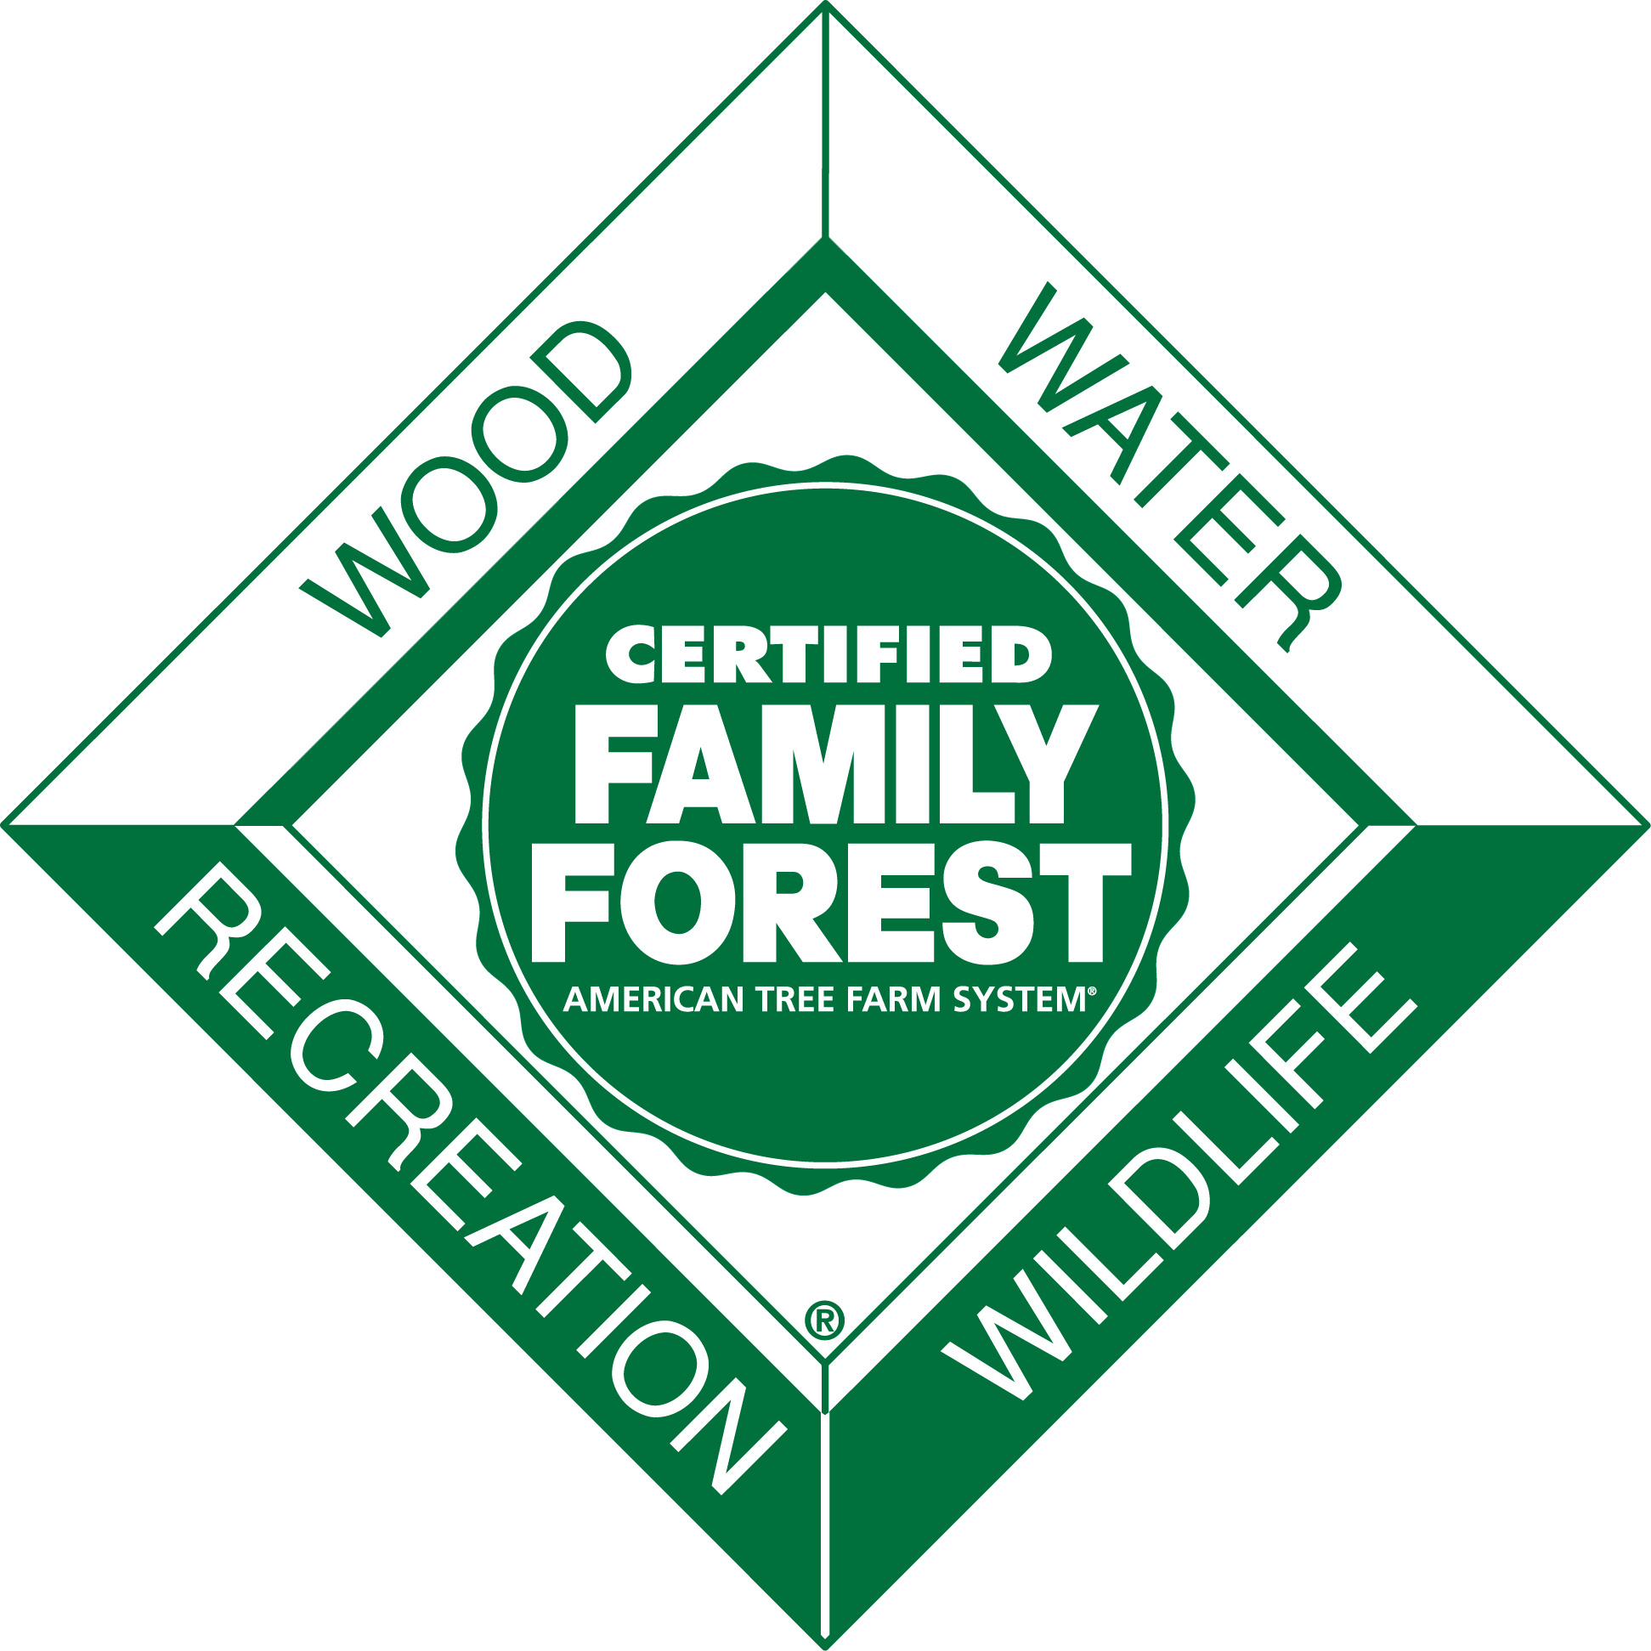
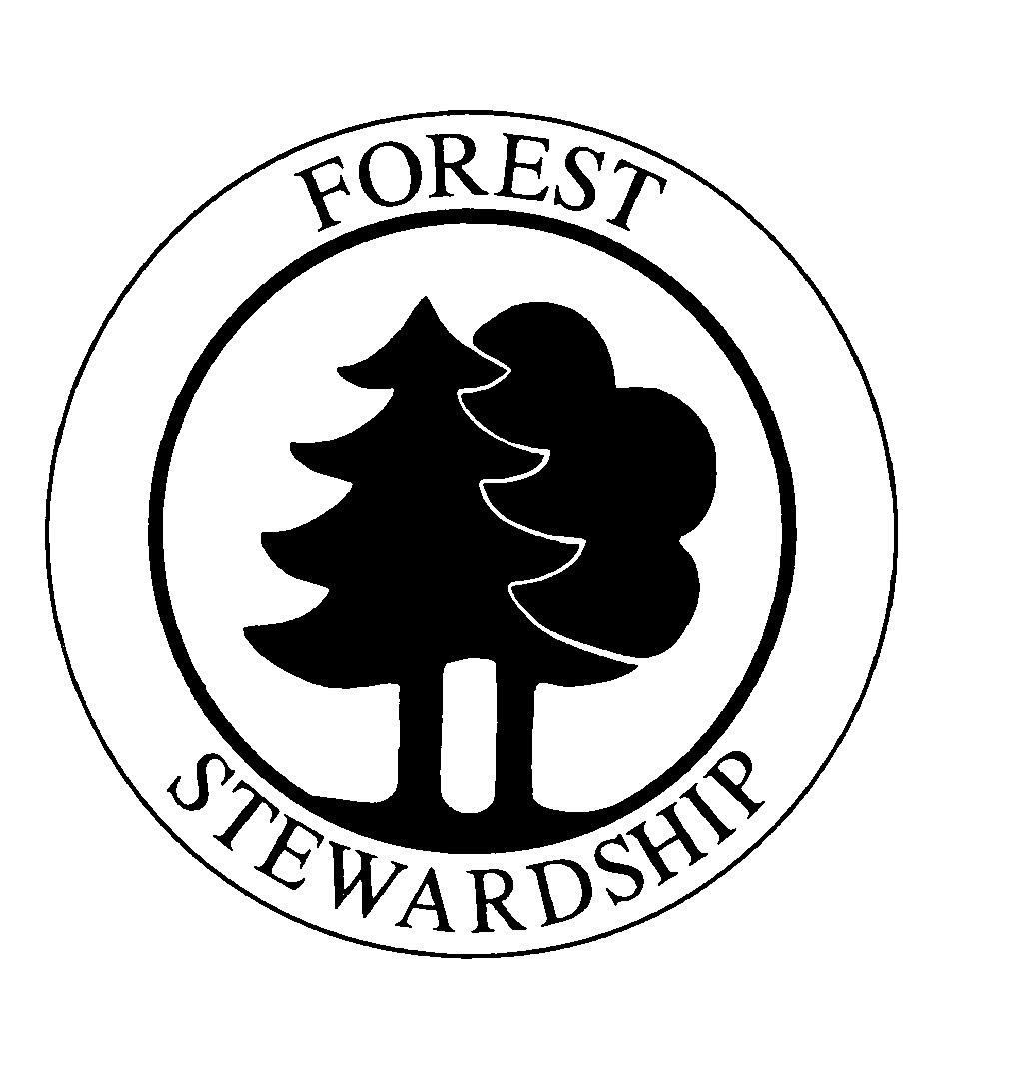
TABLE OF CONTENTS

Property Description 2
Property History 3
Forest Management Goals 3
Property Map(s) 4
Forest Natural Resources Enhancement and Protection 5
Protect Special Sites & Social Considerations 5
Air, Water, and Soil Protection 6
Fish, Wildlife and Biodiversity 7
Management of Forest Resources 7
Other 8
Stand Level Information 9
Stand 1 Objectives 9
Stand 1 Current Conditions 9
Stand 1 Desired Future Stand Condition 10
Stand 1 Forest Management Activities 11
Management Activity Schedule and Tracking 13
Signatures and Approvals 14

This template should be used in association with the landowner and the forester guides which include detailed instructions on how to correctly complete the template to develop a management plan that will meet the requirements for the American Tree Farm System (ATFS), Natural Resources Conservation Service (NRCS) and the US Forest Service. Please refer to the guide when working with your forester or natural resource professional to develop your plan.

This template was developed by the US Forest Service, Natural Resources Conservation Service (NRCS), and the American Forest Foundation’s American Tree Farm System (ATFS) using information from the following state joint Forest Stewardship, ATFS and NRCS templates:
- Mississippi Forest Stewardship Management Plan developed by the Mississippi Stewardship Forest, Mississippi Forestry Commission and the US Forest Service
- Missouri Common Forest Plan Format developed by the Missouri Department of Conservation and NRCS
- Montana Forest Stewardship Plan/Tree Farm Plan developed by the Montana Forest Stewardship Program, Montana Tree Farm Program, Montana State University Extension, Montana DNRC, US Forest Service and NRCS
- Oregon Forest Stewardship Plan Template develop by Oregon State University Forestry Extension Program

Thanks to the following reviewers: Tim Albritton, Dean Berry, Karen Bennett, Jill Butler, Dave Casey, Linda Casey, Jim Cathcart, Bill Chaney, Wade Conn, Dean Cumbia, Robert Etheridge, Jonas Feinstein, Carri Gaines, Nate Goodrich, Andy Henriksen, Joe Holmberg, Debra Huff, Gary Johnson, Bob Logar, Leah MacSwords, Naomi Marcus, Carol Nielsen, James Poole, Robert Radspinner, S.R. Raymond, George Rheinhardt, Steve Smith, Raymond Sowers, Rich Steensma, Pam Synder, Rob Wait, Doug Wallace, and Daniel Wand.

Property Description

Legal property description
Nearest city or town
Tax Parcel Number (optional)

FSA Farm and Tract Numbers (if applicable)

GPS coordinates (optional)

Total ownership acreage Total forested acreage

Total acreage covered by this plan

Number of unique stands of trees

Do you reside on the property?
Yes No

Basic topography (estimate percent of total acreage that is)

Complex topography (many steep ravines and aspects)

Simple topography (few ravines and changes of aspect)

Percent of land that is Flat (<5% grade) ___________ Gentle Slope (6 to 20% grade) _________

Steep Slope (> 21% grade) __________

Road Conditions (check): Excellent (80% accessible) Good (at least 50%)

Fair (at least 25%) Poor (less than 10%)

Estimated improved road length (bulldozed with graveled surface)
Estimated unimproved road length (bulldozed with but original soil/bedrock)
Which watershed is the property located in (include appropriate watershed unit for your state):

Property History

Forest Management Goals

Property Map(s)

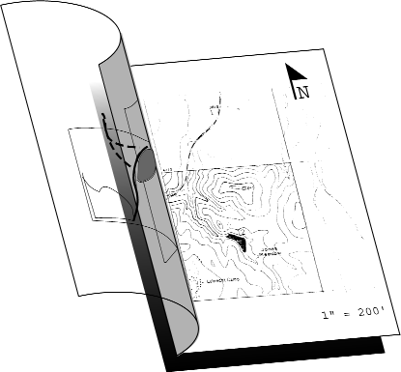

Attach property map(s) here.

Forest Natural Resources Enhancement and Protection
This section relates to the natural resource elements found throughout the entire property. Some of the treatments related to these resources may qualify for federal and state assistance programs. For this section, include appropriate activities and treatments in the Management Activity Schedule and Tracking table as well as on the map(s). Complete the Activity Schedule and draw and label the areas of management on the map if using this plan as part of an assistance program application. There is no need to repeat this information in the stand specific section.

For each resource element, consider:
- What treatments/monitoring/protection are planned?
- When will you implement treatments (season, year), follow-up activities, etc?
- Where will the management take place: entire stand, part of a stand, acres?
- Do you have applicable permits, professional assistance, and applications for the assistance programs?

Protect Special Sites & Social Considerations
Special sites

Adjacent stand or ownership concerns

Recreation

Access

Air, Water, and Soil Protection
What goals do you have, or what steps will you take to conserve, protect and enhance your forest’s air, water and soil resources?
Soil protection

Roads

Streams, wetlands, ponds, lakeshore

Effects of Natural Disasters

Rangeland Resources (if applicable)

(optional) Carbon sequestration

Fish, Wildlife and Biodiversity
Describe the resources on your property and the activities you are planning to accommodate your goals.
Fish &Wildlife

State and Federal threatened or endangered species - plants or animals

Management of Forest Resources

Protection from Pests

Reforestation and Afforestation

(optional) Prescribed Fire/Burns

Management Plan Implementation Constraints

Other

Stand Level Information
For each stand, write what your management objectives are and a brief description of the stand and its current and desired future conditions as well as the management activities. Further detailed inventory/plot data can be included if desired.

Stand 1 Objectives
Stand 1 ___________________ Acres
Objectives:

Stand 1 Current Conditions
General description

Current forest type and current age

Forest Type Age

Bird’s-eye view of current stand condition (check one)
Wild Evenly Evenly spaced Variable density
stand spaced with openings spaced with openings
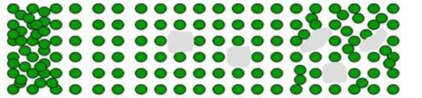
Current spacing (in feet) Large (>9“DBH) (ft) Pole (5-8”DBH) (ft) Seedling (<5”DBH) ____(ft)
Size and shape of openings
Current structure:
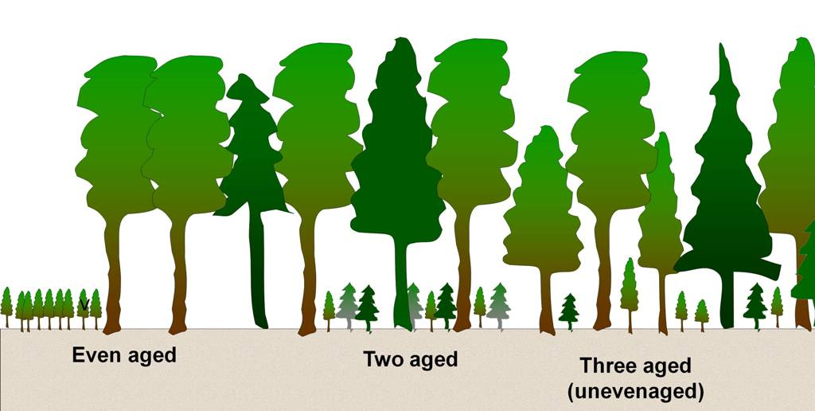
Unevenaged
One canopy layer Two canopy layer Multi-layer/Unevenaged

Stand 1 Desired Future Stand Condition
Desired forest type and expected longevity

Forest Type Age

Desired species to naturally regenerate
Desired species to plant

Bird’s-eye view of desired future stand condition (check one)
Wild Evenly Evenly spaced Variable density
stand spaced with openings spaced with openings
Desired spacing (in feet) Large (>9“DBH) (ft) Pole (5-8”DBH) (ft) Seedling (<5”DBH) ____(ft)
Size and shape of openings

Desired structure:
Unevenaged
One canopy layer Two canopy layer Multi-layer/Unevenaged
Other Desired Stand Descriptions:

Stand 1 Forest Management Activities
If a subset of the stand is being treated, the general area can either be described or identify the impacted areas on your map

Forest Health Management

Harvesting

Slash management

Post harvest activities

Permits

Best Management Practices

Monitoring

Add more pages as needed for each additional stand of trees.

Management Activity Schedule and Tracking
Stand | Unit (Acres/  Feet, etc) | NRCS Practice Code* | Treatment Activity Short Description  (or reference to  description in Plan) | Dates |  | Assistance Program (s) Used? | Net Cash Flow (optional)
 |  |  |  | Planned | Completed | Assistance Program (s) Used? | Cost | Income

Add more pages as needed. *NRCS Practice Code needed if practice will be submitted for a NRCS assistance program, otherwise leave blank.

Signatures and Approvals

Landowner
I have reviewed this plan and believe the management recommendations will help me meet my goals and objectives for my property. I agree to follow this plan to ensure the sustainability of my management.
________________________
Landowner Date

Forest Stewardship Program
I certify that this Forest Management Plan meets the requirements of the federal Forest Stewardship Program.
________________________
Plan Author Date

I certify that this Forest Management Plan meets the requirements of the federal Forest Stewardship Program.
________________________
State Forestry Representative Date

Forest Stewardship Tracking Number: (if necessary) _______

NRCS Assistance Programs
I certify that this Forest Management Plan meets the requirements of the USDA Environmental Quality Incentives (EQIP) Program and/or the Quality Criteria for forest activity plans in Section III of the USDA NRCS Field Office Technical Guide.
_____________________
Technical Service Provider Number Date
.
________________________
District Conservationist Date

American Tree Farm Program
I certify that this Forest Management Plan meets the requirements of the American Forest Foundation’s American Tree Farm System.
_____________________
ATFS Inspecting Forester Number Date

Certified Tree Farm Number: (e.g. AL 1234) _______ Date of ATFS Certification: _______

