
WARM SEASON GRASS ESTABLISHMENT
Cultivar Recommendations & Information for CRP Plantings

Ohio Natural Resources Conservation Service

Ohio Conservation Planning Fact Sheet
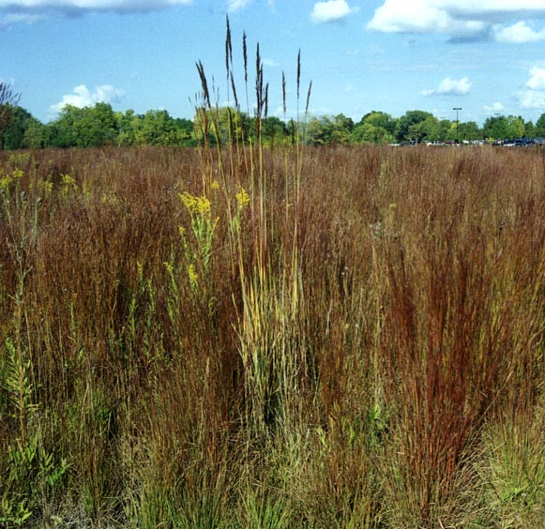
Selection of adapted cultivars is very important in the successful establishment of warm season grasses. Producers would not think of planting corn or soybeans without picking out a named, tested variety that would do well on their farm. However, when it comes to CRP plantings, many producers just plant whatever is available or cheapest, without regard to the cultivar, adaptability or origin of what they are planting. The following information on warm season grass cultivars is intended to assist producers in selecting seed that will increase the success of their CRP plantings. (Recommendations are primarily for CRP cover and do not address all of the other potential considerations for forage, landscape or restoration plantings).

General Guidelines

Variety should be adapted to the warm, humid, high rainfall conditions found in Ohio. Generally cultivars that originated in states closer to Ohio or at the same latitude will be better adapted than those that originated in the arid areas of west or western mid-west. Matching a cultivar to soil type and drainage preference may be as important as point of origin. Finally, local experiences and local performance are an important source of information, as is use of quality local ecotype seed where commercially available.

It is recommended to purchase seed separately and blend yourself as opposed to mixes unless mixes are from a reputable suppliers and state individual cultivars in the mix. Pre-blended mixes may contain bin run seed of unknown origin or variety. Some suppliers may be willing to prepare mixes containing recommended cultivars for Ohio. Purchase certified seed if available, it is more like to be true to cultivar.

Ohio Recommended Cultivars

The following cultivars are recommended for CRP planting in Ohio. Information is based on a literature review, on field experiences of NRCS, Pheasants Forever, ODNR Div. of Wildlife personnel, NRCS plant materials program and others experienced with warm season grasses. The top cultivar (***) in each list is the preferred cultivar for Ohio. Additional suitable cultivars are listed in order of descending preference:

Switchgrass Big Bluestem Little Bluestem Indiangrass SideOats Grama
Blackwell *** Rountree *** Aldous *** Rumsey *** El Reno ***
Shelter Niagara Blaze Oto Butte
Pathfinder Pawnee Camper Holt
Trailblazer Tomahawk
Shawnee
The Natural Resources Conservation Service provides leadership in a partnership effort to help people conserve, maintain, and improve our natural resources and environment.

An Equal Opportunity Employer and Provider
The following cultivars are not recommended (nr) or conditionally recommended (*) for CRP for Ohio, based on past experiences. See the following cultivar descriptions for additional comments on conditional recommendations (keep in mind native prairie enthusiasts have many different and divergent opinions on where cultivars fit or how they perform):

Switchgrass Big Bluestem Little Bluestem Indiangrass SideOats Grama

Cave-In-Rock * Kaw* Camper* Osage* Trailway *nr*
Kanlow* Pawnee* Cimarron *nr* Lometa *nr* Niner *nr*
Nebraska 28* Champ *nr* Pastura *nr* Cheyenne *nr* Pierre *nr*
Alamo *nr* Earl *nr* Kildeer *nr*
Bison *nr*
Bonilla *nr*

Cultivar Specific Information

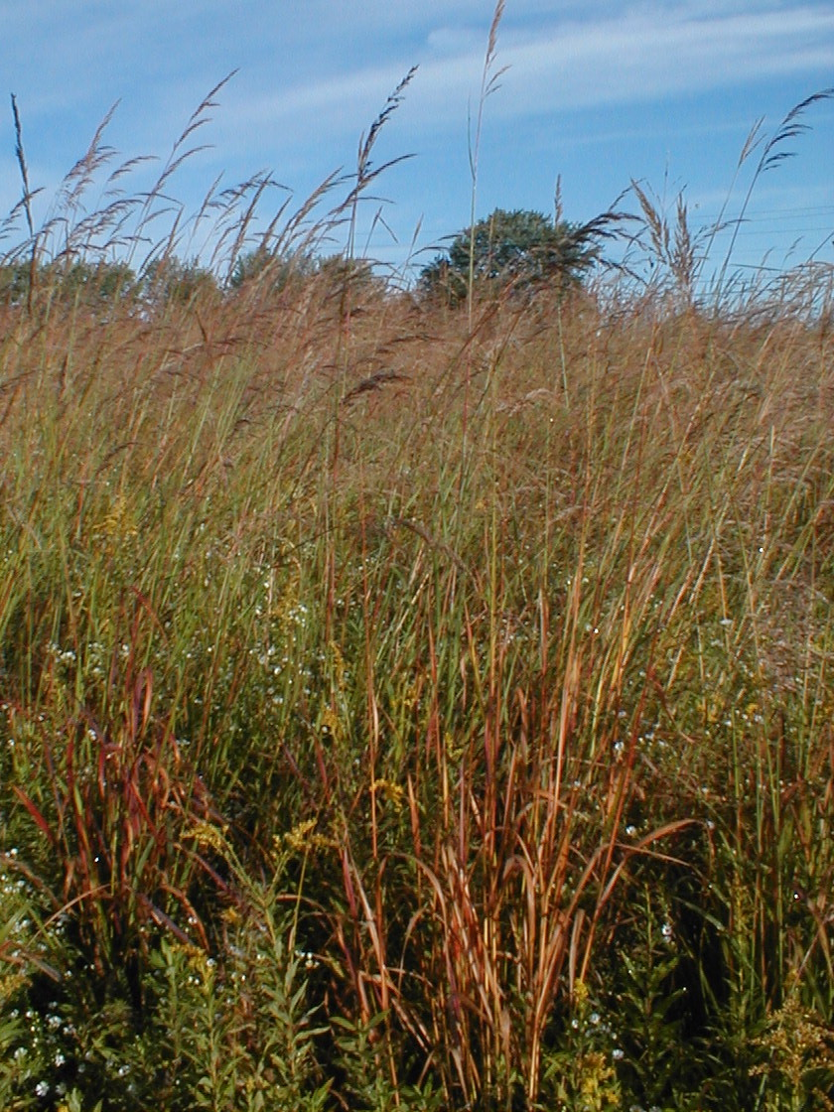
Switchgrass

Blackwell Blackwell originated in Oklahoma. NRCS released in Kansas (1944). Geographic use area is southern Wisconsin to New York and south. It is disease resistant and medium in height. It is a preferred cultivar for Ohio. Heavy vigorous roots make it an excellent choice for conservation use. *Preferred*

Shelter Shelter originated in New York, material was collected from West Virginia near Ohio River. It was a NRCS Plant Materials release (1986) for conservation and wildlife purposes. It was selected for its durability and stiff stems, which provides superior standability in the winter. Shelter is closest to Ohio in origin and very suitable for use in Ohio. *rec*

Pathfinder Pathfinder is late maturing, winter hardy, vigorous switchgrass. Originated in Kansas and was released in Nebraska. Geographic area of use is southern Minnesota to southern Michigan. It is hardy to zones 4&5 and should be suitable for use in Ohio. Missouri literature indicates it is a good establisher. *rec*

Trailblazer Trailblazer is a Nebraska release which incorporates the best qualities of Pathfinder and adds even more winter hardiness. It is hardy to zones 3and 4, and is recommended by the Cooperative Extension Service as an improved cultivar suitable for Ohio. Missouri literature indicates poor establisher. Disease resistance is lower and it should not be put in lowlands where fog or humidity will accumulate. *rec*
Switchgrass continued:
Shawnee Shawnee is a Purdue release developed from Cave-In-Rock. It was selected for a shorter cultivar with improved forage quality. Shawnee would be a more acceptable choice for CRP than Cave-In-Rock. *rec*

Cave-In-Rock Cave-In-Rock originated in Illinois and is a 1973 NRCS release from Missouri. It is grown in southern Wisconsin to New York and south. It is noted for its disease resistance, tolerance to flooding, and adaptability to growing conditions and high humidity in the Eastern States. Because of it’s adaptability it grows tall and plants can reach more than 5’ at maturity. Because of this it is not recommended by wildlife managers in Ohio nor liked by some landowners. However, it will make excellent growth on Ohio soils and is a commonly used species for forage production. Where the tall height can be tolerated it is an excellent cultivar. Cave-In-Rock works well in Southern Ohio. *cond*

Kanlow Kanlow is a lowland switchgrass cultivar that originated in Kansas and Oklahoma. It is especially well suited to poorly drained sites or area subject to flooding. Kanlow is reported by NRCS Big Flats PMC (New York) as hardy to zones 4&5, so it may be a satisfactory choice for Ohio. However it is reported as taller than Cave-In-Rock. *cond*

Nebraska 28 Is a Nebraska release suited to the sand hills of Nebraska. It is adapted to sandy soils, thus is not recommended for clay or poorly drained soils in Ohio. It is hardy to zones 4 & 5 and may possibly do well on sandy soils in Ohio but Bluestems or Indiangrass may be better choices for wildlife cover on these sites. NE 28 cultivar is almost out of production. *cond*

Alamo Alamo originated in Texas and is a southern cultivar. It is not recommended for Ohio. *NR*

Big Bluestem

Rountree Rountree was collected from west central Iowa and is a 1983 NRCS release from Missouri. Cultivar was selected for increased seedling growth rate, increased rust and increased lodging resistance. It was developed for areas further north and into the eastern portion of the country, including the Great Lakes region. Has good seedling vigor, resists lodging and rust. It is the preferred recommendation for Ohio. *Preferred*

Niagara Niagara is a New York release (1985) with widespread adaptation in the east. It is hardy in zones 5& 6, has better disease resistance that Kaw and Pawnee, and should be a very well adapted cultivar for Ohio. One of the top two cultivars for Ohio. *rec*

Pawnee Pawnee was developed in Nebraska and is hardy in zones 5& 6. The cultivar is recommended by the Cooperative Extension Service as suitable for Ohio. It prefers neutral till soils and is more suited to Western Ohio than the acid soils of eastern Ohio.*rec*

Kaw Kaw originated in western Kansas and is adapted to droughty sites. Widely used in Eastern 2/3rds of U.S. Widely recommended and is recommended by the Cooperative Extension Service as a cultivar suitable for Ohio. However, ODNR Div of Wildlife has not had much success with at their wildlife production areas and does not recommend it. Use of this cultivar in Ohio should probably be limited to dry or sandy soil sites. *cond*
Big Bluestem Continued:
Champ Champ is an Iowa and Nebraska release adapted to low rainfall areas of western Nebraska and Dakotas. It is not recommended, as there are better varieties for Ohio. *NR*

Earl Earl is a Texas release. It is not well suited to Ohio. *NR*
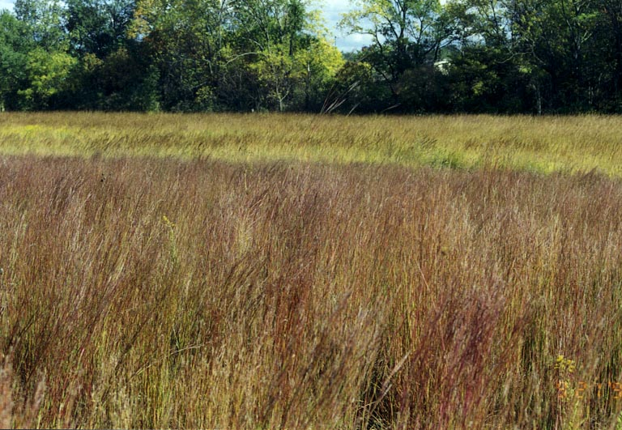
Bison Bison is a North Dakota release. It is not well suited to Ohio. *NR*

Bonilla Bison is a South Dakota release. It is not well suited to Ohio. *NR*

Indiangrass

Rumsey Rumsey is a 1983 NRCS release collected from south central Illinois and released in Missouri. It was selected for seedling vigor and resistance to lodging. It is widely adapted in the Midwest and recommended by Cooperative Extension Services in Ohio, Missouri and Iowa. It has good stem strength and will remain standing well into the winter. Hardy in zones 4,5 & 6. Rumsey is the preferred recommendation for Ohio. *Preferred*

Oto Oto is a Kansas/Nebraska release which has been tested in Ohio and is recommended by Cooperative Extension Service. It is highly productive and is hardy in zones 4 & 5. Should do satisfactory in Ohio. *rec*

Holt Holt is a Nebraska release but has been grown throughout the upper Midwest. Well adapted to areas needing reclamation and revegation. It is not highly productive for forages. Hardy in zones 4&5. Should do satisfactory in Northern Ohio. *rec*

Tomahawk Tomahawk is a North Dakota release with superior hardiness and persistence. Adapted to upper Midwest. ODNR experience is it is a variety, which tends to go down in winter. Has done satisfactory in Ohio but there may be other species which are better suited. *rec*

Osage Osage originated in Kansas and Oklahoma. It is hardy to zones 6&7. It is well adapted to droughty sites. Since Osage is a species that is adapted to dryer climates, it probably is not a recommended species for northern Ohio but may be suitable for ridgetops in Southern Ohio. *cond*

Nebraska 54 Developed from native grass stands along right-of–ways in Nebraska. Adapted to southern and eastern Nebraska, northern Kansas and northern Missouri. Hardy in zones 3,4, and 5. May do okay in Ohio but other cultivars are probably better. *NR*

Indiangrass continued:

Cheyenne Developed in Oklahoma for drier climates. Not suitable for Ohio. *NR*

Lometa Developed in Texas. Not suitable for Ohio. *NR*

Little Bluestem

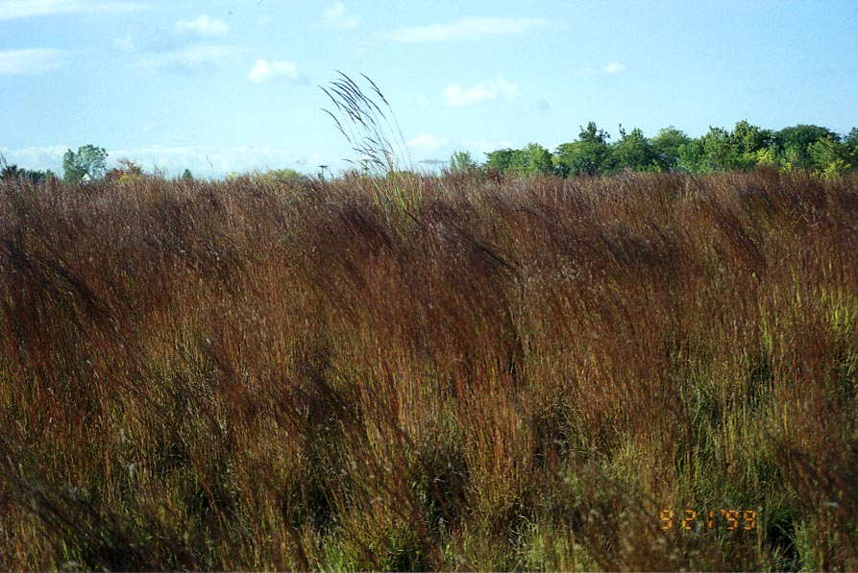
Aldous Selected in Kansas, Aldous is a NRCS 1966 release. It is widely adaptable with a geographic range of adaptation from southern Wisconsin to New York and south. It is tall, leafy, vigorous with some resistance to rust and is hardy in zones 4,5,6. Aldous is the preferred recommendation for Ohio. *Preferred*

Blaze Originated in Nebraska. Initially developed as ornamental, turns brilliant red in fall after first frost and provides interesting and colorful landscape. Selected for seedling vigor and green leaf character. Geographic range southern Minnesota, Wisconsin and Michigan. Hardy to zones 4&5. Well adapted to most locations. Blaze is a good species for Ohio with fall visual interest. *rec*

Camper Camper originated in Nebraska and is adapted to central Minnesota south and New York south. Hardy to zones 4&5. It has been reported as doing satisfactory in northern Ohio but Blaze or Aldous are probably better choices. *rec*

Cimarron Originated in Southwest Kansas. Suited to drier climates and lighter soils. Not suitable for Ohio. *NR*

Pastura Developed in New Mexico for sites with high elevations and low rainfall. Not suitable for Ohio. *NR*

SideOats Grama

El Reno Selected in Kansas and released by NRCS (1944), the El Reno cultivar is hardy in zones 4,5,& 6 and adapted from New York and Michigan south. It grows rapidly and is noted for disease resistance and winter hardiness. El Reno is the preferred cultivar for Ohio. *Preferred*

Butte Butte is a Nebraska release that is adapted from central Minnesota to southern Michigan and south. It is adapted to zones 4&5. It is winter hardy long lived and matures early.
Butte should do satisfactory in Ohio. *rec*
SideOats Grama continued:

Trailway Trailway is a Nebraska release. It is winter hardy and late maturing and recommended for zones 3&4 in southern New England and uplands in Nebraska. It is not recommended for Ohio, may be possible choice if better cultivars are not available. *NR*

Others Niner is a southwestern U.S. cultivar. Vaughn is a Colorado and New Mexico cultivar. Pierre and Kildeer are Northern Great Plains (Dakota) cultivars. None of these are suited to our climate nor recommended for Ohio. *NR*

Legend: *rec* Indicates recommended species which should perform fairly well across state
*cond* Indicates not generally recommended but may fit in certain niches or conditions
*NR* Indicates not recommended for use in Ohio on CRP

Note:
Above information summarized from comments from several sources of literature and individuals with field experiences in Ohio. Information is foremost for suitability for CRP and not necessarily solely accurate for species to be utilized for forage production, landscaping or native prairie restoration plantings. Consult other sources of information as well for these uses. Information presented is for the state as a whole. It is realized that site variations or intended purposes or personal preferences may change when and where a cultivar is or is not suited.

Prepared By:
Steve Davis, CCA, NRCS
Area Resource Conservationist & Certified Crop Advisor

Input provided by: Bob Hendershot, Grassland Specialist, NRCS
Jim Inglis, Regional Wildlife Biologist, Pheasants Forever
Dave Burgdorf, NRCS Plant Materials Specialist
John Blakeman, Meadow Environments LLC
Norm Widman, Conservation Agronomist, NRCS
Private Lands Biologists, ODNR Division of Wildlife
Rose Lake Plant Materials Center, NRCS, East Lansing, MI

References Consulted: Vegetating with Native Grasses In Northeastern North America, USDA NRCS and Ducks Unlimited Canada, Nov 1997

Big Bluestem, Indiangrass & Switchgrass, Publication G04673, Jimmy Henning, Dept of Agronomy, University of Missouri-Columbia, Oct.1993

Warm Season Grasses for Hay & Pasture, Iowa State Univ. Ext. Oct. 1994

Various Plant Fact Sheets & Plant Release Notes –USDA Plant Materials Program and PLANTS Data Base

Grass Varieties in the United States, USDA NRCS, Agriculture Handbook 170, Revised Nov. 1994

