Collecting & Planting Hardwood Cuttings
Conservation Practice Job Sheet Practice #___

Landowner____________________________ Location________________________

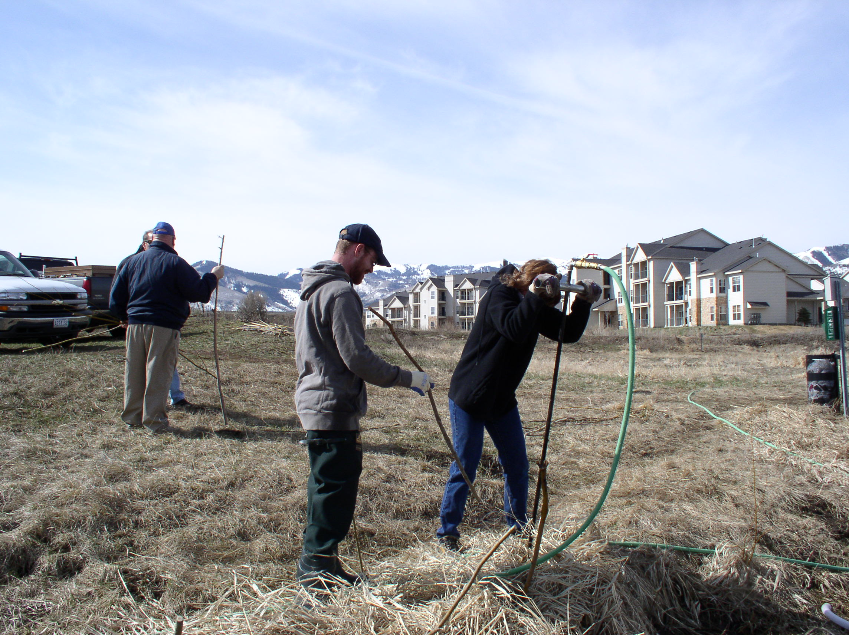

Purpose

Dormant hardwood cuttings of species such as willows, cottonwoods, and dogwoods can be used as an inexpensive and viable plant material for the restoration of woody plant communities along riparian areas. This job sheet provides guidelines for the successful collection and planting of hardwood cuttings when implementing a conservation plan.

Guidelines
Planting willow cutting with a Waterjet Stinger.

- Identify donor plants
  - It is critical that you select the right species. Identify donor plants during the growing season. Select stands that appear healthy.
  - Determine if poles (stems) are of adequate diameter (>3/4 inches for shrubs; >2-3 inches for trees) and sufficient length (>4 feet for shrubs; >7 feet for trees).

- Harvest cuttings
  - Cuttings must be harvested during the dormant season (after leaf fall, but before bud swell).
  - Make clean cuts on live wood at least 1 year old. Avoid using very old wood, suckers, and current year’s growth. Again, diameter of cuttings should be >3/4 inches for shrubs or >2-3 inches for trees and length should be >4 feet for shrubs or >7 feet for trees.
  - Do not remove more than 1/3 of any individual donor plant.

- Prepare cuttings
  - Trim all side branches off cuttings.
  - Cut the apical bud, plus several inches, off the top of the cutting.
  - (Optional) - Seal the top 1-2 inches of the cutting by dipping it into a 50-50 mix of light-colored latex, water-based paint and water (this helps prevent disease and water loss and it will help you plant the cutting with the top up!).

- Storage of cuttings
  - It is best to harvest cuttings in early spring and plant immediately but if this is not possible, cuttings can be stored safely for about 4 months.
  - Store cuttings in a cool, dark, and moist place. Do NOT store in a wet area as this will promote root growth and weaken the cutting.
  - Soak the bottom 1/3 of cutting in water for 1-5 days prior to planting.

Collecting & Planting Hardwood Cuttings – Job Sheet

- Planting cuttings
  - Ideally, cuttings should be planted in early spring after high water level drops, although, they can be planted in the fall with lower success. It is highly recommended that a Waterjet Stinger be used to plant cuttings, if available.
  - Ensure that top of cutting is pointing up. Plant cuttings to the depth of the low water table. At least half of the cutting should be in the ground (2/3 in, 1/3 out is best).
  - It is essential to have good contact between the cutting and the soil; air pockets will kill the roots. Pour mud into the planting hole with the cutting if soil is not moist.
  - Carefully tamp soil around cutting.

Groundwater Level
High Flow
Low Flow
Cutting
45° Angle

PLANT SPECIES | Spacing | # of Cuttings Needed
Additional Specifications and Notes:

