TECHNICAL NOTE

USDA - Natural Resources Conservation Service
Boise, Idaho – Salt Lake City, Utah

TN RANGE NO. 73 July 2012

Harvest Efficiency in Prescribed Grazing

Shane Green, State Rangeland Management Specialist, NRCS, Salt Lake City, Utah
Brendan Brazee, State Range Conservationist, NRCS, Boise, Idaho

This technical note transmits information on the concepts and terminology surrounding harvest efficiency and how they can be applied in conservation planning.

Background

Most range conservationists learned the concept of utilization during their education in range management. The old “take half, leave half” rule of thumb (figure 1) still applies with the new concept of harvest efficiency. The term ‘harvest efficiency’ is relatively new in range management. This term first appeared in the Journal of Range Management in 1980 (Beaty and Engel, 1980), and was first introduced in NRCS through the 1997 edition of the National Range and Pasture Handbook (NRPH). The Society for Range Management Glossary of Terms Used in Range Management (1989 edition) did not contain the term “harvest efficiency”, but the concept could be found in the definition of Utilization (Use): The proportion of current year’s forage production that is consumed or destroyed by grazing animals. Recognizing that some forage is consumed and some is destroyed is a key concept to understanding harvest efficiency.

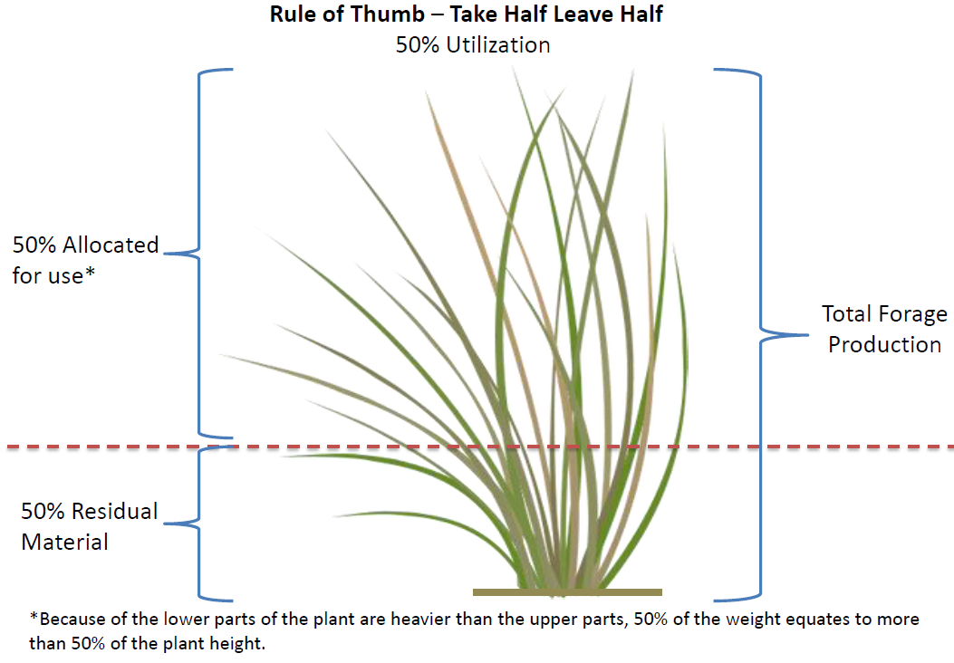
Figure 1 – Illustration of the utilization concept

Definition

The NRPH defines harvest efficiency as “The total percent of vegetation harvested by a machine or ingested by a grazing animal compared to the total amount of vegetation grown in the area in a given year…. Harvest efficiency is the percentage of forage actually ingested by the animals from the total amount of forage produced.” Figure 2 illustrates this concept.
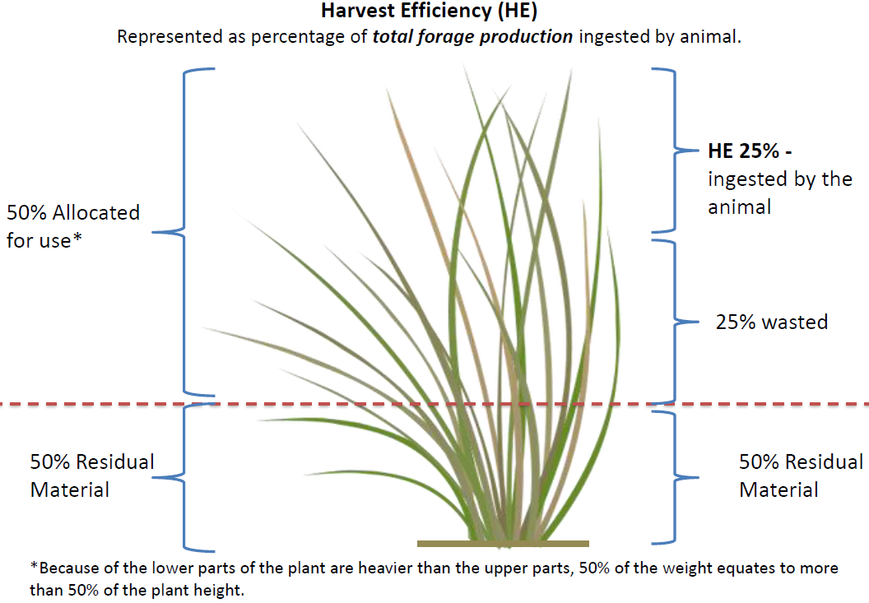
Figure 2 – Illustration of the harvest efficiency concept

Total forage production (TFP) includes only the forage species in the plant community, and represents all of their above ground annual production, not just that portion above a stubble height. The ‘Leave Half’ portion (50 percent) represents post-grazing residual forage (R). This is the most important part of the old take half, leave half rule of thumb for grazing. The ‘Take Half’ portion (50 percent) allocated for use represents utilization (U), and includes both consumed and destroyed portions. The ‘ingested’ portion (25 percent) represents harvest efficiency (HE), or that portion that is actually ingested by the grazing animal. The ‘wasted’ portion (25 percent) represents forage that was utilized but went to waste through trampling, desiccation, manure and urine, bedding, etc.

Finding the Correct Value
Units and Equations
Animal Unit Day (AUD)
Daily Herbage Intake (DHI) = lbs/AUD
Stocking Rate (SR) = AUD/area
Intake (I) = DHI * SR
Total Forage Production (TFP) = lbs/area
Harvest Efficiency (HE) = I/TFP*100
Residual (R) = lbs/area
Utilization (U) = 1-(R/TFP)*100
Grazing Efficiency (GE) = I/(TFP-R)*100

The NRPH recommends the following: “For continuous grazing, harvest efficiency usually averages:
Rangeland 25 percent
Pastureland 30 percent
Grazed cropland 35 percent”

These values can fluctuate depending on the stocking density. As further explanation, the NRPH says “Harvest efficiency increases as the number of animals increases in an area and they consume plant material before it senesces, transfers to litter, or otherwise leaves the area.” Recent research has verified these values to be correct. If total forage production (TFP) is estimated and animal intake (I) is assumed to be a generally accepted value, the actual harvest efficiency can be calculated.
The equation is:

I/TFP*100 = HE

For example:

$$\frac{30 lbs forage/day*50 mother cows \left(1000 lbs each\right)*90 days in the pasture}{1500 acre pasture*375 lbs/ac total forage production}*100=24\% Harvest Efficiency$$

If the residual (R) left over following grazing is estimated, utilization (U) can be calculated as well. The equation is:

1-(R/TFP)*100 = U

For example:

$$1-\frac{1500 acre pasture*(188 lbs)/ac residual forage following grazing }{1500 acre pasture*375 lbs/ac total forage production}*100=50\% Utilization$$

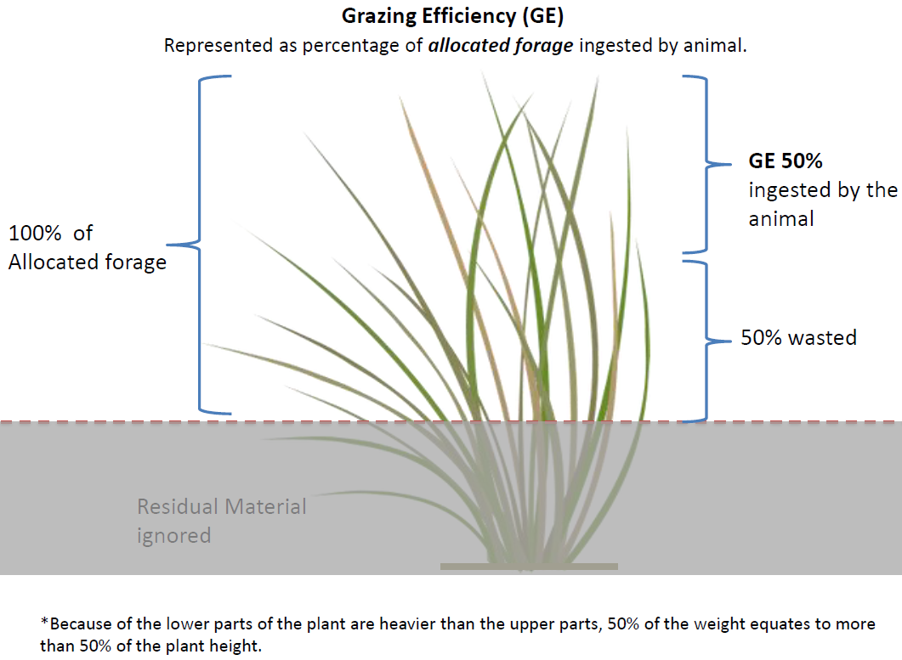
Figure 3 – Illustration of the grazing efficiency concept
The relationship between utilization and harvest efficiency has been documented. Grazing studies on rangelands in Wyoming, South Dakota, Kansas, Colorado, North Dakota, and Oklahoma have shown that at 50 percent utilization rates, harvest efficiency is 25 percent. If utilization is increased to 65 percent, harvest efficiency increases to about 37 percent. If utilization is decreased to 40 percent, harvest efficiency decreases to about 15 percent (Smart et al, 2010). However, utilization rates should not be increased for the sole purpose of improving harvest efficiency.
Another related expression of efficiency is grazing efficiency (GE) (figure 3). Of all forage utilized (this includes what is wasted), that portion actually ingested by the animal is grazing efficiency. The equation for grazing efficiency is:

I/(TFP-R)*100 = GE

For example:

$$\frac{30 lbs forage/day*50 mother cows \left(1000 lbs each\right)*90 days in the pasture}{1500 ac*375lbs/ac total forage production- 1500 ac*(188 lbs)/ac residual}=48\% Grazing Efficiency$$

Stock density (number of head/area) can be used as a tool to improve both harvest efficiency and grazing efficiency (Briske, 2011 and Gerrish, 2004). As stock density increases, grazing distribution improves, selectivity decreases, and the proportion of utilized forage that is actually ingested (grazing efficiency) increases. So, increased harvest efficiency and grazing efficiency can happen by increasing stock density while utilization remains at targeted levels.

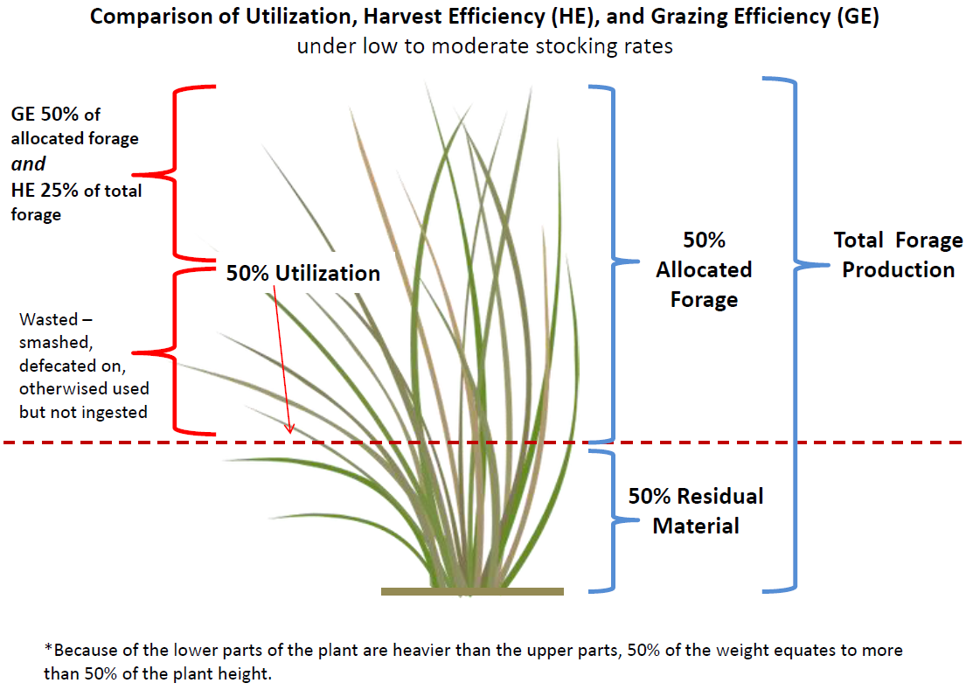
Figure 4 – Comparison of the utilization, harvest efficiency and grazing efficiency concepts

Table 1 and Figure 4 contrasts the concepts of utilization, harvest efficiency, and grazing efficiency. Under a basic grazing scenario, typical values for rangeland are portrayed. Under the high stock density scenario, utilization remains at 50 percent but harvest efficiency improves. Understanding these concepts and relationships are key to providing sound technical advice to cooperators using the prescribed grazing practice during the conservation planning process.

Table 1
Utilization | Harvest Efficiency | Grazing Efficiency
Proportion of annual forage production that is removed or destroyed | Proportion of total forage production ingested by the grazing animal | Proportion of utilization that is ingested by the grazing animal
basic grazing scenario
50% | 25% | 50%
high stock density scenario
50% | 35% | 70%

Contacts:

Shane Green, State Rangeland Management Specialist, NRCS, Salt Lake City, Utah
Brendan Brazee, State Rangeland Management Specialist, NRCS, Boise, Idaho

Literature Cited:

Beaty E. R., and J. L. Engel. 1980. Forage Quality Measurements and Forage Research: A Review, Critique and Interpretation, Journal of Range Management, Vol. 33, No. 1, pp. 49-54

Briske, D.D., editor. 2011. Conservation Benefits of Rangeland Practices: Assessment, Recommendations, and Knowledge Gaps. United States Department of Agriculture, Natural Resources Conservation Service.

Gerrish, Jim. 2004. Management intensive Grazing – The Grassroots of Grass Farming

Smart A. J., J. D. Derner, J. R. Hendrickson, R. L. Gillen, B. H. Dunn, E. M. Mousel, P. S. Johnson, R. N. Gates, K. K. Sedivec, K. R. Harmoney, J. D. Volesky, and K. C. Olson. 2010. Effects of Grazing Pressure on Efficiency of Grazing on North American Great Plains Rangelands. Rangeland Ecology & Management: Vol. 63, No. 4, pp. 397-406

Society for Range Management. 1989. A Glossary of Terms Used in Range Management. Glossary revision special committee, Publications committee. Denver, Colorado

USDA Natural Resources Conservation Service. 1997. National Range and Pasture
Handbook. Fort Worth, TX: US Department of Agriculture, Natural Resource Conservation Service, Grazing Lands Technology Institute.

Daily intake rate for an animal unit NRCS uses, National Range and Pasture Handbook 600.0603(a)
Daily intake rate for an animal unit NRCS uses, National Range and Pasture Handbook 600.0603(a)

